Set up a YouTube account - if the parish already has a google account you can use that.

(don’t use an existing one unless you want your parishioners to see the videos you already have etc)

If you have to set up a fresh account, you will need to wait 24 hours before you can live stream from it.

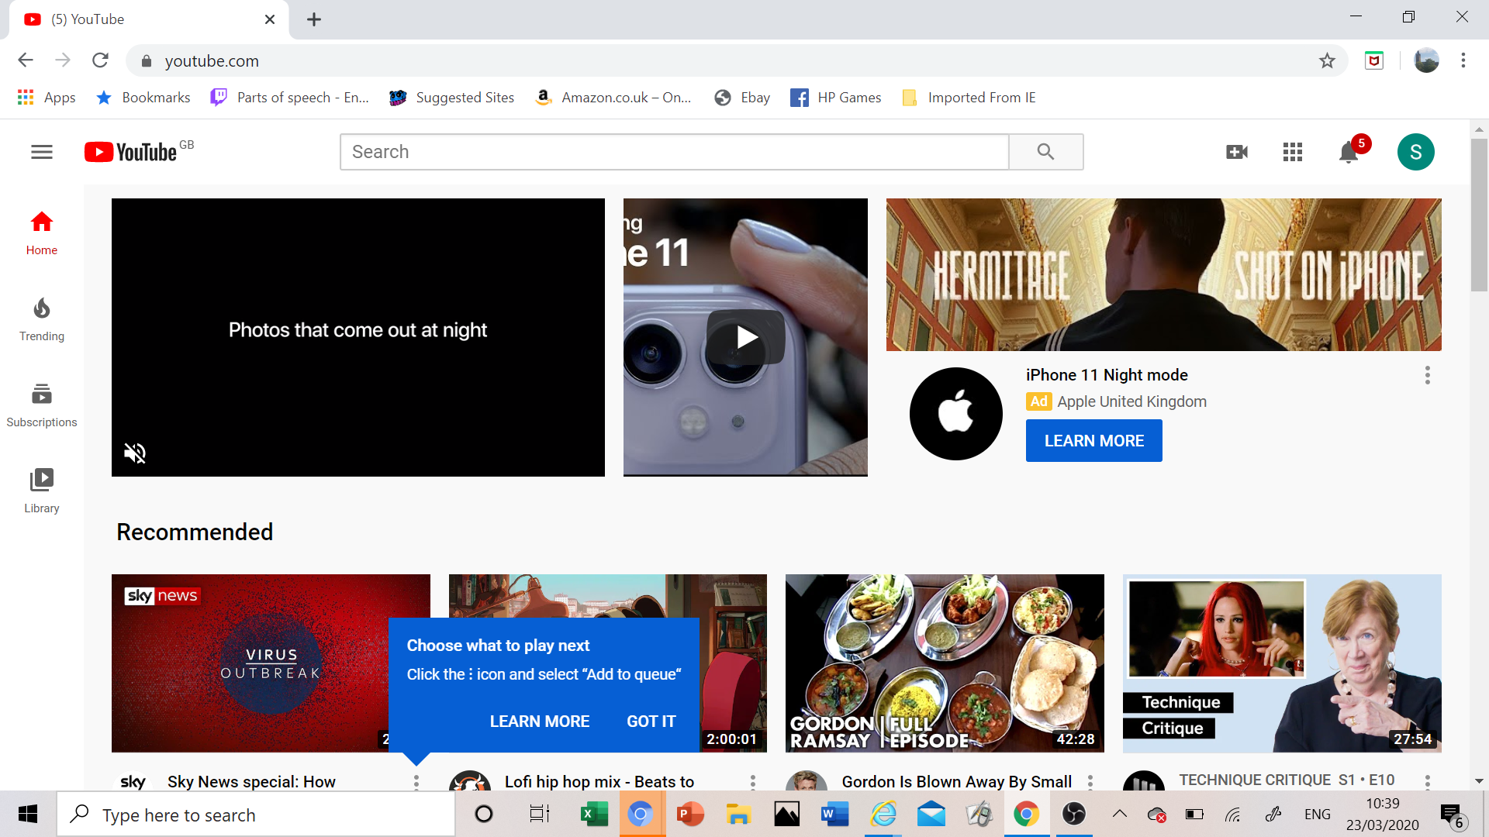

Next we need one extra bit of software called OBS

This is also free software. So still no money spent… just google it.

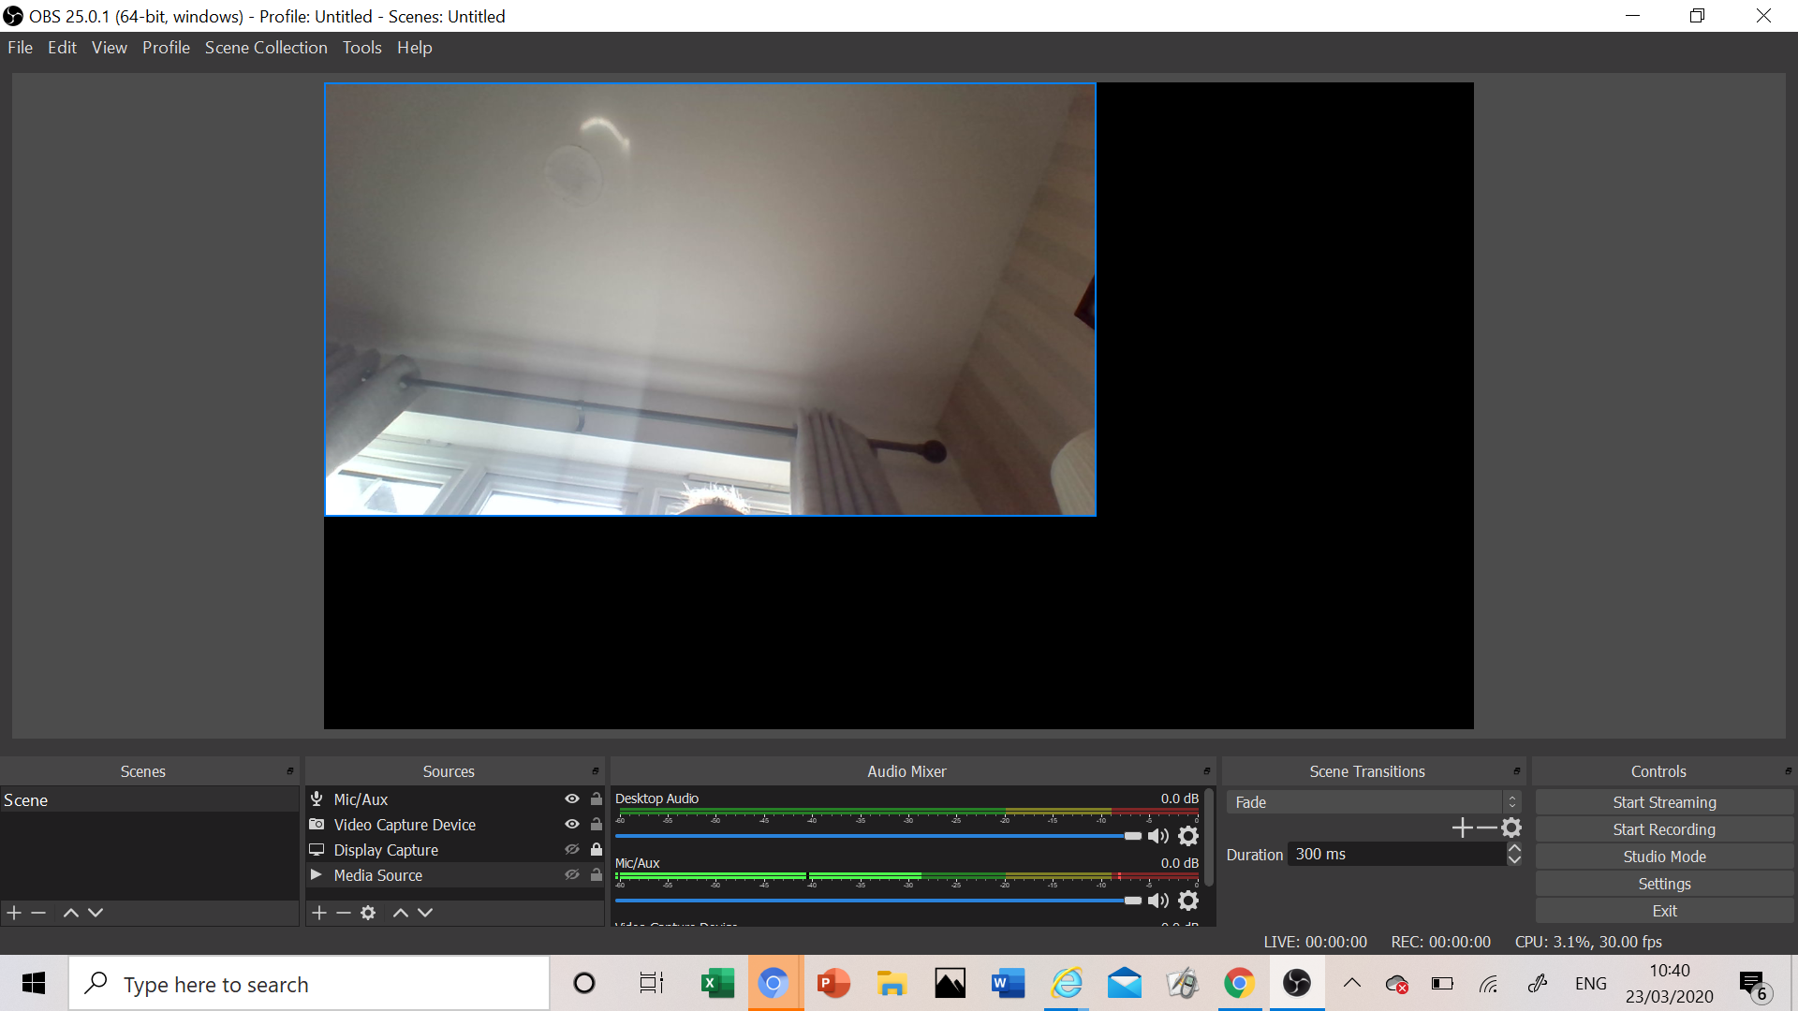

This is the software that we send the image signal to, and the audio signal to.

The internal camera and mic will work - not amazingly - but you will be able to have decent communication with the parish that way!

Now to make youtube and obs talk to each other.

Go to youtube and press the camera with the plus sign in it (top right corner)

Choose “go live”

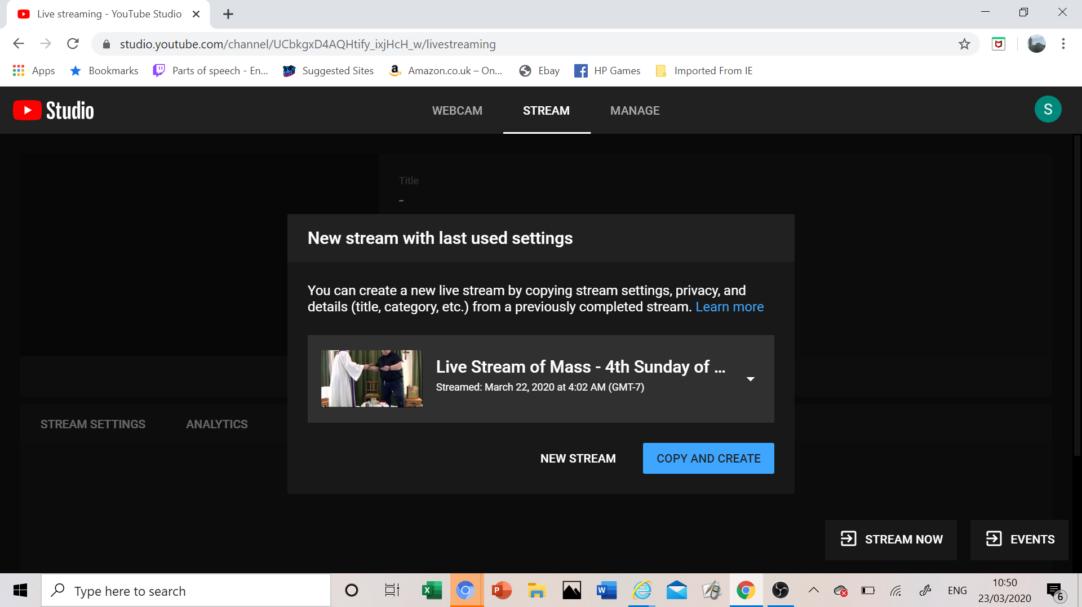

Click New Stream and fill in all he obvious things (see below)

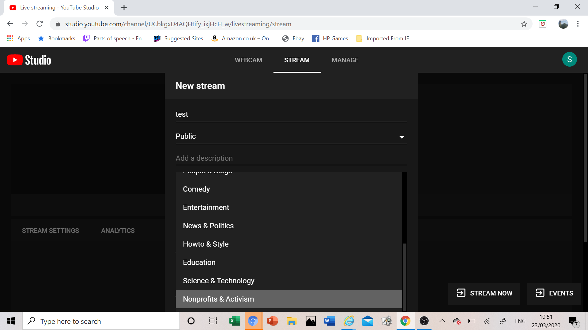

Then hit “STREAM NOW”

The next page gives you the “key” so that you can talk between OBS and YouTube
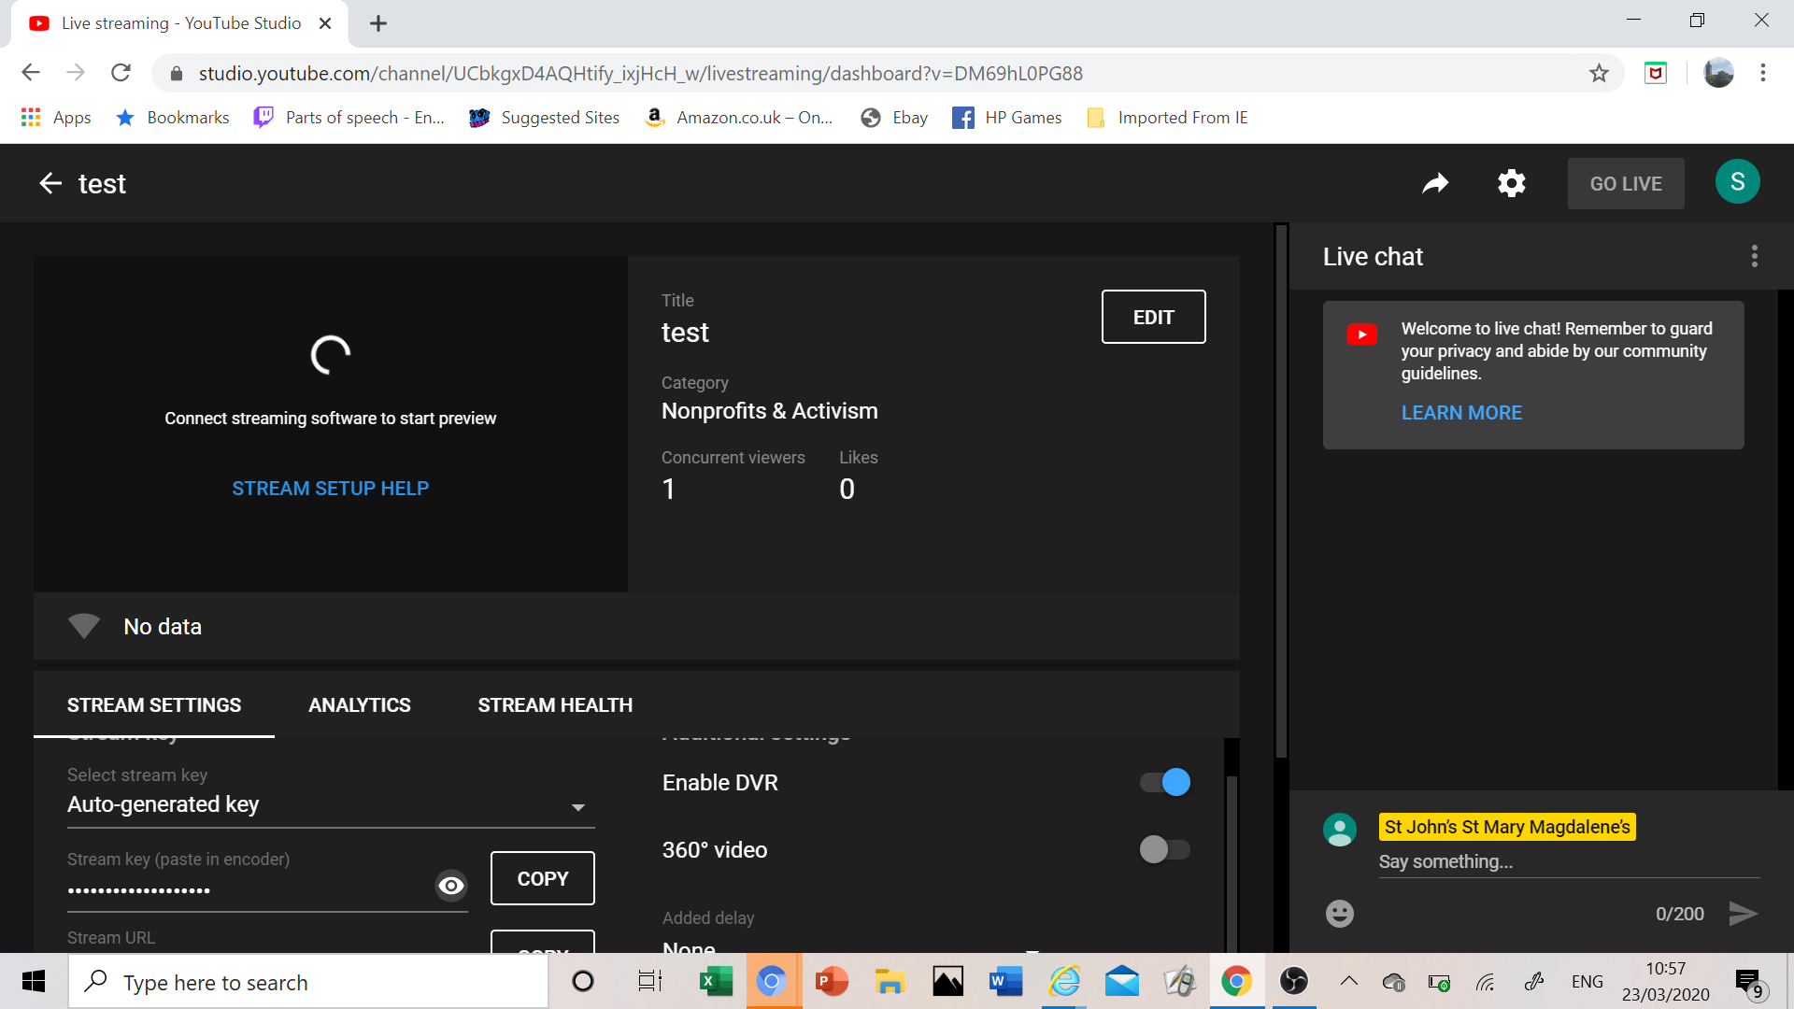

Copy the key

Go to OBS

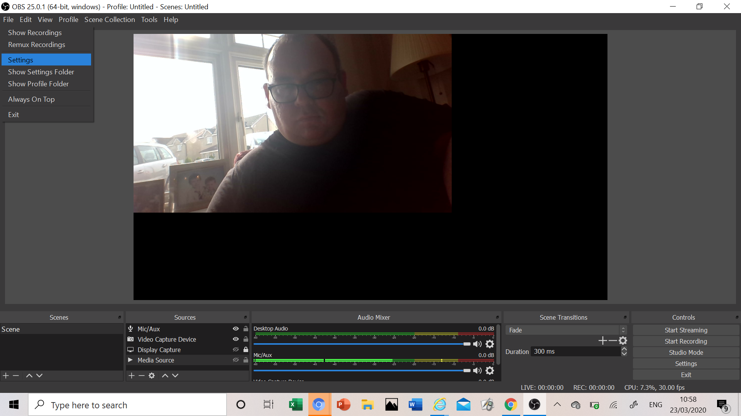

Then we go into settings, then “stream”
Paste in your youtube key.
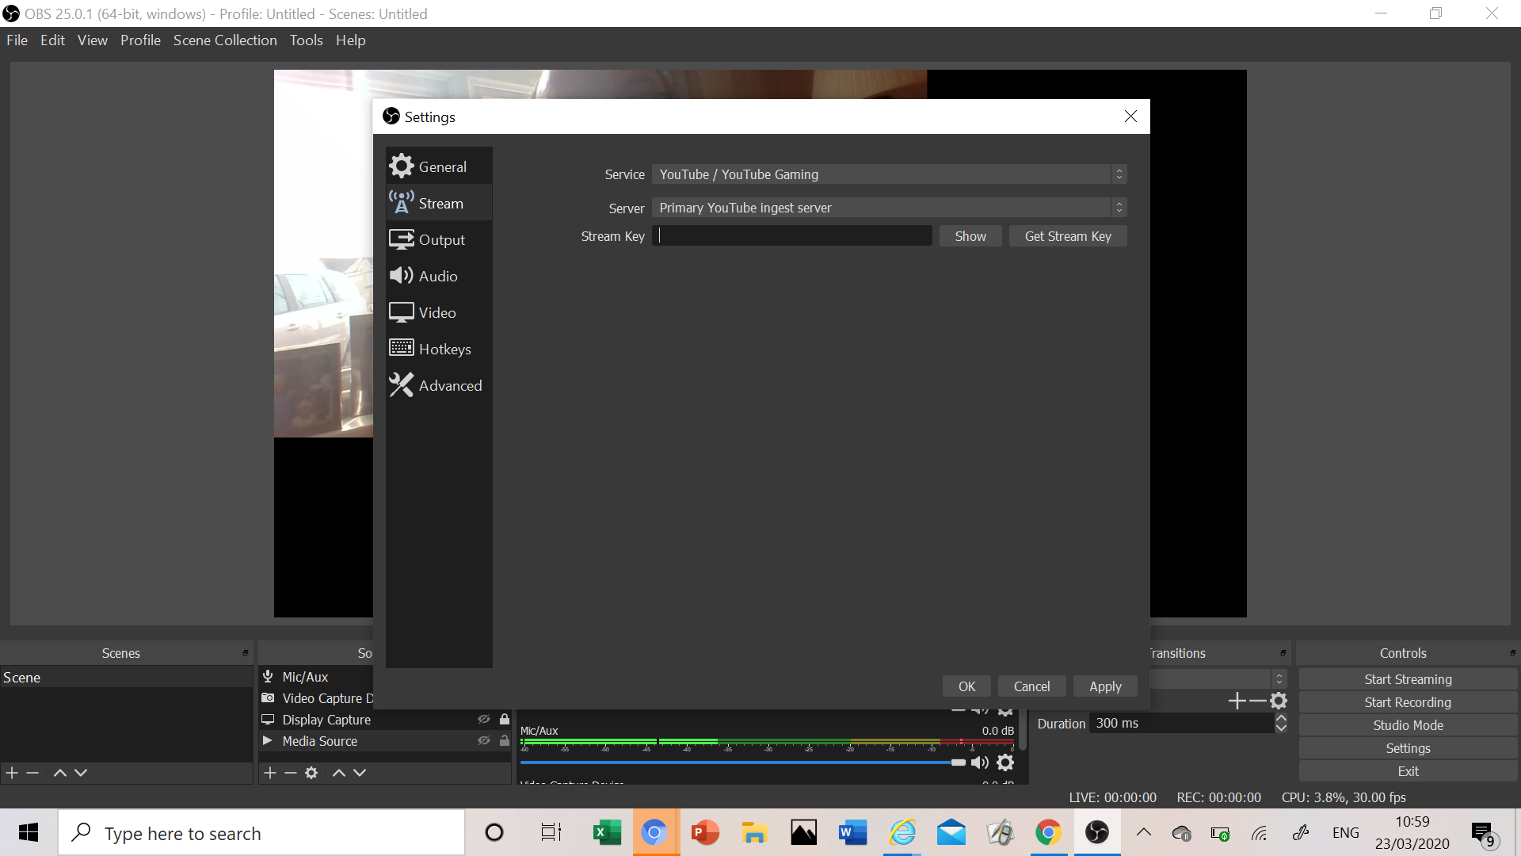

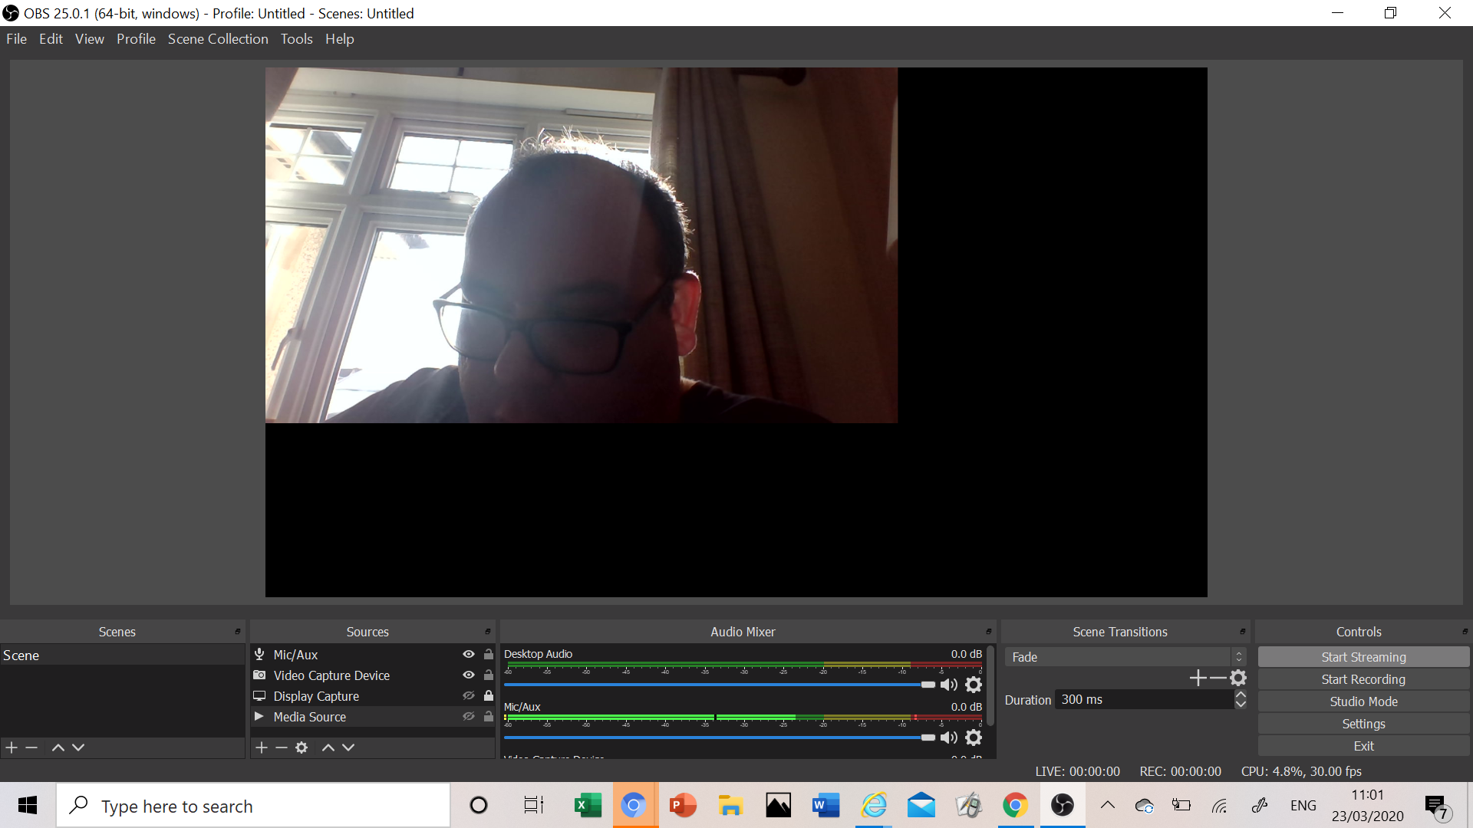

Click “start streaming”

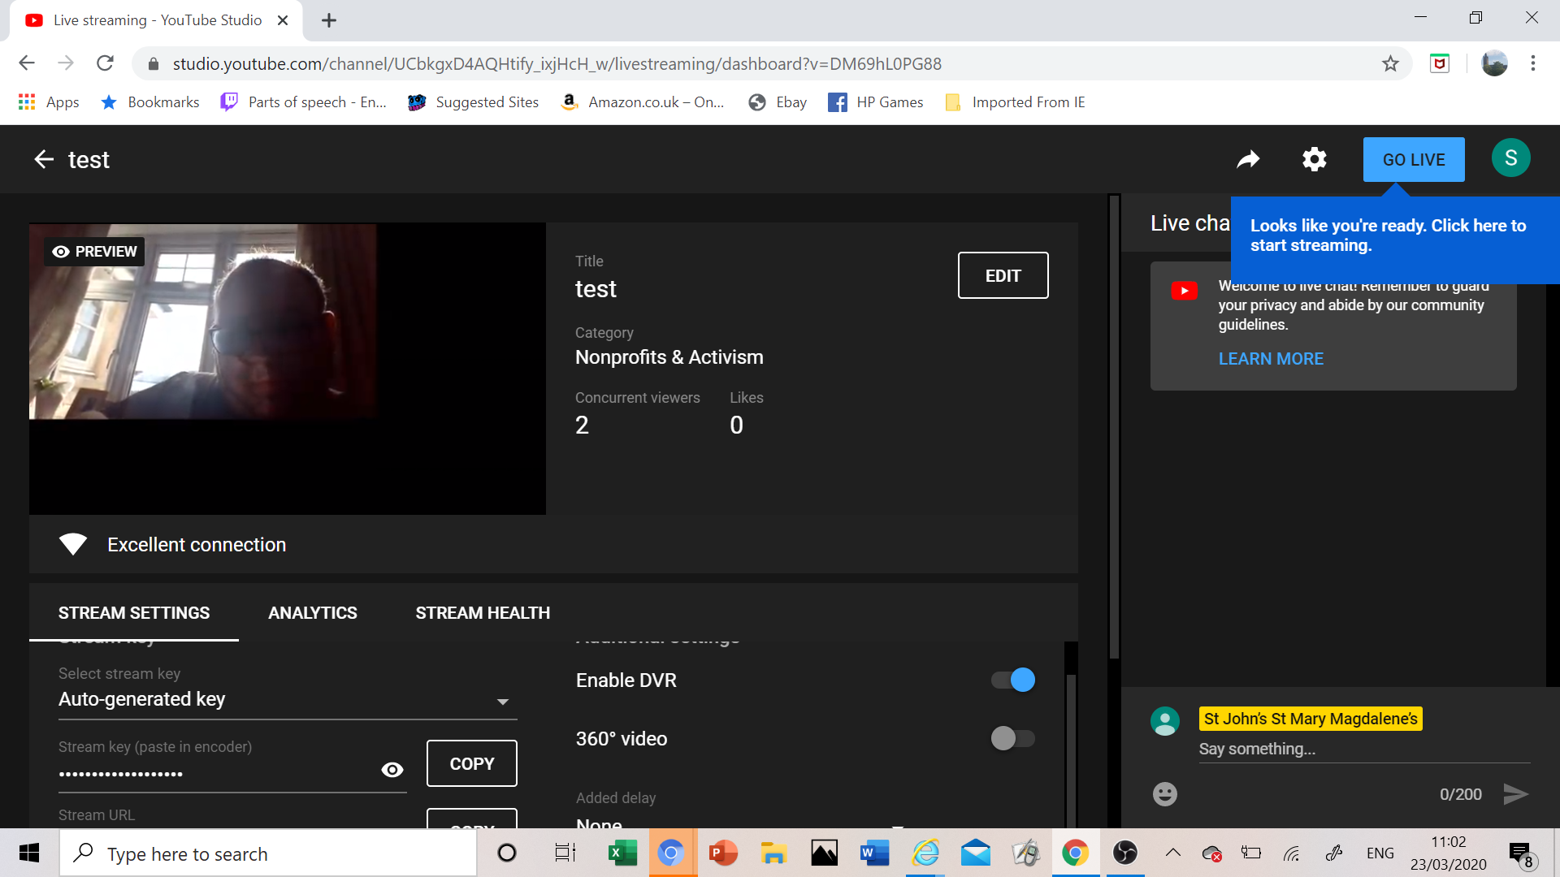

Now it appears on youtube.

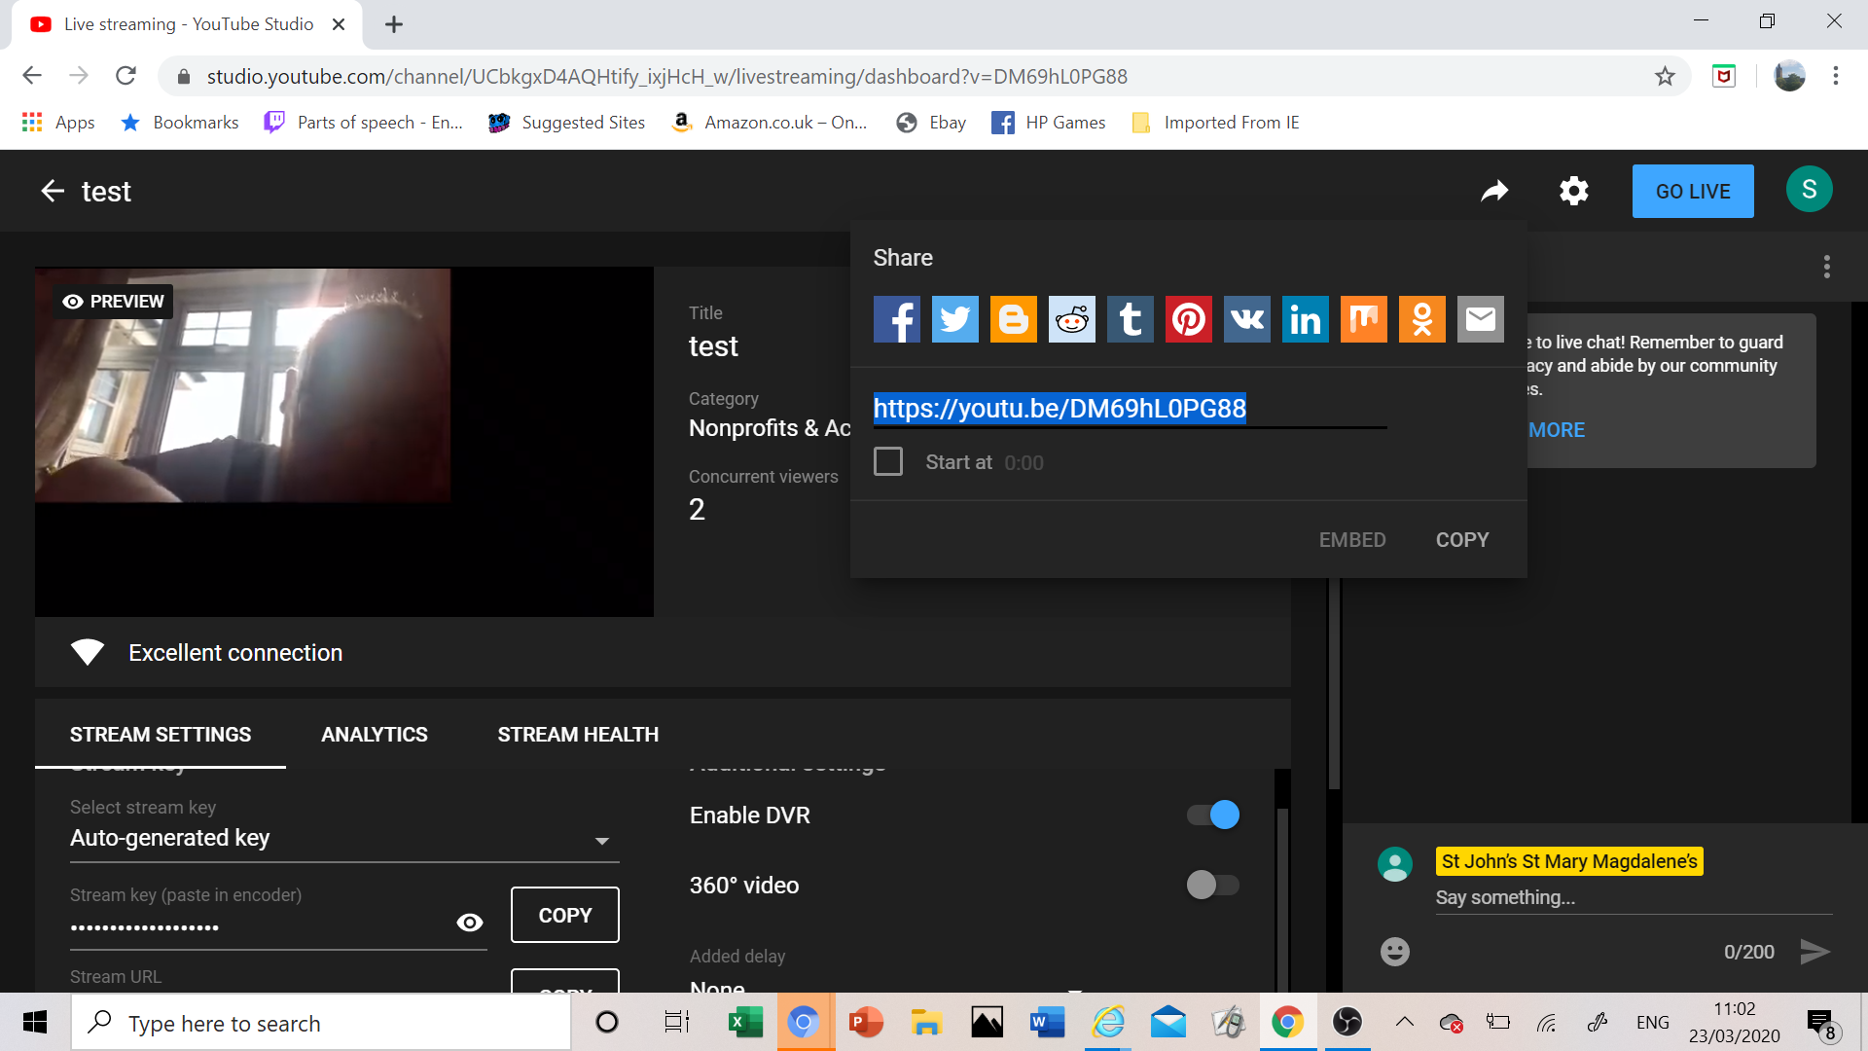

You get your sharing link there and then hit “go live”

To be expert…

- You can add an external microphone
- You can add a external camera (it has to be a USB webcam - or if you want to go up a level, an HDMI camera has to have a converter to be a USB device by the time it hits the computer.

These may be things your parishioners have lying aroung!

