The World Day of Migrants and Refugees is the last Sunday of September; this year it will be celebrated on 27 September.
The Holy Father has chosen “Forced like Jesus Christ to flee” as his message: to focus on the pastoral care of internally displaced people.
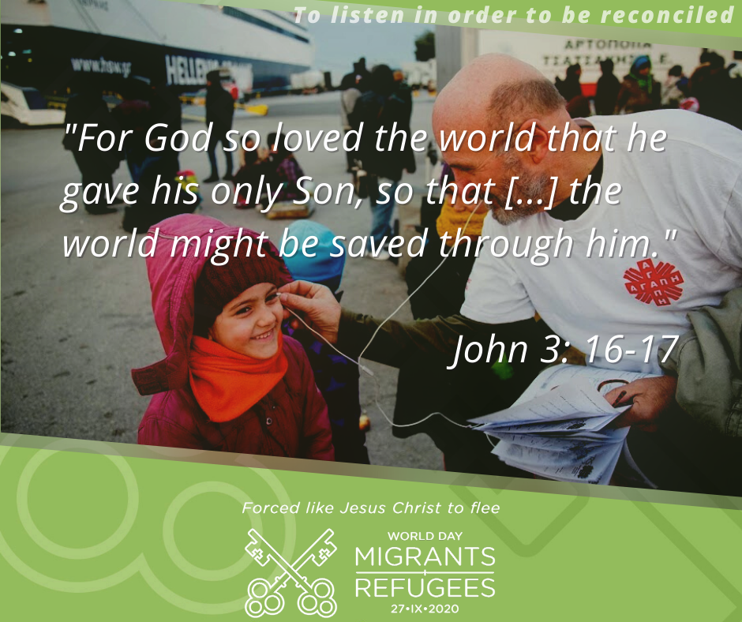

Here are some prayers of intercession offered for Sunday 27th September based on the Pope’s message – parishes may wish to add a prayer for Mercy Baguma, who died in Glasgow recently:
Father, you entrusted to Saint Joseph what you held most precious: the child Jesus and his Mother, in order to protect them from the dangers and threats of the wicked during their years as migrants and refugees. Grant that we may experience his protection and help. Lord, hear us…
Today is the World Day of Migrants and Refugees. Saint Joseph shared in the sufferings of those who flee from the hatred of the powerful. May he console and protect all our brothers and sisters driven by war, poverty and necessity to leave their homes and their lands to set out as refugees for safer places. Lord, hear us…
Help migrants and refugees, through the intercession of Saint Joseph, to find the strength to persevere. Give them comfort in sorrows and courage amid their trials. Lord, hear us…
Lord God, you have given us the mandate to welcome each other. Grant to us and to those who welcome migrants and refugees some of the tender love of Saint Joseph, this just and wise father, who loved Jesus as a true son and sustained Mary at every step of the way. Lord, hear us…
May Saint Joseph, who earned his bread by the work of his hands, watch over those who have seen everything in life taken away, and obtain for them the dignity of a job and the serenity of a home. We ask this through Jesus Christ, your Son, whom Saint Joseph saved by fleeing to Egypt, and trusting in the intercession of the Virgin Mary, whom he loved as a faithful husband. Lord, hear us…
Pope Francis says this in his message: Full message online at https://migrants-refugees.va/world-day-of-migrants-refugees/
Displaced people offer us this opportunity to meet the Lord, “even though our eyes find it hard to recognise him: his clothing in tatters, his feet dirty, his face disfigured, his body wounded, his tongue unable to speak our language”…
When we talk about migrants and displaced persons, all too often we stop at statistics. But it is not about statistics, it is about real people! If we encounter them, we will get to know more about them. And knowing their stories, we will be able to understand them. We will be able to understand, for example, that the precariousness that we have come to experience as a result of this pandemic is a constant in the lives of displaced people…
“But a Samaritan, as he journeyed, came to where the man was; and when he saw him, he had compassion, and went to him and bound up his wounds, pouring on oil and wine; then he set him on his own beast and brought him to an inn, and took care of him” (Lk 10:33-34). Fears and prejudices – all too many prejudices – keep us distant from others and often prevent us from “becoming neighbours” to them and serving them with love. Drawing close to others often means being willing to take risks, as so many doctors and nurses have taught us in recent months. This readiness to draw near and serve goes beyond a mere sense of duty. Jesus gave us the greatest example of this when he washed the feet of his disciples: he took off his cloak, knelt down and dirtied his hands (cf. Jn 13:1-15)…
A love that reconciles and saves begins with listening. In today’s world, messages multiply but the practice of listening is being lost. Yet it is only through humble and attentive listening that we can truly be reconciled. In 2020, silence has reigned for weeks in our streets. A dramatic and troubling silence, but one that has given us the opportunity to listen to the plea of the vulnerable, the displaced and our seriously ill planet. Listening gives us an opportunity to be reconciled with our neighbour, with all those who have been “discarded”, with ourselves and with God, who never tires of offering us his mercy….
God did not want the resources of our planet to benefit only a few. This was not the Lord’s will! We have to learn to share in order to grow together, leaving no one behind. The pandemic has reminded us how we are all in the same boat….
We must find “the courage to create spaces where everyone can recognize that they are called, and to allow new forms of hospitality, fraternity and solidarity”…
To preserve our common home and make it conform more and more to God’s original plan, we must commit ourselves to ensuring international cooperation, global solidarity and local commitment, leaving no one excluded…
Father, you entrusted to Saint Joseph what you held most precious: the child Jesus and his Mother, in order to protect them from the dangers and threats of the wicked. Grant that we may experience his protection and help. May he, who shared in the sufferings of those who flee from the hatred of the powerful, console and protect all our brothers and sisters driven by war, poverty and necessity to leave their homes and their lands to set out as refugees for safer places…
Resource by Archdiocese of St Andrews & Edinburgh, Caritas, Justice and Peace Commission/Refugees workgroup https://archedinburgh.org/pastoral-governance/caritas-justice-peace/

