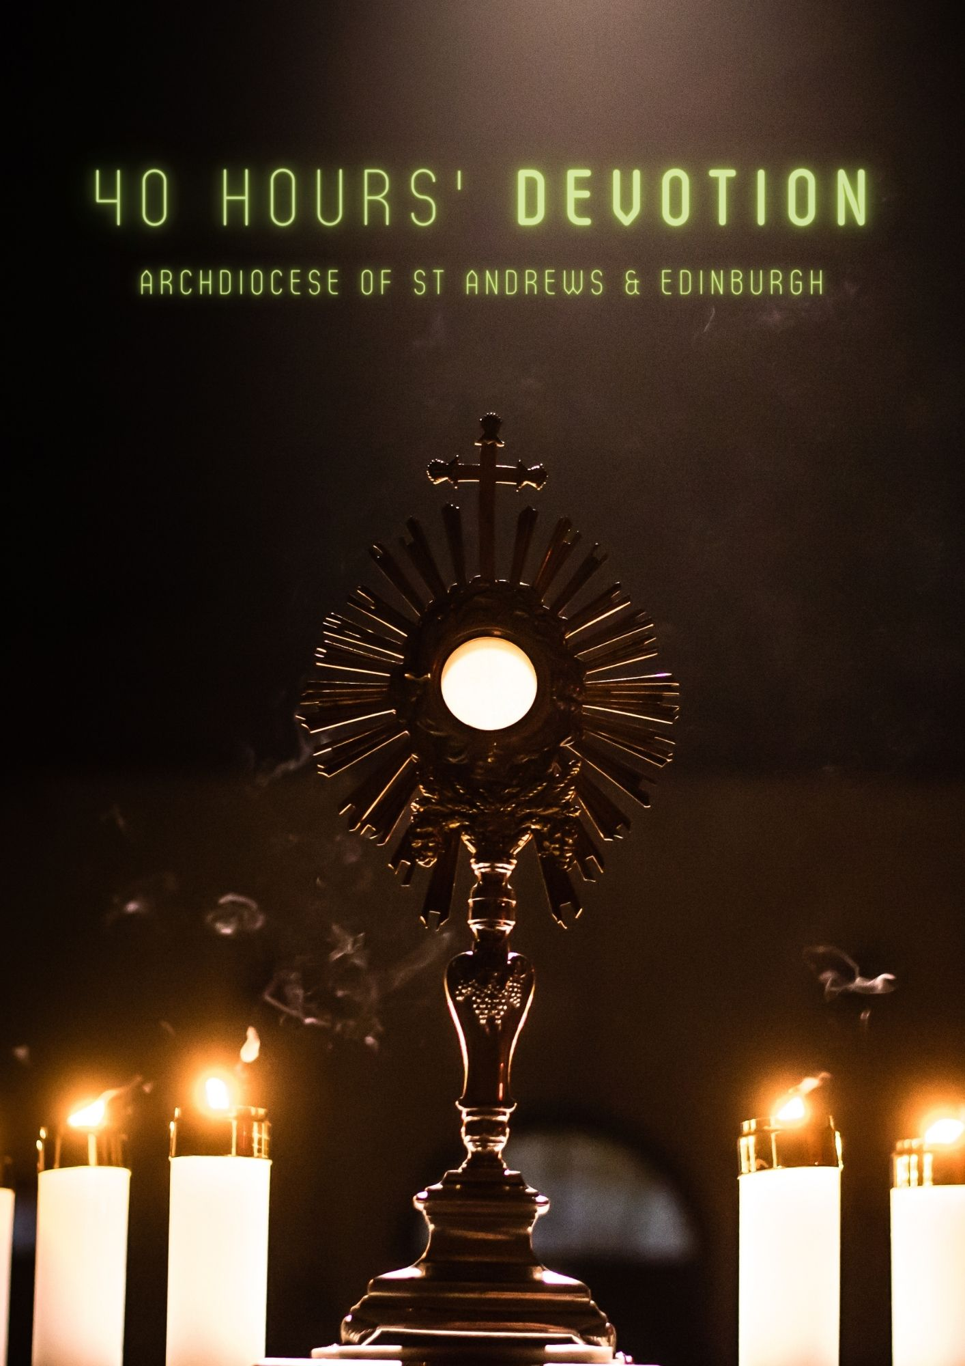

TIME FOR PERSONAL PRAYER AND REFLECTION

A VISIT TO THE BLESSED SACRAMENT

The Eucharist is the Sacrament of the presence of Christ, who gives Himself to us because He loves us. He loves each one of us in a unique and personal way in our practical daily lives: in our families, among our friends, at study, work, relaxation.

He loves us when He fills our days with freshness, and when, in times of suffering, He allows trials to weigh upon us: even in the most severe trials, He lets us hear His voice. Yes, dear friends, Christ loves us and He loves us forever! He loves us even when we disappoint Him, when we fail to meet His expectations for us.

He never fails to embrace us in His mercy.

How can we be not grateful to this God who has redeemed us, going so far as to accepting the foolishness of the cross?

To God who has come to be at our side and stayed with us to the end.

Pope Saint John Paul II Closing of World Youth Day 2000

PRAYER
O heart of Jesus in the Blessed Sacrament,
burning with love for us,
inflame our hearts with love for You.
Father, may this Sacrament fill us with love,
draw us closer to Your Son
and help us to recognise Him in others.
Through Christ the Lord. Amen.
O Sacrament most holy, O Sacrament divine,
all praise and all thanksgiving be every moment Thine.
Anonymous 19th Century Prayer

O my God, I believe, I adore, I hope and I love You. I ask pardon for all those who do not believe, do not adore, do not hope, do not love You.
Fatima Prayer

REFLECTION
We are now in the presence of the infinite Majesty of God,
who was once pleased, for love of us, to come down from heaven and become Man on earth, and to die on a cross to save us.
and is now in the Blessed Sacrament, to listen to our prayers and grant us the graces that we ask of Him.
St Francis of Assisi (1181 – 1286)

PRAYER
I adore You O Jesus, true God and true Man, here present in the holy Eucharist, humbly kneeling before You and united in spirit with all the faithful on earth and in heaven. In deepest gratitude for so great a blessing, I love You, my Jesus, with my whole heart, for You are all perfect and all worthy of love. Give me grace nevermore in any way to offend, and grant that, being refreshed by Your Eucharistic presence here on earth, I may be found worthy to come to the enjoyment with Mary of Your eternal and ever blessed presence in heaven. Amen.

I believe that You, O Jesus, are in the most Blessed Sacrament
I love You and desire You! Come into my heart. I embrace You.
O never leave me!

May the burning and most sweet power of Your love, O Lord Jesus Christ,
absorb my mind, that I may die through Your love, who was pleased to die through love of my love. Amen.
St Francis of Assisi (1181 – 1286)

REFLECTION

I place myself in the presence of Him, in whose Incarnate Presence I am before I place myself there. I adore You, O my Saviour, present here as God and as Man, in soul and in body, in true flesh and blood. I acknowledge and confess that I kneel before that Sacred Humanity, which was conceived in Mary’s womb, and lay in Mary’s bosom; which grew up to twelve, wrought miracles, and spoke words of wisdom and peace; which in due season hung on the cross, lay in the tomb, rose from the dead, and now reigns in heaven. I praise, and bless, and give myself wholly to Him, who is the true Bread of my soul, and my everlasting joy.

St John Henry Cardinal Newman (1801 – 1890)

PRAYER
Grant, O Lord, we pray,
that we may delight for all eternity
in that share in Your divine life
which is foreshadowed in the present age
by our reception of Your precious Body and Blood.
Who live and reign for ever and ever. Amen.
St Thomas Aquinas (1225 – 1274)

REFLECTION

We need silence to be able to touch souls. The essential thing is not what we say, but what God says to us and through us. All our words will be useless unless they come from within—words which do not give the light of Christ increase the darkness.

Every holy hour we make so pleases the Heart of Jesus that it will be recorded in Heaven and retold for all eternity. It opens the floodgates of God’s merciful love upon the world.

Adoration of the Blessed Sacrament is the best time you will spend on earth. It will make your soul everlastingly more glorious and beautiful in Heaven. A Holy Hour of adoration helps bring everlasting peace to your soul and in your family. It brings us personal peace and strength. It brings us a greater love for Jesus, for each other, and for the poor. Every holy hour deepens our union with Him and bears much fruit.

Nowhere on earth are we more welcomed or loved than before Jesus in Eucharist. When you look at the crucifix, you understand how much Jesus loved you. When you look at the Sacred Host you understand how much Jesus loves you now. This is why we need Perpetual Eucharistic Adoration in every Parish throughout the entire World.

St Theresa of Calcutta (1910 – 1997)

PRAYER

Oh Jesus, concealed in the Host, my sweet Master and faithful Friend, how happy my soul is to have such a Friend who always keeps me company.

How happy I am to be a dwelling place for You, O Lord! My heart is a temple in which You dwell continually.

My Lord Jesus Christ, I believe that You are really here in this Sacrament.

Night and day You remain here compassionate and loving.

You call, You wait for, You welcome everyone who comes to visit You.

I thank You, Jesus my Divine Redeemer for coming upon the earth for our sake and for instituting the Adorable Sacrament of the Holy Eucharist in order to remain with us until the end of the world.

I thank You for hiding beneath the Eucharistic species Your infinite majesty and beauty, which Your Angels delight to behold, so that I might have courage to approach the throne of Your mercy.

I thank You dear Jesus for having become the priceless Victim, to merit for me the fullness of heavenly favours.

Awaken in me such confidence in You that their fullness may descend ever more fruitfully upon my soul.

I thank You for offering Yourself in thanksgiving to God for all His benefits, spiritual and temporal, which He has bestowed on me. Grant me grace and perseverance in your faithful service. Amen.

Extract from 7 Secrets of the Eucharist by Vinny Flynn

REFLECTION

One day St John Vianney, the Curé d’Ars, noticed a peasant sitting in church, silently looking at the tabernacle in which the Blessed Sacrament was reserved. When the saint asked what he was doing, the peasant replied, “I look at Him and He looks at me.” The ‘prayer of simple regard’, a silent stillness in the presence of our Lord, is hard to achieve in an overactive life, but it is one to which all of us must aim. Words and lists, petitions and intercessions, that much overused form of prayer, can be just busy distractions from the silent prayer of simple regard, just as initiatives, programmes, targets, and action plans can be no more than symptoms of panic in a Church that seems to have lost its Faith.

When I come to a human heart in Holy Communion, My hands are full of all kinds of graces which I want to give to the soul, but souls do not even pay attention to me. They leave Me to Myself and busy themselves with other things…They treat Me as a dead object.
St Faustina Kowalska (1905 – 1938)

PRAYER
Most Holy Trinity, Father, Son and Holy Spirit, I offer You the most precious Body, Blood, Soul and Divinity of Jesus Christ, present in all the tabernacles of the world, in reparation for the outrages, sacrileges, and indifference with which He Himself is offended. And through the infinite merits of His most Sacred Heart and the Immaculate Heart of Mary, I beg of You the conversion of poor sinners.

O Jesus, concealed in the Host, my sweet Master and faithful Friend, how happy my soul is to have such a Friend who always keeps me company. How happy I am to be a dwelling place for You, O Lord! My heart is a temple in which You dwell continually.
St Faustina Kowalska (1905 – 1938)

O Jesus, concealed in the Blessed Sacrament of the Altar, my only love and mercy, I commend to You all the needs of my body and soul. You can help me because You are Mercy itself. In You lies all my hope.
St Faustina Kowalska (1905 – 1938)

REFLECTION
What miracles! Who would ever have imagined such! If the angels could be jealous of men, they would be so for one reason: Holy Communion.
St Maximilian Kolbe (1894 – 1941)

The Eucharist involves more than just receiving; it also involves satisfying the hunger of Christ. He says “Come to Me.” He is hungry for souls. Nowhere does the Gospel say: “Go away” but always “come to Me.”

St Theresa of Calcutta (1910 – 1997)
The time you spend with Jesus in the Blessed Sacrament is the best time you will spend on earth. Each moment that you spend with Jesus will deepen your union with Him and make your soul everlastingly more glorious and beautiful in Heaven and will help bring about everlasting peace on earth.

St Theresa of Calcutta (1910 – 1997)

Father of Mercy and God of all Consolation, graciously look upon me and impart to me the blessing which flows from this holy Sacrament. Overshadow me with Your loving kindness and let this Divine Mystery bear fruit in me.
St Blaise (Died c. 316)

Christ held Himself in His hands when He gave His Body to His disciples saying: “This is My Body.” No one partakes of this Flesh before he has adored it.
St Augustine (354 – 430)

A thousand years of enjoying human glory is not worth even an hour spent sweetly communing with Jesus in the Blessed Sacrament.
St Pio of Pietrelcina (1887 – 1968)

Our Lord in the Blessed Sacrament has His hands full of graces, and He is ready to bestow them on anyone who asks for them.
St Peter of Alcantara (1499 – 1562)

PRAYER
O Mary! teach us the life of adoration!
Teach us to see, as thou didst,
all the mysteries and all the graces in the Eucharist.
to live over again the Gospel story
and to read it in the light of the Eucharistic Life of Jesus.
Remember, O our Lady of the Most Blessed Sacrament,
that you are the Mother of all adorers of the Holy Eucharist.
St Peter Julian Eymard (1811 – 1868)

REFLECTION

To please Me, dear child, it is not necessary to know much; all that is required is to love Me, your Friend, to be deeply sorry for ever having offended Me, Your Saviour, and desirous of being ever faithful to Me, Your Redeemer, in the future.

Speak to Me now as you would to one of your dearest friends.

Tell Me all that now fills your mind and heart. Will you commend them to Me?

I want to help, but I will never force Myself into your life, I will wait for you and love you from a distance, if that is what it takes!

Tell Me those you worry about and tell Me what you would wish Me to do for them. Do not fear, ask for much. I love generous hearts, which, forgetting themselves, wish well to others.

Ask Me for graces for yourself. Are there not many graces and blessings, many you would wish to name, that would make you happier, more useful and pleasing to others, and more worthy of My love?

Tell Me simply how self-indulgent you are, how proud, how touchy, how selfish, how cowardly, how idle, uncertain in your good resolutions.

Ask Me to help you to improve. Poor child! do not blush!

Tell Me them with humility, knowing how poor you are without them, how unable to gain them by yourself.

Ask for them with much love, that they may make you more pleasing to Me.

Do not hesitate to ask for the goods of body and mind, for health, for memory, for success. I can give everything, and I always give when the gifts would make souls more holy.

What do you want today, My child? Oh, if you knew how I long to do you good! Ask Me to bless and crown your efforts.

Have you no joys to tell Me, your Friend? Why not confide in Me your pleasures?

Tell Me what has happened since yesterday to console you, to make you look happy, to give you joy.

Have you no promises to make Me? You know I read the very bottom of your heart. Men are deceived, but not God; be frank.

Are you resolved to avoid the occasion of sin, to give up the object which leads you astray; not to read that book which excites your imagination; to withdraw your friendship from that person who is irreligious, and whose presence disturbs the peace of your soul?

Will you go at once and be kind to that companion who annoyed you?

When you end this time here with Me (I can never end My time with you) will you take Me with you in your heart?

Will you remember that I am with you?

Will you turn to Me when you are in trouble or anxious or worried?

Will you be grateful to Me for all that I will do for you throughout the day?

Will you remember to say to Me "I thank you”?

Gratitude draws benefits, and the benefactor loves to be reminded of his bounty. Will you place all your trust in Me?

ANIMA CHRISTI
Soul of Christ, sanctify me.
Body of Christ, save me.
Blood of Christ, embolden me.
Water from the side of Christ, wash me.
Passion of Christ, strengthen me.
O good Jesus, hear me.
Within Your wounds hide me.
Never permit me to be separated from You.
From the evil enemy defend me.
At the hour of my death call me
and bid me come to You that with Your Saints
I may praise You from age upon age. Amen. (cf. Roman Missal)
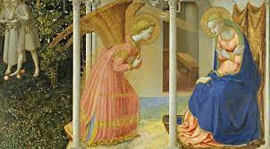
THE HOLY ROSARY

Five Joyful Mysteries
The Annunciation.
The Visitation.
The Nativity.
The Presentation.
The Finding of the Child Jesus in the Temple.

Five Mysteries of Light
Christ's Baptism in the Jordan.
Christ's Self-Revelation at the Marriage at Cana.
Christ's Proclamation of the Kingdom of God with his call to conversion.
Christ's Transfiguration.
Christ's Institution of the Eucharist.
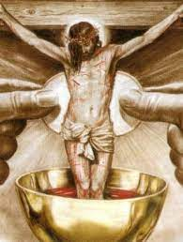
Five Sorrowful Mysteries
The Agony in the Garden.
The Scourging at the Pillar.
The Crowning with Thorns.
The Carrying of the Cross.
The Crucifixion.

Five Glorious Mysteries
The Resurrection.
The Ascension.
The Descent of the Holy Spirit.
The Assumption.
The Coronation of Our Blessed Lady in Heaven.

HAIL HOLY QUEEN
Hail Holy Queen, Mother of Mercy! Hail our life, our sweetness, and our hope! To you do we cry, poor banished children of Eve; to you do we send up our sighs, mourning and weeping in this vale of tears. Turn, then, O most gracious advocate, Your eyes of mercy towards us and after this, our exile, show unto us the blessed fruit of Your womb, Jesus. O clement, O loving, O sweet Virgin Mary.
V. Pray for us, O holy Mother of God.
R. That we may be made worthy of the promises of Christ.

8
Let us pray.
O God, whose only begotten Son, by His life, Death and Resurrection has
purchased for us the rewards of eternal life; grant, we beseech You,
that meditating on these mysteries of the most Holy Rosary of the
Blessed Virgin Mary, we may both imitate what they contain
and obtain what they promise. Through the same Christ our Lord. Amen.

The Litany of Loreto
Lord, have mercy, Lord, have mercy.
Christ, have mercy, Christ, have mercy.
Lord, have mercy, Lord, have mercy.
Christ, hear us, Christ, hear us.
Christ, graciously hear us, Christ, graciously hear us.
God the Father of Heaven, Have mercy on us.
God the Son, Redeemer of the world, Have mercy on us.
God the Holy Spirit, Have mercy on us.
Holy Trinity, one God, Have mercy on us.
Holy Mary, Pray for us.
Holy Mother of God, Pray for us.
Holy Virgin of Virgins, Pray for us.
Mother of Christ, Pray for us.
Mother of the Church, Pray for us.
Mother of Mercy, Pray for us.
Mother of Divine Grace, Pray for us.
Mother of Hope, Pray for us.
Mother most pure, Pray for us.
Mother most chaste, Pray for us.
Mother inviolate, Pray for us.
Mother undefiled, Pray for us.
Mother most amiable, Pray for us.
Mother most admirable, Pray for us.
Mother of good counsel, Pray for us.
Mother of our Creator, Pray for us.
Mother of our Saviour, Pray for us.
Virgin most prudent, Pray for us.
Virgin most venerable, Pray for us.
Virgin most renowned, Pray for us.
Virgin most powerful, Pray for us.
Virgin most merciful, Pray for us.

Virgin most faithful, Pray for us.
Mirror of justice, Pray for us.
Seat of wisdom, Pray for us.
Cause of our joy, Pray for us.
Spiritual Vessel, Pray for us.
Vessel of honour, Pray for us.
Singular vessel of devotion, Pray for us.
Mystical Rose, Pray for us.
Tower of David, Pray for us.
Tower of ivory, Pray for us.
House of gold, Pray for us.
Ark of the covenant, Pray for us.
Gate of heaven, Pray for us.
Morning star, Pray for us.
Health of the sick, Pray for us.
Refuge of sinners, Pray for us.
Solace of Migrants Pray for us.
Comforter of the afflicted, Pray for us.
Help of Christians, Pray for us.
Queen of angels Pray for us.
Queen of Patriarchs, Pray for us.
Queen of Prophets, Pray for us.
Queen of Apostles, Pray for us.
Queen of Martyrs, Pray for us.
Queen of Confessors, Pray for us.
Queen of Virgins, Pray for us.
Queen of all Saints, Pray for us.
Queen conceived without original sin Pray for us.
Queen assumed into heaven, Pray for us.
Queen of the most Holy Rosary, Pray for us.
Queen of families, Pray for us.
Queen of peace, Pray for us.
Lamb of God, who takes away the sins of the world, Spare us, O Lord.
Lamb of God, who takes away the sins of the world, Graciously hear us, O Lord.
Lamb of God, who takes away the sins of the world, Have mercy on us.

V. Pray for us, O holy Mother of God.

R. That we may be made worthy of the promises of Christ.

Let us pray.

Grant, we beseech You,
O Lord God, that we, Your servants,
may enjoy perpetual health of mind and body;
and by the intercession of the Blessed Mary, ever Virgin,
may be delivered from present sorrow and obtain eternal joy.
Through Christ our Lord. Amen.

THE MEMORARE
Remember, O most gracious Virgin Mary,
that never was it known
that anyone who fled to thy protection,
implored your help, or sought your intercession, was left unaided.
Inspired by this confidence, I fly unto you
O Virgin of virgins, my Mother.
To you do I come, before you I stand, sinful and sorrowful.
O Mother of the Word Incarnate,
despise not my petitions,
but in your mercy hear and answer me. Amen.
PRAYER TO THE HOLY SPIRIT
Come, O Holy Spirit,
fill the hearts of Your faithful,
and enkindle in them the fire of Your love.
Send forth Your spirit
and they shall be created
And You shalt renew the face of the earth.

ACT OF FAITH
O my God, I believe in You and all Your Church teaches, because You have said it and Your word is true.

ACT OF HOPE
O my God, I hope in You, for grace and for glory, because of Your promises,
Your mercy and Your power.

ACT OF CHARITY
O my God, because You are so good, I love You with all my heart, and for Your sake, I love my neighbour as myself.

PRAYER OF SAINT IGNATIUS
Dearest Lord, teach me to be generous;
teach me to serve You as You deserve;
to' give and not to count the cost;
to fight and not to heed the wounds;
to toil and not to seek for rest;
to labour and to seek no reward
save that of knowing that I do Your holy will. Amen.
Saint Ignatius of Loyola (1491 – 1556)

PRAYER TO MY GUARDIAN ANGEL
O angel of God, my guardian dear,
to whom God's love commits me here.
Ever this day be at my side
to light, to guard, to rule and guide. Amen.

PRO-LIFE PRAYERS
God our Father, who brought order out of chaos
and light out of darkness, come now into our presence
as we pray for those whose lives have been torn and broken
through chaos and who are unable to see the light of life.
You are the Creator of all life and have made man and
woman in your own image.
May all peoples recognise You as their Creator
and their bodies as made in Your image.
Light of Christ, illumine the darkness of our lives and our minds so that we may always see You as the Light of the World and Giver of Life.
May those who are thinking about having an abortion
or who are coming to terms with their abortion,
feel Your loving and forgiving presence in their lives.
May our prayer here and our witness to the world
be a light and example to others.

FOR GUIDANCE IN MY VOCATION
12

Lord, make me know Your ways, Lord, teach me Your paths (Ps 25:4).

As You have given me the gift of life for some definite purpose,

grant me the grace to know Your will for me.

Whatever it may be, give me the courage

to embrace it joyfully and lovingly

and to be faithful to You always. Amen.

Our Father.

Hail Mary.

Glory be.

St Andrew and St Margaret, pray for us.
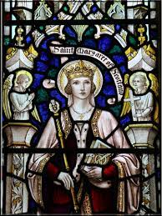
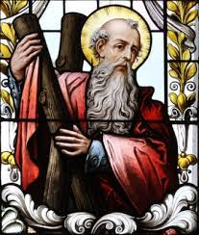

PRAYER FOR VOCATIONS
O Jesus, good and gentle Shepherd,
grant that the men from our community may have
the grace and the courage to hear and answer Your call to the priesthood.
Give them the wisdom to realise that life is a gift.
Let them realise their life is part of Your plan.
Call forth those You have chosen to spread the Gospel message and help them to freely respond to a life of service in the Church.
May the parents and families of our parish support and encourage our young men to search for, follow and answer the call of God in their lives. Amen.

BENEDICTION

The hymn will be sung as the Blessed Sacrament is incensed:

O SALUTARUS HOSTIA

Tantum ergo Sacraméntum
Venerémur cérnui:
Et antíquum documéntum
novo cedat rítui:
præstet fides suppleméntum
sénsuum deféctui.

Genitóri, genitóque
Laus et lubilátio,
salus, honor, virtus quoque
sit et benedíctio:
procedénti ab utróque
compar sit laudátio.
Amen.

V. Panem de caelo praestítisti eis.

R. Omne delectaméntum in se habéntem.
Let us pray.
O God, who in this wonderful Sacrament
have left us a memorial of Your Passion,
grant us, we pray,
so, to reverence the sacred mysteries of Your Body and Blood
that we may always experience in ourselves
the fruits of Your redemption.
Who live and reign for ever and ever. Amen.

The Priest or Deacon puts on the humeral veil as a mark of special respect. He lifts the monstrance containing the Blessed Sacrament and makes the Sign of the Cross over us. As he does so, we bow our heads in adoration, and make the Sign of the Cross. A server incenses Christ, truly present, and the bell is rung.

DIVINE PRAISES

The Divine Praises are said to make up for the times we or others have used God's name in vain or with lack of respect:

Blessed be God.
Blessed be His Holy Name.
Blessed be Jesus true God and true Man.
Blessed be the Name of Jesus.
Blessed be His most Sacred Heart.
Blessed be His most Precious blood.
Blessed be Jesus in the most holy Sacrament of the altar. Blessed be the Holy Spirit, the Paraclete.
Blessed be the great Mother of God, Mary most Holy.
Blessed be her holy and Immaculate Conception.
Blessed be her glorious Assumption.
Blessed be the name of Mary, Virgin and Mother.
Blessed be St Joseph, her most chaste Spouse. Blessed be God in his Angels and in his Saints.

As the Blessed Sacrament is reposed, the following is sung:

Adorémus in ætérnum sanctíssimum Sacraméntum.

Laudáte Dóminum omnes gentes:
laudáte eum omnes pópuli.

Quóniam confirmáta est super nos misericórdia eius:
et véritas Dómini manet in ætérnum.

Glória Patri, et Fílio, et Spirítui Sancto.
Sicut erat in princípio,
et nunc et semper,
et in sæcula sæculórum. Amen.

COMPLINE

V. O God come to our aid. (all make the Sign of the Cross)
R. O Lord make haste to help us.
V. Glory be to the Father… (all bow)
R. As it was in the beginning… Amen. Alleluia.

Examination of conscience
The priest invites the faithful to examine their conscience.

I confess to almighty God
and to you, my brothers, and sisters,
that I have greatly sinned
in my thoughts and in my words,
in what I have done and in what I have failed to do, (all strike their breast)
through my fault, through my fault,
through my most grievous fault;
Therefore, I ask blessed Mary ever-Virgin,
all the Angels and Saints,
and you my brothers and sisters,
to pray for me to the Lord our God.

May almighty God have mercy on us, forgive us our sins,
and bring us to everlasting life.
Amen.

Lord, have mercy, Lord, have mercy.
Christ, have mercy, Christ, have mercy.
Lord, have mercy, Lord, have mercy.

PSALMODY

Ant. He will conceal you with His wings; you will not fear the terror of the night.

Side 1 He who dwells in the shelter of the Most High
and abides in the shade of the Almighty
says to the Lord: ‘My refuge,
my stronghold, my God in whom I trust!’

Side 2 It is He who will free you from the snare
of the fowler who seeks to destroy you.
He will conceal you with his pinions
and under His wings you will find refuge.

You will not fear the terror of the night
16
nor the arrow that flies by day,
nor the plague that prowls in the darkness
nor the scourge that lays waste at noon.

A thousand may fall at your side,
ten thousand fall at your right,
you, it will never approach;
His faithfulness is buckler and shield.

Your eyes have only to look
to see how the wicked are repaid,
you who have said, ‘Lord, my refuge!’
and have made the Most High your dwelling.

Upon you no evil shall fall,
no plague approach where you dwell.
For you has He commanded his angels,
to keep you in all your ways.

They shall bear you upon their hands
lest you strike your foot against a stone.
On the lion and the viper you will tread
and trample the young lion and the dragon.

Since he clings to me in love, I will free him; protect him for he knows my name.
When he calls, I shall answer: ‘I am with you.’
I will save him in distress and give him glory.

With length of life, I will content him.
I shall let him see my saving power.
(all bow)

Glory be to the Father, and to the Son, and to the Holy Spirit.

As it was in the beginning, is now, and ever shall be, world without end. Amen.

Ant. He will conceal you with His wings; you will not fear the terror of the night.

SCRIPTURE READING Apocalypse 22:4-5

They will see the Lord face to face, and His name will be written on their
foreheads. It will never be night again and they will not need lamplight or
sunlight, because the Lord God will be shining on them.
They will reign for ever and ever.
SHORT RESPONSORY
V. Into Your hands, Lord, I commend my spirit (P.T. Alleluia, alleluia).
R. Into Your hands, Lord, I commend my spirit (P.T. Alleluia, alleluia).
V. You have redeemed us, Lord God of truth.
R. Into Your hands, Lord, I commend my spirit (P.T. Alleluia, alleluia).
V. Glory be to the Father and to the Son and to the Holy Spirit.
R. Into Your hands, Lord, I commend my spirit (P.T. Alleluia, alleluia).

CANTICLE Nunc Dimittis Lk:2:29-32

Ant. Save us, Lord, while we are awake; protect us while we sleep; that we may keep watch with Christ and rest with Him in peace. (P.T. Alleluia.)

At last, all powerful Master,
You give leave to Your servant
to go in peace, according to Your promise.

For my own eyes have seen Your salvation
which You have prepared for all nations,
the light to enlighten the Gentiles
and give glory to Israel, Your people.

Glory be to the Father and to the Son
and to the Holy Spirit.
As it was in the beginning, is now, and ever shall be,
world without end. Amen.

Ant. Save us, Lord, while we are awake; protect us while we sleep; that we may
keep watch with Christ and rest with Him in peace. (P.T. Alleluia.)

Let us pray.
Visit this house, we pray you, Lord:
drive far away from it all the snares of the enemy.
May your holy angels stay here and guard us in peace,
and let your blessing be always upon us.
Through Christ our Lord.
Amen.
The Lord grant us a quiet night and a perfect end. Amen.

SALVE REGINA
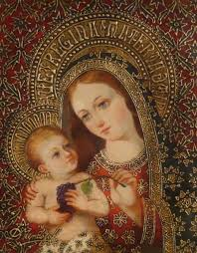
Salve, Regína,
mater misericórdiæ;
vita, dulcédo, et spes nostra, salve.
Ad te clamámus,
éxsules fílii Evæ,
ad te suspirámus,
geméntes et flentes
in hac lacrimárum valle.
Eia, ergo, advocáta nostra,
illos tuos misericórdes óculos
ad nos convérte;
et Iesum, benedíctum fructum ventris tui,
nobis post hoc exílium osténde.
O clemens, O pia,
O dulcis
Virgo María.

Excerpts from the English translation of The Roman Missal © 2010, International Commission on English in the Liturgy Corporation. All rights reserved. Scripture from The Jerusalem Bible © 1985 by Darton Longman and Todd Ltd. and Doubleday and Co. Ltd.
Excerpts from the Divine Office © 1974, hierarchies of Australia, England and Wales, Ireland. All rights reserved.
Psalm 91 (90) in Compline is from The Abbey Psalms and Canticles by the Monks of Conception Abbey © 2018, 2010 United States Conference of Catholic Bishops, Washington, DC. All Rights Reserved. No part of this work may be reproduced or transmitted in any form or by any means, electronic or mechanical, including photocopying, recording, or by any information storage and retrieval system, without permission in writing from the copyright owner.

