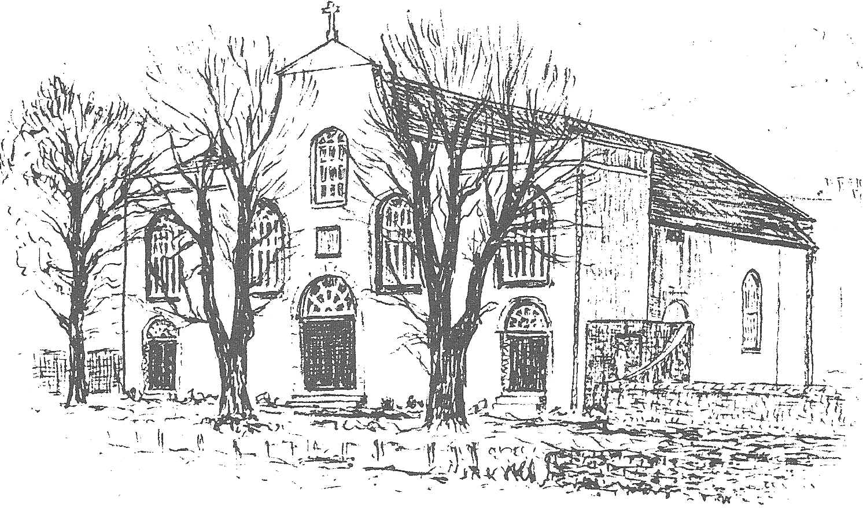

THIS IS AN EDITABLE TEMPLATE

TOUR OF St. (N. of Church), (N. of Town)
Video tour example available at https://youtu.be/5iSsGflN-cE

Welcome to our Self-Guided Tour. This pamphlet is a tool to be used to guide you through this Tour and explain the many sections of our holiest of places.

Our present Church building was opened on ??th March 19?? by the then Archbishop ????. It was dedicated in 19?? after the debt was paid. At this time twelve candles were placed around the wall and lit.

This Church Tour has been designed to allow you to start at any point and continue following the number in the sheet. In specific areas, there are people assigned to answer any and all questions that you may have.

Please enjoy your tour. This pamphlet is yours, so you can enjoy your tour over and over again in the future.

Check off each place you visit:
( ) 1. The Holy Water Font
( ) 2. The Pews
( ) 3. The Celtic Cross
( ) 4. The Confessional
( ) 5. Stations of the Cross
( ) 6. Statues of Our Lady;The Most Sacred Heart of Jesus; Saints Joseph, Anthony & Teresa and Votive Candles
( ) 7. Baptismal Font, Paschal (Easter) Candle
( ) 8. Holy Oils
( ) 9. Ambo, Lectionary
( ) 10. Tabernacle, Sanctuary Lamp
( ) 11. Sanctuary, Altar, Sacramentary, Credence Table
( ) 12. Principal Celebrant’s/Archbishop’s Chair
( ) 13. Processional Cross
( ) 14. Sacristy, Vestments
( ) 15. Monstrance, Candles, Thurible, Incense Cope
( ) 16. Sacred Vessels
( ) 17. The Choir
( ) 18. Holy Water Jars
( ) 19. Statue & Icon: Saint (whichever saint church is named after)
( ) 20. War memorial Board and Book of the Dead

- THE HOLY WATER FONT & THE IMAGE OF THE HOLY FAMILY

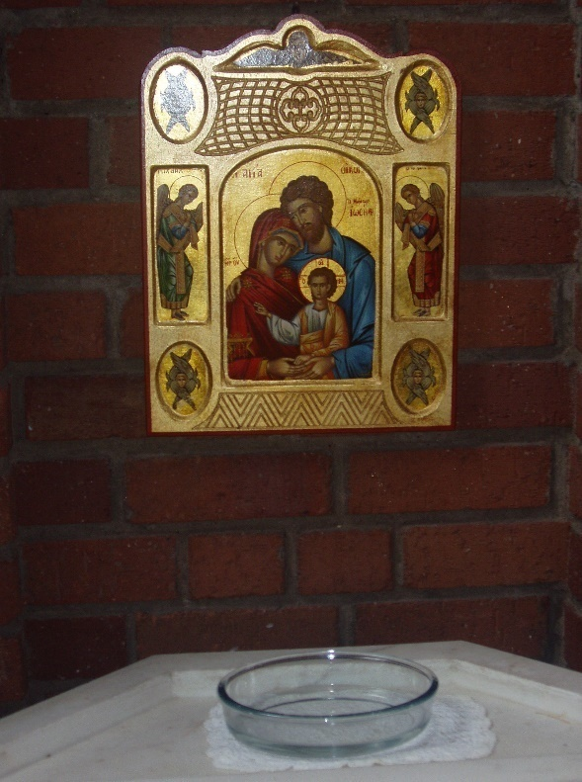

The church is the central place where the community – God’s family – come together to pray. We enter the Church and find a bowl with Holy Water, above which is an image of the Holy Family of Jesus, Mary and Joseph. We dip our fingers in the Holy Water and bless ourselves with the Sign of the Cross. This water and the Sign of the Cross remind us that we became members of God’s family at our Baptism.
To make the Sign of the Cross, dip the fingers of your right hand lightly in the Holy Water and the Sign of the Cross saying,

In the name of the Father (touch your forehead)
And of the Son (touch your chest)
And of the Holy (touch your left shoulder)
Spirit (touch your right shoulder)
Amen.

- THE PEWS
The seats we sit on in Church are called pews, which is a type of bench. When we come to the pew, we genuflect, (kneel bending our right knee to the ground) towards the tabernacle where Jesus is truly present in the Blessed Sacrament.
two walls.

- THE CELTIC CROSS
This Cross was hand made by ???? for use in processions and to help us pray.

- THE CONFESSIONAL
The Confessionals are a special place where people celebrate the Sacrament of Penance. This is a Sacrament in which God forgives us of all our sins. The confessional is a small room where we kneel or sit in front of a screen to confess our sins and speak to the priest. We tell the priest we are sorry for our sins and he gives us God’s forgiveness.

- STATIONS OF THE CROSS
The Stations of the Cross tell the story of what happened to Jesus on Good Friday, the day he died on the Cross. Usually a Church has seven stations on one of the walls and seven on the other side. Saint ?????? has the stations on two walls.

- VOTIVE CANDLES, STATUES OF OUR LADY; THE MOST SACRED HEART OF JESUS; ST JOSEPH; ST ANTHONY AND ST TERESA
The Votive Candles. A candle can be considered a sacramental i.e. something that helps us to pray, and it is burned by the faithful before relics, shrines, and images of Christ or Saints. As such, it is an act of love by the person who lights it, believing it is the proper way of offering thanksgiving or of obtaining aid in seeking the fulfilment of a petition.
The Statues of Our Lady; the Most Sacred Heart of Jesus; St Joseph, St Anthony and St Teresa are placed there so we can focus on our prayers.

- BAPTISMAL FONT, PASCHAL CANDLE
The Baptismal Font is usually made of stone or marble. It is where the priest baptises people, and so welcomes them into the Church. Mostly babies are baptised, but sometimes adults are too.
The Large Candle that stands in the sanctuary during Easter time and near the Baptismal Font during the rest of the year is called the Paschal (Easter) Candle. The Paschal Candle reminds the faithful of Christ’s undying presence among them, of his victory over sin and death, of their share in His victory by virtue of their baptism. It recalls the Easter Vigil, the night when the Church awaits the Lord’s Resurrection and when the new light for the living and the dead is kindled. During funerals, the Paschal Candle is placed near the coffin. The Paschal Candle stands for Jesus, who is the light of the world. It is also lit at all baptisms and the person being baptised receives a small candle lit from the Paschal Candle. This small baptismal candle symbolises our Faith.

- HOLY OILS
The Church uses Three Holy Oils in the Sacraments. The Archbishop blesses these oils at a special diocesan celebration called the Chrism Mass, which takes place during Holy Week at Saint Mary’s Cathedral in Edinburgh and each parish receives some for use during that year.

- Holy Chrism is the holiest of the oils and is scented with balm. It symbolises spiritual strength. Chrism is used to anoint people in three of our Sacraments: Baptism, Confirmation, and Holy Orders.
- Oil of the Catechumens is used in Baptism and is used in preparing adults who wish to be received into the Catholic faith.
- Oil of the Sick is used for the Sacrament of the Sick, when the priest anoints the sick person on their forehead and the palms of their hands. It is a sign of the healing power of Christ and of His sacrament.

- AMBO, LECTIONARY
The place in the sanctuary where the reader stands to proclaim the Word of the Lord is called the Ambo. This is also where the lectionary is placed. The lectionary is the book which contains the readings from the Bible that we hear during the Liturgy of the Word at Holy Mass.

- TABERNACLE, SANCTUARY LAMP
The Tabernacle is the special place where the Blessed Sacrament is reserved. The Blessed Sacrament is another name for the Body of Christ. The Consecrated Hosts are in the Tabernacle for visitation to the sick and we pray before the Blessed Sacrament. The priest prays the Eucharistic Prayer during Mass and asks that Holy Spirit comes upon these hosts and change them into the Body of Christ.
The Sanctuary lamp candle is always burning near the tabernacle to remind us that Jesus is present. When we enter the Chapel and pass in front of the Tabernacle, we genuflect to show respect for Jesus present in the Blessed Sacrament. What day of the year do you think it is not lit?

- SANTUARY, ALTAR, ROMAN MISSAL, CREDENCE TABLE
The sanctuary is the front part of the Church building where the altar and the Ambo are situated. The community (God’s people) gather together for Holy Mass where the bread and wine is transformed into the Body and Blood of Jesus. At Holy Communion, we receive His Body and Blood just as the disciples shared with Christ at The Last Supper. The Altar is the special table of the Lord’s Supper. At Holy Mass, we bring our gifts of bread and wine to the Altar where the priest asks the Holy Spirit to come upon our gifts and change the bread and wine into the Body and Blood of Christ. A white cloth covers the altar, with white being a symbol of purity.
Candles are always on the altar. We light the candles during Mass to remind us that Jesus is present with us.
Roman Missal is the large red book that contains the prayers spoken or sung by the priest at the Eucharistic celebration.
Credence Table is a table to the side of the altar upon which are placed the things needed for sacred functions, particularly the Mass, such as the chalice, cruets and Ciboria.

- PRINCIPAL CELEBRANT’S/ARCHBISHOP’S CHAIR
The Principal Celebrant or Archbishop sits on this chair symbolising his authority as leader and teacher during Holy Mass.

- PROCESSIONAL CROSS
A crucifix shows Jesus on the cross. It reminds us how much Jesus loves us and that He was willing to die for us. We carry the processional cross at the beginning of Holy Mass to remind us of the death and resurrection of Jesus.

- SACRISTY, VESTMENTS
The Sacristy is the room where the vestments and sacred vessels are kept. The priest prepares for the Holy Mass in the Sacristy. The priest wears special clothes at Holy Mass called vestments.
The ALB is long, white garment. The priest or deacon wear this garment.
The priest also wears a stole and chasuble over the alb. The chasuble is a sleeveless liturgical outer garment used primarily for the celebration of Holy Mass. This garment covers the entire body with only an opening for the priest’s head. The stole is a long narrow band of material several inches wide, worn around the neck by priests and bishops, and from the left shoulder like a sash by deacons. The priest wears a chasuble and stole of a different colour for different seasons such as Lent and Advent.
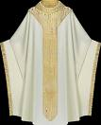
The colours of the chasuble are:
Green for Ordinary Time
Purple for Lent; Advent& Funeral
Red for Pentecost
White or Gold for Easter; Christmas: Baptisms & Weddings

- MONSTRANCE, THURIBLE, INCENSE, COPE
The Monstrance is a sacred vessel designed to expose the Blessed Sacrament, (a consecrated host) to the faithful for adoration.
The Thurible is a metal container where the incense is burned over lighted charcoal. A long chain usually holds it. The Boat is a small Brass container shaped like ‘a boat’, which holds the incense that is transferred to the Thurible with a spoon. Small grains of incense, when placed on a burning piece of charcoal, give off a sweet-smelling smoke. When the smoke rises up into the sky or to the roof, it is like our prayers, which we believe rise to God. We call incense a Sacramental, a symbol that helps us remember God.
The cope is a long semicircular cloak, open in the front and reaching down to the heels, fastened at the top of the priest’s chest and has a hood at the back. It is rarely used by the celebrant at Holy Mass. Rather the cope is mainly used for processions, benediction, the solemn singing of the Liturgy of the Hours and during other services.

- SACRED VESSELS
Within the Sacristy are the Sacred Vessels. The Chalice is the name of the sacred cup that holds the Wine, which is transformed into the Blood of Christ at the Holy Mass. Cruets hold the water and sometimes the wine we bring to the Altar during Holy Mass. When members of the community bring the gifts to the Altar at the Offertory Procession, they sometimes carry the wine in a carafe (large glass container). The cruet contains the water. A Ciborium is a cup-like vessel that holds the altar breads which will be changed into the Body of Christ. The breads are then called the hosts. The Blessed Sacrament, when kept in the Tabernacle, is kept in the ciborium.

- THE CHOIR
Music helps raise our minds and hearts to God in praise and thanksgiving. Every parish community needs people who will share their talents to sing and play the church organ if it has one.
- HOLY WATER JARS
It is from these jars that the smaller fonts used at the entrances of the Church are filled.

- STATUE & ICON OF SAINT ???????
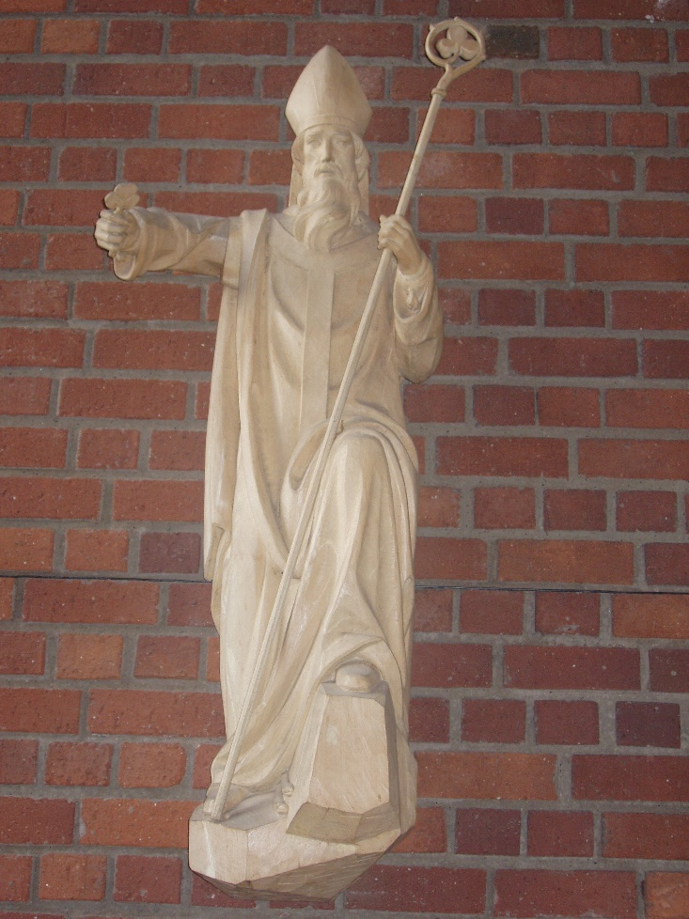

Saint ?????? is the Patron Saint of ?????? and of our parish here in ?????? whom our Church is named after. He is also the patron saint of our local Catholic School.

- WAR MEMORIAL, THE BOOK OF THE DEAD
In the Book of the Dead we put the names of our parishioners who have died. In November we have a special Mass when we remember by name those who have died in the last year.

