*Be sealed with the gifts of the*

*Holy Spirit*

*Child’s name*

*Celebrated*

*Sacrament of Confirmation*

*On*

*?????*

*By*

*Archbishop ??????????*

*The Parish of ????????????????????????????*

***Summer Kerr abercrombie***

*received the*

*Sacrament of Confirmation*

*on the*

*26th April 2020*

*in*

*St. Patrick’s Church*

*kilsyth*

*By*

*Archbishop Leo Cushley*

*Parish Priest:__________________________*

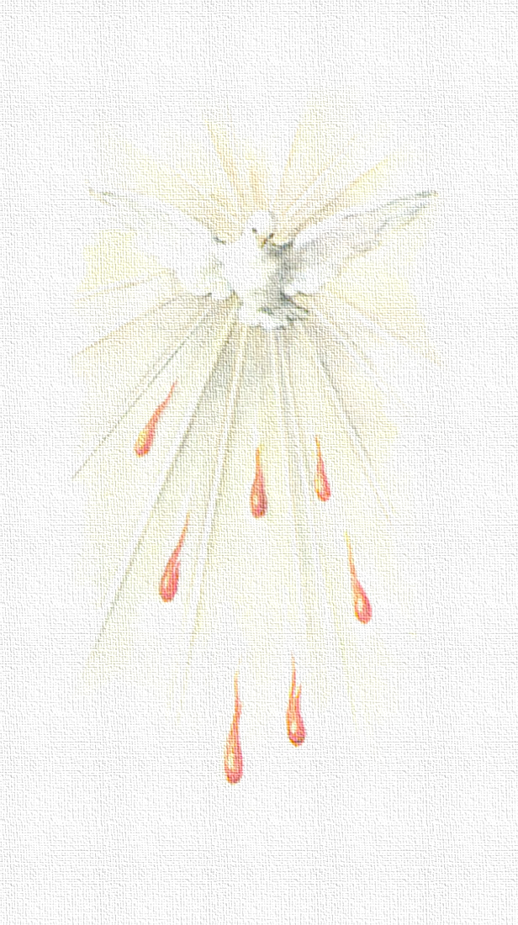

*Be sealed with the*

*Gift of the Holy Spirit*