Important Dates!
PARISH LOGO HERE

Here is a list of important dates for you and your child as they prepare to receive the Sacrament of Confirmation:
What | Where | When
Parents’ Meeting | Chapel Hall (Example) | 07/10/19
Priest & Parent Meetings | Fill in as appropriate | Fill in as appropriate
Enrolment Ceremony

Presentation of the Creed
Presentation of the Creed
Parents’ Meeting (Practical/Theoretical)
Sacrament of Confirmation

Important Dates!
PARISH LOGO HERE

Here is a list of important dates for you and your child as they prepare to receive the Sacrament of Confirmation:
What | Where | When
Parents’ Meeting | Chapel Hall (Example) | 07/10/19
Priest & Parent Meetings | Fill in as appropriate | Fill in as appropriate
Enrolment Ceremony

Presentation of the Creed
Presentation of the Creed
Parents’ Meeting (Practical/Theoretical)
Sacrament of Confirmation
The Catholic Parish of
Enter Parish Name/Town
Sacrament of Confirmation

PARISH LOGO HERE

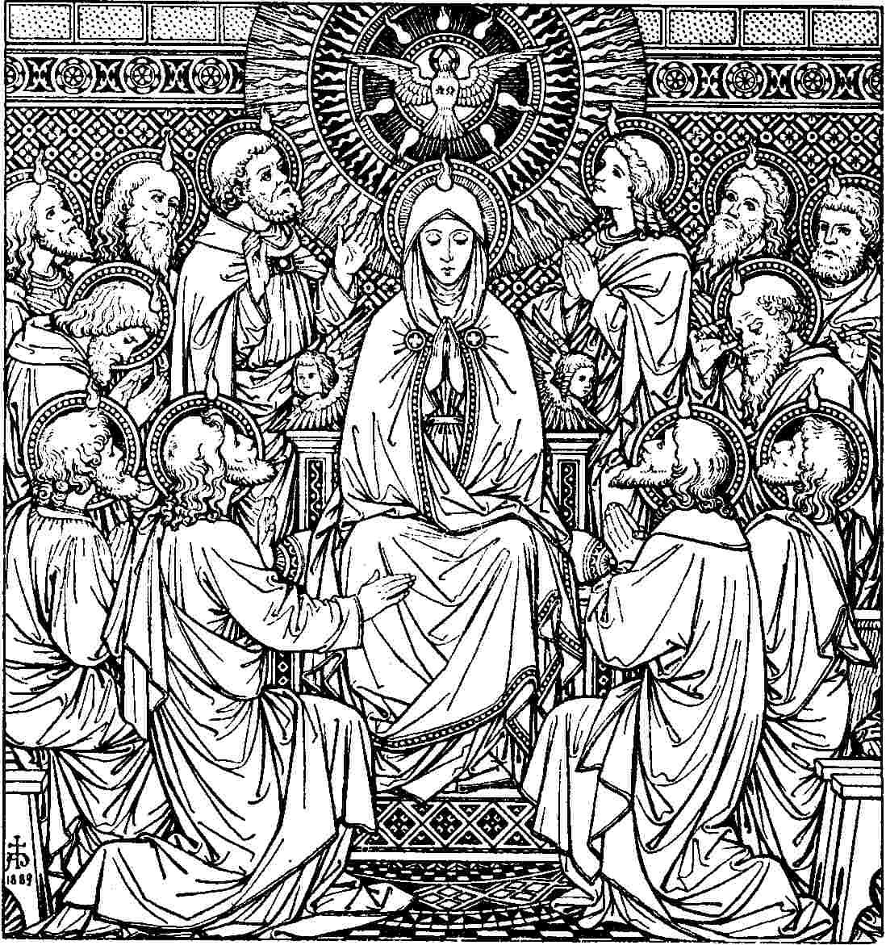

Prayer
Sacramental Programme 20**-20**

The Catholic Parish of
Enter Parish Name/Town
PARISH LOGO HERE
Sacrament of Confirmation

Prayer

Sacramental Programme 20**-20**

