Prayer to the Holy Spirit

Come Holy Spirit fill the hearts of your faithful
and enkindle in them the fire of your love.
Send forth Your Spirit and they shall be created and
You shall renew the face of the earth.

O God; who has taught the hearts of the faithful
by the light of your Holy Spirit
grant that, by the gift of the same Spirit,
we may be always truly wise and ever rejoice
in His consolation.
Through the same Christ our Lord.
Amen

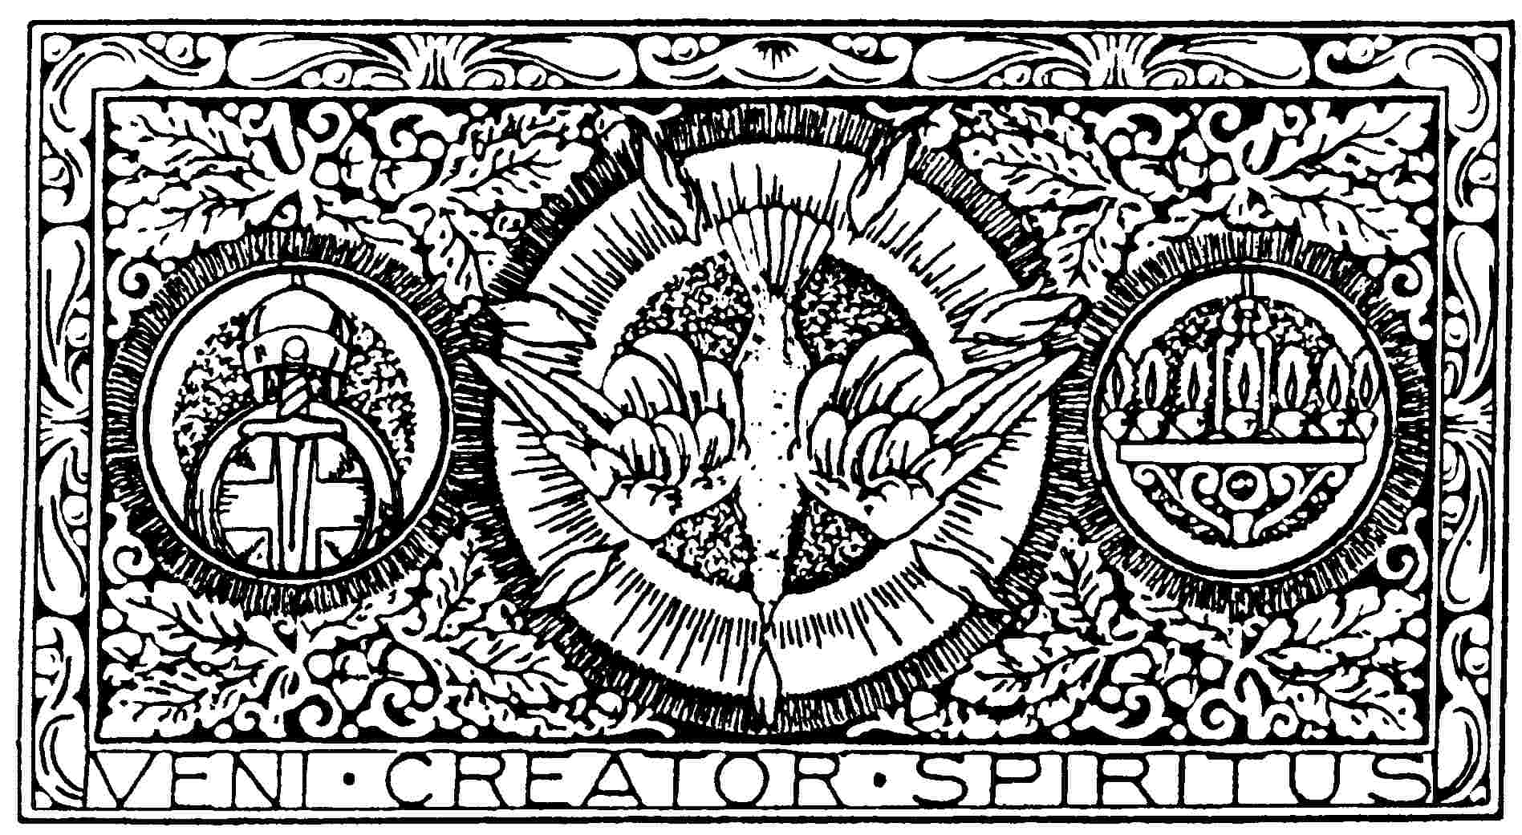
St ?????? is a Parish of the Archdiocese of St Andrews and Edinburgh
a Charity registered in Scotland – number SC008540
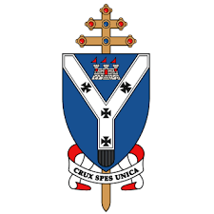
Parish Logo Here
Parish Name
Month/Year
Sacrament of Confirmation

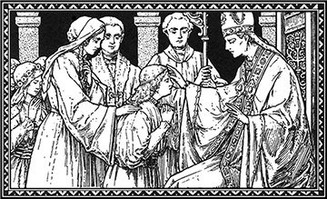

Guide for Parents

*The information here is provided as a suggestion to be edited appropriately*

The Sacrament of Confirmation will take place on the ***

Dress code
Children should wear their school uniforms.

Seating
All the children and their sponsor will sit together on the front pews, on the left hand side, names plates will be in place on the day. Two representatives from each family will sit in the corresponding seat of their child on the opposite side. There will be no other seats reserved. Please also note, the upper floor will only be opened after the downstairs is full.
Holy Mass
The head teacher will do the readings and a parent of the confirmandi will be invited to do the Prayers of Intercession. The Offertory will be carried by two class teachers and two catechists.
How the Sacrament will be administered
Each child will come out with their sponsor and STAND in front of the Archbishop. The sponsor will hand over the card with the chosen Saints name. The Archbishop will anoint the child’s head and offer the sign of peace then, both child and sponsor return to their places.
Reception
There will be a food provided for each child with tea, coffee & biscuits being served in the hall and we would like to invite the confirmandi and three other members of each family to come along (party of 4 per family). We will have a large cake which will be cut once everyone is seated.
Certificates
Will be presented in the hall. A family photo of the child and two family members with the Archbishop.
Gifts
We strongly encourage only to buy or encourage others to give gifts that reflect the Sacrament or the life of the Church. In other words we suggest not giving money as a gift, rather something from our piety shop or another shop that sells devotional items. One suggestion would be to buy a crucifix for confirmandi’s bedroom or a picture or statue of the saint they have chosen for confirmation.
Photos
There will be a group photo taken before Mass begins on the altar with the Archbishop and class teachers by the parish photographer ONLY. There will be the opportunity for each child to have a photograph individually with the Archbishop in the hall when he presents them with their certificates. Parish photographer will take these photos and we will inform you at a later date how you can access these photos. After the reception, the church will remain open to allow you to take more photographs.

NO OTHER PHOTOS TO BE TAKEN DURING MASS OTHER THAN BY THE PARISH PHOTOGRAPHER.

