Season of Creation 2019
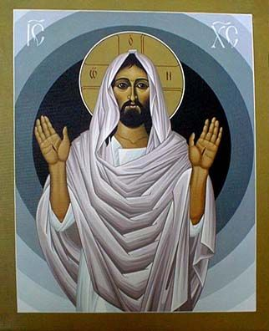

The Web of Life:
Biodiversity as God’s Blessing

Archdiocesan Commission of St Andrews and Edinburgh
for Caritas, Justice and Peace

The icon of The Risen Christ is by William Hart McNichols permission to use has been sought.
The image of Mother Earth was added.
Contents
Introduction 6
Pope Francis and Creation 7
Letter from the Dicastery for Promoting Integral Human Development 10
An Invitation to Join the Season of Creation 11
2019 Theme: The Web of Life: Biodiversity as God’s Blessing 12
Season of Creation 2019 in the Archdiocese of St Andrews and Edinburgh 14
Season of Creation Journey 14
Structure of Weekly Material 15
Prayer of the Faithful 15
Prayers for Creation 15
Professions of Faith 16
Prayers for Going Forth 16
Newsletter / Facebook / Website Inserts 16
Additional Resources 16
Sunday 1st September Living Humbly 17
Gathering 19
Sign of the Cross 19
Penitential Rite I 20
Readings for 22nd Sunday of the Year C 21
Gospel Reflection Material for Season of Creation I 23
Blessing 24
Sunday 8th September Ecological Conversion 25
Gathering 26
Sign of the Cross 26
Penitential Rite II 27
Readings for 23rd Sunday of the Year C 28
Gospel Reflection Material for Season of Creation II 30
Blessing 31
Sunday 15th September Reconciliation with God, Creation and Humanity 32
Gathering 33
Sign of the Cross 33
Penitential Rite III 34
Readings for the 24th Sunday of the Year C 35
Gospel Reflection Material for Season of Creation III 39
Blessing 40

Sunday 22nd September Towards an Authentic Christian Lifestyle 41
Gathering 43
Sign of the Cross 43
Penitential Rite IV 44
Readings for the 25th Sunday of the Year C 45
Gospel Reflection Material for Season of Creation IV 47
Sunday 29th September Listening and Acting 48
Gathering 50
Sign of the Cross 50
Penitential Rite V 51
Readings for the 26th Sunday of the Year C 52
Gospel Reflection Material for Season of Creation V 54
Blessing 55
Prayer of the Faithful 56
From the Season of Creation 56
Adapted from the Franciscans for Ecology: 56
Adapted from the USCCB Ecological Liturgy Resource: 56
Developed by the Global Catholic Climate Movement Team: 57
Prayers for Creation 58
A Prayer for Our Earth 58
A Christian Prayer in Union with Creation 59
Season of Creation 2019 Prayer 60
Professions of Faith 61
The Maasai Creed 61
Profession of Faith from El Salvador 62
Profession of Faith from Indonesia 63
A Creation Care Creed 65
Prayers for Going Forth 66
Invocation 66
Prayer to the Holy Spirit 68
Newsletter / Facebook / Website inserts 69
General 69
World Day of Prayer for Creation 69
Global Climate Strike 69
Season of Creation 2019 70
Top Ten Takeaways from Laudato Si’ 74

Additional Resources 75
CAFOD 75
Eco Congregation Scotland 75
Global Catholic Climate Movement 75
Justice and Peace Scotland 75
SCIAF 76
350 76

Introduction

This booklet aims to support the many parishes, or groups with parishes, that are already actively engaged in issues relating to Climate Change and to give support to those who would like engage.

The following are the key sections:
Pope Francis and Creation
We give an insight into the importance of creation for Pope Francis, as reflected in his choice of the name Francis, and then powerfully and eloquently explored in his encyclical Laudato Si’ – On the Care of Our Common Home.
Recognising the custom and theological insight of the Orthodox Church he followed their tradition and established the World Day of Prayer for the Care of Creation for the Catholic Church and positively responded to existing ecumenical initiatives by encouraging active participation in the Season of Creation.
Each year the universal Church is invited to fully participate in the Season of Creation and this year the Dicastery for Promoting Integral Human Development has sent out a letter warmly encouraging us all to fully celebrate this year’s Season of Creation. This booklet is an attempt to respond to this invitation.
Conscious of the wealth of information available we have tried to bring together material that can be used within our Archdiocese this year.
Season of Creation 2019 in the Archdiocese of St Andrews and Edinburgh
We have focussed on the five Sundays of the Season of Creation and prepared core material relating to the themes we have developed.
Hopefully our liturgies will lead us on a journey of deeper gratitude for the wonderous gift of creation and a commitment to take action to respond to the cry of the earth and the cry of the poor at this critical time.
Finally, we have added some extension material that could be used either at Mass or during special services.
We hope the material is useful and would very much welcome your feedback on it and ways we could develop it for future use.
The material will be available on the Archdiocesan website and there will be copies of the material on Pages 74-75 as downloadable jpegs.

Pope Francis and Creation
On March 16, 2013, few days after his election, Pope Francis, departing from his prepared speech, shared the events that led to his decision to choose the name Francis.
I will recount the story.
In the election, I had beside me the archbishop emeritus of Sao Paolo, and also the prefect emeritus of the office of the Congregation for the Clergy, Cardinal Claudio Hummes.
A great friend, a great friend.
When the thing became a little dangerous, he comforted me. And when the votes were up to two-thirds, there was the expected applause because the pope had been elected. And he embraced me, and kissed me, and he said to me:
“Don’t forget about the poor.”
And that word entered here, the poor, the poor.
Immediately with the thought of the poor, I thought of St Francis of Assisi.
I thought of wars, while the vote counting continued. Until the end of all the votes ..
And Francis the man of peace. That was how the name came into my heart. Francis of Assisi.
And for me the man of poverty, the man of peace, who loves and guard’s creation. At this time that we have a relationship with creation that is not very good, right?
And the man who gives us this spirit of peace – the poor man.
How I would like a Church that is poor and for the poor.

Our relationship with creation was the subject of Pope Francis’ universally acclaimed encyclical Laudato Si’: On the Care of Our Common Home.

On the 6th August 2015 Pope Francis established the World Day of Prayer for the Care of Creation, acknowledging that such a day was already a custom in the Orthodox Church.
Sharing the concern of my beloved brother, Ecumenical Patriarch Bartholomew, for the future of creation (cf. Laudato Si’, 7-9), and at the suggestion of his representative, Metropolitan Ioannis of Pergamum, who took part in the presentation of the Encyclical Laudato Si’ on care for our common home, I wish to inform you that I have decided to institute in the Catholic Church the “World Day of Prayer for the Care of Creation” which, beginning this year, is to be celebrated on 1 September, as has been the custom in the Orthodox Church for some time.

Pope Francis clearly expressed his hopes for the celebration of the day.
The annual World Day of Prayer for the Care of Creation will offer individual believers and communities a fitting opportunity to reaffirm their personal vocation to be stewards of creation, to thank God for the wonderful handiwork which he has entrusted to our care, and to implore his help for the protection of creation as well as his pardon for the sins committed against the world in which we live. The celebration of this Day, on the same date as the Orthodox Church, will be a valuable opportunity to bear witness to our growing communion with our Orthodox brothers and sisters. We live at a time when all Christians are faced with the same decisive challenges, to which we must respond together, in order to be more credible and effective. It is my hope that this Day will in some way also involve other Churches and ecclesial Communities, and be celebrated in union with similar initiatives of the World Council of Churches.

In his message World Day of Prayer for Creation, September 1 2016 Pope Francis began by praising the work that was being carried out by Churches, Christian Communities and other religions.
It is most encouraging that concern for the future of our planet is shared by the Churches and Christian communities, together with other religions. Indeed, in past decades numerous efforts have been made by religious leaders and organizations to call public attention to the dangers of an irresponsible exploitation of our planet. Here I would mention Patriarch Bartholomew of Constantinople who, like his predecessor Patriarch Dimitrios, has long spoken out against the sin of harming creation and has drawn attention to the moral and spiritual crisis at the root of environmental problems. In response to a growing concern for the integrity of creation, the Third European Ecumenical Assembly in Sibiu in 2007 proposed celebrating a “Time for Creation” during the five weeks between 1 September (the Orthodox commemoration of God’s creation) and 4 October (the commemoration of Francis of Assisi in the Catholic Church and some other Western traditions). This initiative, supported by the World Council of Churches, has since inspired many ecumenical activities in different parts of the world. It is also encouraging that throughout the world similar initiatives promoting environmental justice, concern for the poor and responsible social commitment have been bringing together people, especially young people, from diverse religious backgrounds. Christians or not, as people of faith and goodwill, we should be united in showing mercy to the earth as our common home and cherishing the world in which we live as a place for sharing and communion.

Pope Francis identified 6 key points in his message:
- The earth cries out …
- … for we have sinned
- An examination of conscience and repentance
- Changing course
- A new work of mercy
- Let us pray

For the World Day of Prayer for Creation, September 1 2017, Pope Francis and Ecumenical Patriarch Bartholomew issued a joint message that acknowledged our failure to ‘cooperate in the preservation and protection of the natural environment’ as God intended us to do and that urgent action was called for.
The human environment and the natural environment are deteriorating together, and this deterioration of the planet weighs upon the most vulnerable of its people. The impact of climate change affects, first and foremost, those who live in poverty in every corner of the globe. Our obligation to use the earth’s goods responsibly implies the recognition of and respect for all people and all living creatures. The urgent call and challenge to care for creation are an invitation for all of humanity to work towards sustainable and integral development.

The focus of the message for the World Day of Prayer for Creation, September 1 2018 was on water.
It is a very simple and precious element, yet access to it is, sadly, for many people difficult if not impossible. Nonetheless, “access to safe drinkable water is a basic and universal human right, since it is essential to human survival and, as such, is a condition for the exercise of other human rights. Our world owes a great social debt towards the poor who lack access to drinking water, because they are denied the right to a life consistent with their inalienable dignity” (Laudato Si’, 30).

This year the theme is ‘the web of life’ and the Dicastery for Promoting Integral Human Development has sent the following letter that encourages all pastors to celebrate the season. They also give ideas for celebrations, such as incorporating creation care into liturgy, forming committees to promote integral ecology, and participating in advocacy.

Letter from the Dicastery for Promoting Integral Human Development
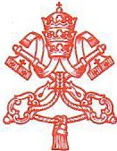
DICASTERO PER IL SERVIZIO
DELLO SVILUPPOUMANO INTEGRALE
My brother in Christ:
Warm greetings to you from Rome.
On the occasion of the International Day of Biodiversity and in anticipation of the fourth anniversary of Laudato Si’, the Dicastery for the Promotion of Integral Human Development invites you to prayerfully consider caring for creation as part of your pastoral leadership.
Caring for creation protects the inheritance the Creator has given us, an inheritance that is essential to our well-being. As Pope Francis said in Laudato Si’, “Nature cannot be regarded as something separate from ourselves or as a mere setting in which we live. We are part of nature, included in it and thus in constant interaction with it.” (LS 139) Protecting this inheritance is a way of fulfilling our role as the stewards of creation; as Pope Benedict XVI said in a meeting with the Diocese of Bolzano-Bressanone, “the task of ‘subduing’ it was never intended as an order to enslave it but rather as the task of being guardians of creation and developing its gifts.”
In fulfilment of this role as the guardians of God’s creation, we extend a particular invitation to join the ecumenical family in celebrating the Season of Creation. During the Season of Creation, which runs from September 1 to October 4 each year, Christians unite in praying and acting together to care for our common home.
September 1, the World Day of Prayer for the Care of Creation, was proclaimed by the Patriarch Dimitrios I for the Orthodox in 1989 and endorsed by Pope Francis in 2015. The season that begins on that date and lasts until October 4, the Feast of St. Francis, is widely embraced. Cardinal Turkson, the Archbishop of Canterbury, Ecumenical Patriarch Bartholomew, and many others have supported this season.
An ecumenical steering committee provides resources to celebrate the Season of Creation, and proposes a theme for each year. The theme for 2019 is “the web of life,” a theme that connects our role as the stewards of God’s creation with the urgent need to protect biodiversity. This theme has important connections to this October' s Synod of Bishops for the Pan-Amazonian region.
More information about the Season of Creation, its connection to the synod, and the wealth of resources available is in the attached overview. I encourage you to share this with all of your parishes.
I am praying for you and all those in your diocese, and I ask that you pray for me.
Respectfully yours in Christ,

Msgr. Bruno Marie Duffé
Secretary - Dicastery for Promoting Integral Human Development
Palazzo San Calisto, 00120 Citta del Vaticano Tel. +39 0669892711 Fax +39 0669892790 info@humandevelopment.va http://www.humandevelopment.va

An Invitation to Join the Season of Creation

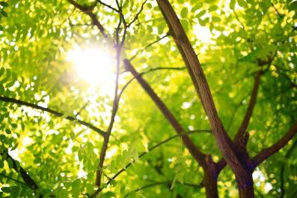
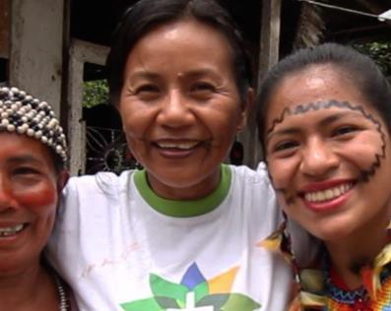
From September to October each year, the Christian community celebrates the Season of Creation by praying and acting together to protect our common home. The season is celebrated by tens of thousands of Christians around the world annually.
The Season of Creation begins on September 1, the World Day of Prayer for Creation. We invite you to plan your participation in the season, and, as a first step, to visit SeasonOfCreation.org. You’ll find a wealth of resources and a registration form for your event.
The theme of this year’s Season of Creation celebration is “the web of life.” We Catholics are uniting with others in the Christian family to protect every creature in God’s beautifully complex web of creation.
Protecting creation in all its glory coincides with another special event this year. In October, just after the Season of Creation closes, bishops from around the world will join His Holiness for a synod on the Amazon, an occasion for prayerful reflection on how we protect the Amazon and the people who share it.
The preparatory document for the synod calls us to listen “to indigenous peoples and to all the communities living in the Amazonia.” In that spirit, we share with you a statement of spirituality from an indigenous community in the Amazon.
“Good living is abundance in life and harmony between brothers and sisters. Equilibrium in the world and protection of the forest. Having food that satisfies us and that gives us more strength, more life. Having health and living in a healthful way with the offerings of mother earth. Finding the light inside each human being.”
The Season of Creation is an opportunity to celebrate the abundance of life and protect the light inside each member of God’s creation.
As you plan your Season of Creation activities, we invite you to consider initiating the season with a Laudato Si’ Mass on September 1. As we move through the season, let’s continue to celebrate together.
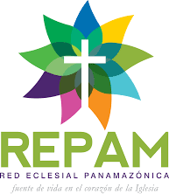
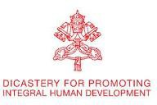
A wealth of resources for implementing Laudato Si’ in your community is available. These include hands-on projects like developing a community group such as Laudato Si' Circles, liturgical suggestions, advocacy ideas, and much more. All resources are available at SeasonOfCreation.org. We look forward to celebrating with you.

2019 Theme: The Web of Life: Biodiversity as God’s Blessing
Each year, the ecumenical steering committee that provides resources to celebrate the Season of Creation suggests a theme. The suggested theme for this year is “the web of life: biodiversity as God’s blessing.” We suggest this theme because it helps us meditate on two essential facts about creation: it comes from God, and we play a part in it.
Genesis 9:12-13 “God said, “This is the sign of the covenant which I am making between Me and you and every living creature that is with you, for all successive generations; I set My bow in the cloud, and it shall be a sign of a covenant between Me and the Earth.”
The book of Genesis begins with God’s affirmation that all of creation is ‘very good’ (Genesis 1:30). We are part of a complex, delicate and interdependent web of life which is valuable because it is created, sustained and redeemed by God. Humanity is called to reflect God’s image through godly leadership within the community of fellow creatures (Genesis 1:26-28). The story of Noah includes God’s redemptive purposes for, and covenant with, not only humanity but the earth and all its creatures (Genesis 9:8-17). In the New Testament we learn that all things were created by and for Christ, giving particular value to each creature (Colossians 1:15-20). God’s ultimate purposes from creation to re-creation encompass all that we today call biodiversity.
The biblical witness is that the web of life - biodiversity - matters not only because human well-being depends on stable and thriving ecosystems and the services they give to us, from clean water and food, to oxygen, clothing and climate regulation, and all the ‘resources’ we use from nature. Biodiversity matters firstly because God gives value to every creature that is created. As the Papal Encyclical Laudato Si’ states, “It is not enough, however, to think of different species merely as potential “resources” to be exploited, while overlooking the fact that they have value in themselves. … Because of us, thousands of species will no longer give glory to God by their very existence, nor convey their message to us. We have no such right” (Laudato Si’: On Care for our Common Home, 33).
Today, human behaviour is destroying the fabric of God’s creation at an unprecedented rate. According to the Living Planet Report 2018, there has been a 60% decline in global wildlife populations between 1970 and 2014. There are multiple causes, from deforestation, habitat destruction, climate change, and pollution of soil, water and air, including the tide of plastic pollution filling the oceans.
Biodiversity loss matters both because all God’s creatures have value in themselves and also as an issue of justice. It is the poor and marginalised who depend most immediately on the health of ecosystems and are affected most severely by the collapse of the natural systems that sustain all life. Billions of people today face the loss of productive soils, clean water, forests, fish and coral reefs, and biodiversity loss is a major driver of human migration. As Kenyan botanist and Christian Dr Stella Simiyu states:
“The rural poor depend directly on the natural resource base. This is where their pharmacy is, this is where their supermarket is, this is in fact their fuel station, their power company, their water company. What would happen to you if these things were removed from your local neighbourhood? Therefore, we really cannot afford not to invest in environmental conservation.”
Under the theme of ‘The Web of Life: Biodiversity as God’s blessing’, Season of Creation 2019 encourages participation of churches and Christians worldwide through:
- Celebrating the goodness of God’s gift of creation in worship, drawing on the Psalms and other scriptures to rejoice in the Creator’s glory
- Reflecting on our mistreatment of creation, repent of the decisions we’ve made, and commit to new practices and habits.
- Learning more about the wildlife and ecology of our communities
- Teaching our communities about God’s web of life, and convey the truth that we can protect both people and our planet
- Practicing nature conservation in our homes, schools, churchyards and community spaces
- Giving voice to the voiceless by advocating for nature in our home communities and beyond
- Preparing for global events that protect nature, such as the World Conservation Congress in June, the UN climate summit in September, the Catholic synod on the Amazon in October, and the UN climate change conference in November

Season of Creation 2019 in the Archdiocese of St Andrews and Edinburgh

Season of Creation Journey
The material that is offered in this booklet is framed within the context of the five Sunday Liturgies of Season of Creation. The material is therefore designed to be used at Sunday Mass or can be adapted for use by groups.
For each Sunday we have identified the following themes: -

The themes invite us to go a journey:
- Recognising that we have very poor relationship with Mother Earth – failing to see it as a gift, we have sought dominion over it, exploited it, failed to live in harmony with it and protect it for future generations. We have also failed to see the world as the Common Home of all humanity and thereby recognise our global interdependence.
We need to learn to the virtue of humility.
- To truly respond to the ecological crisis, we require an ecological conversion. We need to humbly reflect, individually and as community, on our relationship with creation and with all those who share our common home.
What does Jesus ask us to renounce?
- Conversion of heart leads us to recognise that we have sinned against God, Creation and Humanity and we are called to be reconciled with them, through what we say and do.
- To truly respond to the cry of the earth and the cry of the poor we require to reflect on our lifestyle and, individually and as community, seek to move towards more authentic Christian lifestyles.
- Change will be challenging and we will need to listen to those who are offering sound scientific advice on what steps we should take individually, as communities and as nations. Pope Francis has stated clearly that if we do not address climate change humanity will go down.

Structure of Weekly Material
- Reflections from Laudato Si’
There is wealth of insights in Laudato Si’ and we have tried to identify some that link with our theme.
- Gathering Prayer
Setting the focus on the Eucharist as an ‘act of cosmic love’.
- Sign of the Cross
Setting the Sign of the Cross in the blessings of the Triune Lord.
- Penitential Rite
Linking our theme to insights from Laudato Si’
- Readings of the Sunday
- Gospel Reflection Material
Reflection from the Season of Creation Celebration Guide 2019
Reflection from José Pagola on the Gospel of the day.
- Blessing
May our actions reflect what we have received in the Eucharist as we go forth blessed by the Triune Lord.

Prayer of the Faithful
Drawing from a range of resources we offer prayers which can be adapted as required.

Prayers for Creation
- A Prayer for Our Earth
- A Christian Prayer in Union with Creation
- Season of Creation 2019 Prayer

Professions of Faith
The preparatory document for the upcoming synod on the Amazon calls us to listen “to indigenous peoples and to all the communities living in the Amazonia.” The spirituality of indigenous communities is indeed something we can learn from and offer the following ‘Professions of Faith’ that could be used for reflection. They speak powerfully of the dynamic nature of our faith.
- The Maasai Creed
- Profession of Faith from El Salvador
- Profession of Faith from Indonesia
- A Creation Care Creed

Prayers for Going Forth
As missionary disciples we are called to be ‘a Church which goes forth’ empowered by the Spirit. The following prayers express that need.
- Invocation by José Pagola
- Prayer to the Holy Spirit by Diarmuid O’Murchu

Newsletter / Facebook / Website Inserts
- We offer some general quotations that could be published in Newsletters and we have also produced them in a format that could be published in Facebook or on a website.
- For each week we also offer quotations from Laudato Si’ that links to the theme of the liturgy. Again, they are presented in a format that could be published in Facebook or on a website.
- Top Ten Takeaways – this is very helpful resource from Fr Jim Martin SJ.

Additional Resources
There is a wealth of information available on the internet and we have listed some sites that may be of interest.

Sunday 1st September Living Humbly
22nd Sunday of the Year Season of Creation I
We are not God. The earth was here before us and it has been given to us. This allows us to respond to the charge that Judaeo-Christian thinking, on the basis of the Genesis account which grants man “dominion” over the earth (cf. Gen 1:28), has encouraged the unbridled exploitation of nature by painting him as domineering and destructive by nature. This is not a correct interpretation of the Bible as understood by the Church. Although it is true that we Christians have at times incorrectly interpreted the Scriptures, nowadays we must forcefully reject the notion that our being created in God’s image and given dominion over the earth justifies absolute domination over other creatures. …. Each community can take from the bounty of the earth whatever it needs for subsistence, but it also has the duty to protect the earth and to ensure its fruitfulness for coming generations. ~ Laudato Si’ 67

…. our “dominion” over the universe should be understood more properly in the sense of responsible stewardship ~ Laudato Si’ 116

Once the human being declares independence from reality and behaves with absolute dominion, the very foundations of our life begin to crumble, for “instead of carrying out his role as a co-operator with God in the work of creation, man sets himself up in place of God and thus ends up provoking a rebellion on the part of nature”. ~ Laudato Si’ 117

Beginning in the middle of the last century and overcoming many difficulties, there has been a growing conviction that our planet is a homeland and that humanity is one people living in a common home. An interdependent world not only makes us more conscious of the negative effects of certain lifestyles and models of production and consumption which affect us all; more importantly, it motivates us to ensure that solutions are proposed from a global perspective, and not simply to defend the interests of a few countries. Interdependence obliges us to think of one world with a common plan. Yet the same ingenuity which has brought about enormous technological progress has so far proved incapable of finding effective ways of dealing with grave environmental and social problems worldwide. A global consensus is essential for confronting the deeper problems, which cannot be resolved by unilateral actions on the part of individual countries. Such a consensus could lead, for example, to planning a sustainable and diversified agriculture, developing renewable and less polluting forms of energy, encouraging a more efficient use of energy, promoting a better management of marine and forest resources, and ensuring universal access to drinking water. ~ Laudato Si’ 164

Sobriety and humility were not favourably regarded in the last century. And yet, when there is a general breakdown in the exercise of a certain virtue in personal and social life, it ends up causing a number of imbalances, including environmental ones. That is why it is no longer enough to speak only of the integrity of ecosystems. We have to dare to speak of the integrity of human life, of the need to promote and unify all the great values. Once we lose our humility, and become enthralled with the possibility of limitless mastery over everything, we inevitably end up harming society and the environment. It is not easy to promote this kind of healthy humility or happy sobriety when we consider ourselves autonomous, when we exclude God from our lives or replace him with our own ego, and think that our subjective feelings can define what is right and what is wrong. ~ Laudato Si’ 224

Gathering
C: On this World Day of Prayer for the Care of Creation
and the beginning of the Season of Creation
we gather together to celebrate this Eucharist
as an act of cosmic love.
For the Eucharist joins heaven and earth;
it embraces and penetrates all creation.
The world which came forth from God’s hands
returns to him in blessed and undivided adoration:
in the bread of the Eucharist,
“creation is projected towards divinization,
towards the holy wedding feast, towards unification with the Creator himself”.
Thus, our Eucharist is also a source of light
and motivation for our concerns for the environment,
directing us to be stewards of all creation.

Sign of the Cross
C: We begin our Eucharist by recalling
that we gather in the name of blessed Trinity:
C: In the name of the Father:
All: the ultimate source of everything,
the loving and self-communicating foundation of all that exists.
C: In the name of the Son:
All: reflection of the Father,
through whom all things were created,
and who united himself to this earth
when he was formed in the womb of Mary.
C: In the name of the Spirit:
All: infinite bond of love,
intimately present at the very heart of the universe,
inspiring and bringing new pathways.
C: In the name of the Triune Lord,
wonderous community of infinite love,
Father, Son and Spirit.
All: Amen.

Penitential Rite I

C: Lord Jesus,
our Sister, Mother Earth,
cries out to us because of the harm we have inflicted on her
by our irresponsible use and abuse of the goods with which God has endowed her.
Lord, have mercy.
All: Lord, have mercy.

C: Christ Jesus,
we have come to see ourselves as the lords and masters of our Sister,
Mother Earth,
entitled to plunder her at will.
Christ, have mercy.
All: Christ, have mercy.

C: Lord Jesus,
we have forgotten that we ourselves are dust of Mother Earth,
our very bodies are made up of her elements,
we breathe her air and we receive life and refreshment from her waters.
Lord, have mercy.
All: Lord, have mercy.

Readings for 22nd Sunday of the Year C
First Reading: Ecclesiasticus 3:19-21,30-31
My son, be gentle in carrying out your business,
and you will be better loved than a lavish giver.
The greater you are, the more you should behave humbly,
and then you will find favour with the Lord;
for great though the power of the Lord is,
he accepts the homage of the humble.
There is no cure for the proud man's malady,
since an evil growth has taken root in him.
The heart of a sensible man will reflect on parables,
an attentive ear is the sage’s dream.

Second Reading: Hebrews 12:18-19,22-24
What you have come to is nothing known to the senses:
not a blazing fire or a gloom turning to total darkness, or a storm;
or trumpeting thunder or the great voice speaking
which made everyone that heard it beg that no more should be said to them.
But what you have come to is Mount Zion and the city of the living God,
the heavenly Jerusalem
where the millions of angels have gathered for the festival,
with the whole Church in which everyone is a “first-born son”
and a citizen of heaven.
You have come to God himself, the supreme Judge,
and been placed with the spirits of the saints who have been made perfect;
and to Jesus, the mediator who brings a new covenant.

Gospel: Luke 14:1,7-14
On a sabbath day
Jesus had gone for a meal to the house of one of the leading Pharisees;
and they watched him closely.
He then told the guests a parable,
because he had noticed how they picked the places of honour.
He said this, ·
“When someone invites you to a wedding feast,
do not take your seat in the place of honour.
A more distinguished person than you may have been invited,
and the person who invited you both may come and say,
‘Give up your place to this man.’
And then, to your embarrassment, you would have to go and take the lowest place.
No; when you are a guest, make your way to the lowest place and sit there,
so that, when your host comes, he may say,
‘My friend, move up higher.’
In that way, everyone with you at the table will see you honoured.
For everyone who exalts himself will be humbled, and the man who humbles himself will be exalted.”
Then he said to his host,
“When you give a lunch or a dinner, do not ask your friends, brothers, relations or rich neighbours, for fear they repay your courtesy by inviting you in return.
No; when you have a party, invite the poor, the crippled, the lame, the blind;
that they cannot pay you back means that you are fortunate,
because repayment will be made to you when the virtuous rise again.”

Gospel Reflection Material for Season of Creation I
This parable is about generosity to the outsider and stranger, not just looking after our own but seeking to love those on the margins.
These include the victims of climate injustice and food insecurity.

Jesus does not reject love of the family or friendly relations. What he does not accept is that those relations regularly claim priority and become privileged and exclusive. Jesus reminds those who enter the dynamics of the kingdom of God, seeking a more human and fraternal world, that acceptance of the poor and the forsaken has to take precedence over relations based on self-interest and social compromise.
- Is it possible to live in a disinterested manner?
- Can we love without expecting anything in return?
We have strayed so far from the Spirit of Jesus, that often even friendship and family love are a trade-off. Let us not deceive ourselves. The way of gratitude is almost always long and difficult. It is necessary to learn things like this:
- to give without expecting much in return;
- to forgive without requiring recompense;
- to be patient with disagreeable people;
- to help while looking only for the good of the other.

Jesus makes bold to say to the Pharisee who invited him:
“Blessed are you if they cannot repay.”
This beatitude has been so long forgotten that many Christians have never heard it spoken. Nevertheless, it contains a message Jesus loved very much:
“Blessed are those who live for others without any recompense. The Heavenly Father will reward them”.

Blessing
C: May the power and the light of the grace
we have received in this Eucharist
be evident in our relationship to other creatures
and to the world around us.
In this way,
we will help nurture that sublime fraternity with all creation
which Saint Francis of Assisi so radiantly embodied.

And may the blessing of the Triune Lord,
wonderous community of infinite love,
Father, Son and Holy Spirit
come down on you and remain with you for ever.
All: Amen.

Sunday 8th September Ecological Conversion
23rd Sunday of the Year Season of Creation II
Saint John Paul II became increasingly concerned about this issue. In his first Encyclical he warned that human beings frequently seem “to see no other meaning in their natural environment than what serves for immediate use and consumption”. Subsequently, he would call for a global ecological conversion. ~ Laudato Si’ 5

.... the ecological crisis is also a summons to profound interior conversion. It must be said that some committed and prayerful Christians, with the excuse of realism and pragmatism, tend to ridicule expressions of concern for the environment. Others are passive; they choose not to change their habits and thus become inconsistent. So, what they all need is an “ecological conversion”, whereby the effects of their encounter with Jesus Christ become evident in their relationship with the world around them. Living our vocation to be protectors of God’s handiwork is essential to a life of virtue; it is not an optional or a secondary aspect of our Christian experience.
~ Laudato Si’ 217

In calling to mind the figure of Saint Francis of Assisi, we come to realize that a healthy relationship with creation is one dimension of overall personal conversion, which entails the recognition of our errors, sins, faults and failures, and leads to heartfelt repentance and desire to change.
The Australian bishops spoke of the importance of such conversion for achieving reconciliation with creation:
“To achieve such reconciliation, we must examine our lives and acknowledge the ways in which we have harmed God’s creation through our actions and our failure to act. We need to experience a conversion, or change of heart”.
~ Laudato Si’ 218

The ecological conversion needed to bring about lasting change is also a community conversion. ~ Laudato Si’ 219

By developing our individual, God-given capacities, an ecological conversion can inspire us to greater creativity and enthusiasm in resolving the world’s problems and in offering ourselves to God “as a living sacrifice, holy and acceptable” (Rom 12:1). ~ Laudato Si’ 220

Gathering
C: We gather together to celebrate this Eucharist
as an act of cosmic love.
For the Eucharist joins heaven and earth;
it embraces and penetrates all creation.
The world which came forth from God’s hands
returns to him in blessed and undivided adoration:
in the bread of the Eucharist,
“creation is projected towards divinization,
towards the holy wedding feast, towards unification with the Creator himself”.
Thus, our Eucharist is also a source of light
and motivation for our concerns for the environment,
directing us to be stewards of all creation.

Sign of the Cross
C: We begin our Eucharist by recalling
that we gather in the name of blessed Trinity:
C: In the name of the Father:
All: the ultimate source of everything,
the loving and self-communicating foundation of all that exists.
C: In the name of the Son:
All: reflection of the Father,
through whom all things were created,
and who united himself to this earth
when he was formed in the womb of Mary.
C: In the name of the Spirit:
All: infinite bond of love,
intimately present at the very heart of the universe,
inspiring and bringing new pathways.
C: In the name of the Triune Lord,
wonderous community of infinite love,
Father, Son and Spirit.
All: Amen.

Penitential Rite II
C: Lord Jesus,
for destroying the biological diversity of God’s creation.
Lord, have mercy.
All: Lord, have mercy.

C: Christ Jesus,
for degrading the integrity of the earth by causing changes in its climate,
by stripping the earth of its natural forests or destroying its wetlands.
Christ, have mercy.
All: Christ, have mercy.

C: Lord Jesus,
for contaminating the earth’s waters, its land, its air, and its life.
Lord, have mercy.
All: Lord, have mercy.

Readings for 23rd Sunday of the Year C
First Reading: Wisdom 9:13-18
What man indeed can know the intentions of God?
Who can divine the will of the Lord?
The reasonings of mortals are unsure
and our intentions unstable;
for a perishable body presses down the soul,
and this tent of clay weighs down the teeming mind.
It is hard enough for us to work out what is on earth,
laborious to know what lies within our reach;
who, then, can discover what is in the heavens?
As for your intention, who could have learned it, had you not granted Wisdom and sent your holy spirit from above?
Thus have the paths of those on earth been straightened
and men been taught what pleases you,
and saved, by Wisdom.

Second Reading: Philemon 9-10,12-17
This is Paul writing, an old man now and, what is more,
still a prisoner of Christ Jesus.
I am appealing to you for a child of mine,
whose father I became while wearing these chains: I mean Onesimus.
I am sending him back to you, and with him – I could say - a part of my own self.
I should have liked to keep him with me; he could have been a substitute for you, to help me while I am in the chains that the Good News has brought me. However, I did not want to do anything without your consent;
it would have been forcing your act of kindness, which should be spontaneous.
I know you have been deprived of Onesimus for a time, but it was only so that you could have him back for ever, not as a slave any more, but something much better than a slave, a dear brother; especially dear to me, but how much more to you, as a blood-brother as well as a brother in the Lord. ·
So, if all that we have in common means anything to you, welcome him as you would me.

Gospel: Luke 14:25-33
Great crowds accompanied Jesus on his way and he turned and spoke to them.
“If any man comes to me without hating his father, mother, wife, children, brothers, sisters, yes and his own life too, he cannot be my disciple.
Anyone who does not carry his cross and come after me cannot be my disciple. And indeed, which of you here, intending to build a tower, would not first sit down and work out the cost to see if he had enough to complete it?
Otherwise, if he laid the foundation and then found himself unable to finish the work, the onlookers would all start making fun of him and saying,
‘Here is a man who started to build and was unable to finish.’
Or again, what king marching to war against another king would not first sit down and consider whether with ten thousand men he could stand up to the other who advanced against him with twenty thousand?
If not, then while the other king was still a long way off, he would send envoys to sue for peace.
So, in the same way, none of you can be my disciple unless he gives up all his possessions.

Gospel Reflection Material for Season of Creation II
- To follow Jesus means ‘carrying the cross’ (v.27) and ‘giving up all our possessions’ (v.33).
- What does it mean to us living in consumer cultures where worth is measured in possessions to give up all this to Jesus? Is it to be taken literally, or is it about changing our relationship with material things and learning to live lightly, simply and generously, recognising that all we have is God’s gift, to be shared with others, and not to be acquired in ways that damage creation’s thriving?

At first it looks as if Jesus is encouraging prudent and cautious behaviour, so markedly different from the boldness he expects from his own. Nothing could be further from the truth. The mission that Jesus is entrusting to his disciples is so important that no one should commit himself to it unthinkingly, rashly or imprudently.
His warning takes on great relevance in these times of crisis, so decisive for the future of our faith. Jesus invites us, first of all, to reflect in the mature manner in which the two protagonists of the parables “sit down” to reflect. It would be highly irresponsible today for the disciples of Jesus not to know what they want; what they want to achieve; and what resources they need to attain their purpose.
When will we sit down to join forces, reflect together, and cooperatively devise the plan we need to follow? Do we not need to set aside more time, to listen more to the message of the gospel, and to meditate more on it in order to discover new callings, promote charisms and develop a new way to follow Jesus?
Jesus also warns us to be realistic. We are going through an unprecedented socio-cultural change:
- Is it possible to spread the faith in this new world being born, without knowing it well and understanding it from within?
- Is it possible to help people gain an understanding of the gospel if we do not know how men and women today think and fee or if we do not understand the language they speak?
- Is it not a mistake to respond to the challenges of today with dated, irrelevant policies?
It would be foolish in the present crisis to act blindly and unthinkingly. We would expose ourselves to failure, frustration and even ridicule. As the parable warns, an unfinished tower would only invite the contempt of people toward the builder. We must not forget the realistic and humble words of Jesus inviting his disciples to become the leaven in the midst of people, or salt to bring a new flavour to the lives of all.

Blessing
C: May the power and the light of the grace
we have received in this Eucharist
be evident in our relationship to other creatures
and to the world around us.
In this way,
we will help nurture that sublime fraternity with all creation
which Saint Francis of Assisi so radiantly embodied.

And may the blessing of the Triune Lord,
wonderous community of infinite love,
Father, Son and Holy Spirit
come down on you and remain with you for ever.
All: Amen.

Sunday 15th September Reconciliation with God, Creation and Humanity
24th Sunday of the Year Season of Creation III
Saint Francis of Assisi reminds us that our common home is like a sister with whom we share our life and a beautiful mother who opens her arms to embrace us.
This sister now cries out to us because of the harm we have inflicted on her by our irresponsible use and abuse of the goods with which God has endowed her. We have come to see ourselves as her lords and masters, entitled to plunder her at will. The violence present in our hearts, wounded by sin, is also reflected in the symptoms of sickness evident in the soil, in the water, in the air and in all forms of life. This is why the earth herself, burdened and laid waste, is among the most abandoned and maltreated of our poor; she “groans in travail” (Rom 8:22). We have forgotten that we ourselves are dust of the earth (cf. Gen 2:7); our very bodies are made up of her elements, we breathe her air and we receive life and refreshment from her waters.
~ Laudato Si’ 1-2

Pope Benedict asked us to recognize that the natural environment has been gravely damaged by our irresponsible behaviour. The social environment has also suffered damage. Both are ultimately due to the same evil: the notion that there are no indisputable truths to guide our lives, and hence human freedom is limitless. We have forgotten that “man is not only a freedom which he creates for himself. Man does not create himself. He is spirit and will, but also nature”. With paternal concern, Benedict urged us to realize that creation is harmed “where we ourselves have the final word, where everything is simply our property and we use it for ourselves alone. The misuse of creation begins when we no longer recognize any higher instance than ourselves, when we see nothing else but ourselves”. ~ Laudato Si’ 6

The creation accounts in the book of Genesis … suggest that human life is grounded in three fundamental and closely intertwined relationships: with God, with our neighbour and with the earth itself. … these three vital relationships have been broken, both outwardly and within us. This rupture is sin. The harmony between the Creator, humanity and creation as a whole was disrupted by our presuming to take the place of God and refusing to acknowledge our creaturely limitations.
~ Laudato Si’ 66

Gathering
C: We gather together to celebrate this Eucharist
as an act of cosmic love.
For the Eucharist joins heaven and earth;
it embraces and penetrates all creation.
The world which came forth from God’s hands
returns to him in blessed and undivided adoration:
in the bread of the Eucharist,
“creation is projected towards divinization,
towards the holy wedding feast, towards unification with the Creator himself”.
Thus, our Eucharist is also a source of light
and motivation for our concerns for the environment,
directing us to be stewards of all creation.

Sign of the Cross
C: In the name of the Father:
All: the ultimate source of everything,
the loving and self-communicating foundation of all that exists.
C: In the name of the Son:
All: reflection of the Father,
through whom all things were created,
and who united himself to this earth
when he was formed in the womb of Mary.
C: In the name of the Spirit:
All: infinite bond of love,
intimately present at the very heart of the universe,
inspiring and bringing new pathways.
C: In the name of the Triune Lord,
wonderous community of infinite love,
Father, Son and Spirit.
All: Amen.

Penitential Rite III
C: Lord Jesus,
for polluting the atmosphere, the earth and the waters.
Lord, have mercy.
All: Lord, have mercy.

C: Christ Jesus,
for generating waste that is non-biodegradable,
highly toxic and radioactive.
Christ, have mercy.
All: Christ, have mercy.

C: Lord Jesus,
for our throwaway culture,
our failure to preserve resources for present and future generations.
Lord, have mercy.
All: Lord, have mercy.

Readings for the 24th Sunday of the Year C
First Reading: Exodus 32:7-11,13-14
The Lord spoke to Moses,
“Go down now, because your people whom you brought out of Egypt have apostatised. They have been quick to leave the way I marked out for them; they have made themselves a calf of molten metal and have worshiped it and offered it sacrifice.
‘Here is your God, Israel,’ they have cried, ‘who brought you up from the land of Egypt!’”.
Then the Lord said to Moses,
‘I can see how headstrong these people are!
Leave me, now, my wrath shall blaze out against them and devour them;
of you, however, I will make a great nation.’
But Moses pleaded with the Lord his God.
‘Lord,’ he said, ‘why should your wrath blaze out against this people of yours whom you brought out of the land of Egypt with arm outstretched and mighty hand?
Remember Abraham, Isaac and Jacob, your servants to whom by your own self you swore and made this promise:
I will make your offspring as many as the stars of heaven,
and all this land which I promised I will give to your descendants,
and it shall be their heritage for ever.’
So the Lord relented and did not bring on his people the disaster he had threatened.

Second Reading: 1 Timothy 1:12-17
I thank Christ Jesus our Lord, who has given me strength,
and who judged me faithful enough to call me into his service
even though I used to be a blasphemer
and did all I could to injure and discredit the faith.
Mercy, however, was shown me,
because until I became a believer I had been acting in ignorance;
and the grace of our Lord filled me with faith
and with the love that is in Christ Jesus.
Here is a saying that you can rely on and nobody should doubt:
that Christ Jesus came into the world to save sinners.
I myself am the greatest of them;
and if mercy has been shown to me,
it is because Jesus Christ meant to make me the greatest evidence of his inexhaustible patience for all the other people who would later have to trust in him to come to eternal life.
To the eternal King, the undying, invisible and only God,
be honour and glory for ever and ever.
Amen.

Gospel: Luke 15:1-32
The tax collectors and the sinners were all seeking the company of Jesus to hear what he had to say, and the Pharisees and the scribes complained.
‘This man,” they said, “welcomes sinners and eats with them.’
So he spoke this parable to them:
‘What man among you with a hundred sheep, losing one, would not leave the ninety-nine in the wilderness and go after the missing one till he found it?
And when he found it, would he not joyfully take it on his shoulders and then, when he got home, call together his friends and neighbours?
“Rejoice with me,” he would say, “I have found my sheep that was lost.”
In the same way, I tell you, there will be more rejoicing in heaven over one repentant sinner than over ninety-nine virtuous men who have no need of repentance.
‘Or again, what woman with ten drachmas would not, if she lost one, light a lamp and sweep out the house and search thoroughly till she found it?
And then, when she had found it, call together her friends and neighbours? “Rejoice with me,” she would say, “I have found the drachma I lost.” ·
In the same way, I tell you, there is rejoicing among the angels of God over one repentant sinner.’

He also said,
‘A man had two sons. The younger said to his father,
“Father, let me have the share of the estate that would come to me.”
So the father divided the property between them.
A few days later, the younger son got together everything he had and left for a distant country where he squandered his money on a life of debauchery.
‘When he had spent it all, that country experienced a severe famine, and now he began to feel the pinch, so he hired himself out to one of the local inhabitants who put him on his farm to feed the pigs. And he would willingly have filled his belly with the husks the pigs were eating but no one offered him anything.
Then he came to his senses and said,
“How many of my father's paid servants have more food than they want, and here am I dying of hunger! I will leave this place and go to my father and say: Father, I have sinned against heaven and against you; I no longer deserve to be called your son; treat me as one of your paid servants.” ·
So he left the place and went back to his father.
‘While he was still a long way off, his father saw him and was moved with pity. He ran to the boy, clasped him in his arms and kissed him tenderly. Then his son said,
“Father, I have sinned against heaven and against you. I no longer deserve to be called your son.”
But the father said to his servants,
“Quick! Bring out the best robe and put it on him; put a ring on his finger and sandals on his feet. Bring the calf we have been fattening, and kill it; we are going to have a feast, a celebration, because this son of mine was dead and has come back to life; he was lost and is found.”
And they began to celebrate.
‘Now the elder son was out in the fields, and on his way back, as he drew near the house, he could hear music and dancing. ·Calling one of the servants he asked what it was all about.
“Your brother has come,” replied the servant, “and your father has killed the calf we had fattened because he has got him back safe and sound.”
He was angry then and refused to go in, and his father came out to plead with him; but he answered his father,
“Look, all these years I have slaved for you and never once disobeyed your orders, yet you never offered me so much as a kid for me to celebrate with my friends. But, for this son of yours, when he comes back after swallowing up your property - he and his women - you kill the calf we had been fattening.”
‘The father said,
“My son, you are with me always and all I have is yours. But it was only right we should celebrate and rejoice, because your brother here was dead and has come to life; he was lost and is found.”’

Gospel Reflection Material for Season of Creation III
Jesus’ joy and heaven’s joy over one sinner who repents. The celebration (especially for the lost coin) is out of all proportion to what’s been recovered, but reflects the theme of God’s Kingdom as a feast or party.
- in our rightful passion for the poor and the planet, we must not lose sight of the heart of the Gospel, that we each need the transforming acceptance and forgiveness that God in Christ offers us.

In no other parable did Jesus want to have us enter so profoundly into the mystery of God and of the human condition. No other parable is as contemporary for us as the one of the Father who loves.
The younger son says to his father: “Give me my share of the estate”. In claiming it, he is in some way asking for his father’s death. He wants to be free, to break all ties, but he will not be free until his father passes away. His father gives in to his wish without a word: for the son must freely choose his future.
Isn’t this the same situation we are in? Many want to be free of God, to be happy, uninhibited by an eternal Father on their horizon. God has to disappear from society and from our consciences. And just as in the parable, the Father remains silent. God does not bring pressure on anyone.
The son leaves for “a distant country”. He needs to live in another region, far from his father and his family. The father sees him go, but does not leave him. The heart of a father goes with him; every morning he waits for him. Modern society is withdrawing more and more from God, from his authority, from the memory of him. But isn't God following us even while we lose sight of him?
Soon the son takes to a life of “wild living”, which suggests not only a morally disordered life, but also an insane, messy and chaotic existence. In a short time, his adventure becomes a drama. A terrible hunger overtakes him, and he only survives by herding swine as a slave for an unknown man. His own words reveal his tragedy: “Here I am starving to death”. We have a void within us, and the hunger for love can be the first sign of our distance from God. Freedom isn't child's play. What is it we lack? What is it that can fill our hearts? We have all we want, so what is it we hunger for?
The young man “came to his senses”, and entering deeply into the emptiness within, remembered the face of his father that reflected an abundance of food: in the house of my father “they have food to spare and here I am starving to death”. There grows in him a desire for anew freedom close to his father. He recognizes his blunder and makes a decision: “I will set out and go back to my father”.
Will we take the road to God our Father? Many would if they knew the God who according to the parable of Jesus, “ran to meet his son, threw his arms around him, and kissed him”. Those arms and kisses speak of the Father's love better than all the books of theology. At his side we could discover a more honourable and joyful freedom.

Blessing
C: May the power and the light of the grace
we have received in this Eucharist
be evident in our relationship to other creatures
and to the world around us.
In this way,
we will help nurture that sublime fraternity with all creation
which Saint Francis of Assisi so radiantly embodied.

And may the blessing of the Triune Lord,
wonderous community of infinite love,
Father, Son and Holy Spirit
come down on you and remain with you for ever.
All: Amen.

Sunday 22nd September Towards an Authentic Christian Lifestyle
25th Sunday of the Year Season of Creation IV
Ecological culture cannot be reduced to a series of urgent and partial responses to the immediate problems of pollution, environmental decay and the depletion of natural resources. There needs to be a distinctive way of looking at things, a way of thinking, policies, an educational programme, a lifestyle and a spirituality which together generate resistance to the assault of the technocratic paradigm. Otherwise, even the best ecological initiatives can find themselves caught up in the same globalized logic. To seek only a technical remedy to each environmental problem which comes up is to separate what is in reality interconnected and to mask the true and deepest problems of the global system. ~ Laudato Si’ 111

Beginning in the middle of the last century and overcoming many difficulties, there has been a growing conviction that our planet is a homeland and that humanity is one people living in a common home. An interdependent world not only makes us more conscious of the negative effects of certain lifestyles and models of production and consumption which affect us all; more importantly, it motivates us to ensure that solutions are proposed from a global perspective, and not simply to defend the interests of a few countries. Interdependence obliges us to think of one world with a common plan. Yet the same ingenuity which has brought about enormous technological progress has so far proved incapable of finding effective ways of dealing with grave environmental and social problems worldwide. A global consensus is essential for confronting the deeper problems, which cannot be resolved by unilateral actions on the part of individual countries. Such a consensus could lead, for example, to planning a sustainable and diversified agriculture, developing renewable and less polluting forms of energy, encouraging a more efficient use of energy, promoting a better management of marine and forest resources, and ensuring universal access to drinking water.
~ Laudato Si’ 164

Benedict XVI has said that “technologically advanced societies must be prepared to encourage more sober lifestyles, while reducing their energy consumption and improving its efficiency”. ~ Laudato Si’ 193

When people become self-centred and self-enclosed, their greed increases. The emptier a person’s heart is, the more he or she needs things to buy, own and consume. It becomes almost impossible to accept the limits imposed by reality. In this horizon, a genuine sense of the common good also disappears. As these attitudes become more widespread, social norms are respected only to the extent that they do not clash with personal needs. So our concern cannot be limited merely to the threat of extreme weather events, but must also extend to the catastrophic consequences of social unrest. Obsession with a consumerist lifestyle, above all when few people are capable of maintaining it, can only lead to violence and mutual destruction. ~ Laudato Si’ 204

Yet all is not lost. Human beings, while capable of the worst, are also capable of rising above themselves, choosing again what is good, and making a new start, despite their mental and social conditioning. We are able to take an honest look at ourselves, to acknowledge our deep dissatisfaction, and to embark on new paths to authentic freedom. No system can completely suppress our openness to what is good, true and beautiful, or our God-given ability to respond to his grace at work deep in our hearts. I appeal to everyone throughout the world not to forget this dignity which is ours. No one has the right to take it from us. ~ Laudato Si’ 205

A change in lifestyle could bring healthy pressure to bear on those who wield political, economic and social power. This is what consumer movements accomplish by boycotting certain products. They prove successful in changing the way businesses operate, forcing them to consider their environmental footprint and their patterns of production. When social pressure affects their earnings, businesses clearly have to find ways to produce differently. This shows us the great need for a sense of social responsibility on the part of consumers. “Purchasing is always a moral – and not simply economic – act”. Today, in a word, “the issue of environmental degradation challenges us to examine our lifestyle”. ~ Laudato Si’ 206

The Earth Charter asked us to leave behind a period of self-destruction and make a new start, but we have not as yet developed a universal awareness needed to achieve this. Here, I would echo that courageous challenge: “As never before in history, common destiny beckons us to seek a new beginning… Let ours be a time remembered for the awakening of a new reverence for life, the firm resolve to achieve sustainability, the quickening of the struggle for justice and peace, and the joyful celebration of life”. ~ Laudato Si’ 207

If we can overcome individualism, we will truly be able to develop a different lifestyle and bring about significant changes in society.
~ Laudato Si’ 208

Gathering
C: We gather together to celebrate this Eucharist
as an act of cosmic love.
For the Eucharist joins heaven and earth;
it embraces and penetrates all creation.
The world which came forth from God’s hands
returns to him in blessed and undivided adoration:
in the bread of the Eucharist,
“creation is projected towards divinization,
towards the holy wedding feast, towards unification with the Creator himself”.
Thus, our Eucharist is also a source of light
and motivation for our concerns for the environment,
directing us to be stewards of all creation.

Sign of the Cross
C: In the name of the Father:
All: the ultimate source of everything,
the loving and self-communicating foundation of all that exists.
C: In the name of the Son:
All: reflection of the Father,
through whom all things were created,
and who united himself to this earth
when he was formed in the womb of Mary.
C: In the name of the Spirit:
All: infinite bond of love,
intimately present at the very heart of the universe,
inspiring and bringing new pathways.
C: In the name of the Triune Lord,
wonderous community of infinite love,
Father, Son and Spirit.
All: Amen.

Penitential Rite IV
C: Lord Jesus,
for failing to truly listen to the cry of the poor
who are currently suffering from the devasting impact of climate change.
Lord, have mercy.
All: Lord, have mercy.

C: Christ Jesus,
for our failure to respond to the poor who,
because of environmental degradation,
are forced to leave their homes,
with great uncertainty for their future
and that of their children.
Christ, have mercy.
All: Christ, have mercy.

C: Lord Jesus,
these migrants are our brothers and sisters,
for failing to truly love them in our words and deeds.
Lord, have mercy.
All: Lord, have mercy.

Readings for the 25th Sunday of the Year C
Amos 8:4-7
Listen to this, you who trample on the needy
and try to suppress the poor people of the country,
you who say,
‘When will New Moon be over
so that we can sell our corn,
and sabbath, so that we can market our wheat?
Then by lowering the bushel, raising the shekel,
by swindling and tampering with the scales,
we can buy up the poor for money,
and the needy for a pair of sandals,
and get a price even for the sweepings of the wheat.’
The Lord swears it by the pride of Jacob,
‘Never will I forget a single thing you have done.’

1 Timothy 2:1-8
My advice is that, first of all, there should be prayers offered for everyone
- petitions, intercessions and thanksgiving -·
and especially for kings and others in authority,
so that we may be able to live religious and reverent lives in peace and quiet.
To do this is right, and will please God our Saviour:
he wants everyone to be saved and reach full knowledge of the truth. ·
For there is only one God, and there is only one mediator between God and mankind, himself a man, Christ Jesus, who sacrificed himself as a ransom for them all.
He is the evidence of this, sent at the appointed time, and I have been named a herald and apostle of it and - I am telling the truth and no lie - a teacher of the faith and the truth to the pagans.
In every place, then, I want the men to lift their hands up reverently in prayer, with no anger or argument.

Luke 16:1-13
Jesus said to his disciples,
‘There was a rich man and he had a steward who was denounced to him for being wasteful with his property. He called for the man and said,
“What is this I hear about you? Draw me up an account of your stewardship because you are not to be my steward any longer.”
Then the steward said to himself,
“Now that my master is taking the stewardship from me, what am I to do?
Dig? I am not strong enough.
Go begging? I should be too ashamed.
Ah, I know what I will do to make sure that when I am dismissed from office there will be some to welcome me into their homes.”
‘Then he called his master’s debtors one by one. To the first he said,
“How much do you owe my master?”
“One hundred measures of oil,” was the reply.
The steward said, “Here, take your bond; sit down straightaway and write fifty.” To another he said, “And you, sir, how much do you owe?”
“One hundred measures of wheat,” was the reply.
The steward said, “Here, take your bond and write eighty.”
‘The master praised the dishonest steward for his astuteness. For the children of this world are more astute in dealing with their own kind than are the children of light.’
‘And so I tell you this: use money, tainted as it is, to win you friends, and thus make sure that when it fails you, they will welcome you into the tents of eternity. The man who can be trusted in little things can be trusted in great; the man who is dishonest in little things will be dishonest in great. If then you cannot be trusted with money, that tainted thing, who will trust you with genuine riches? And if you cannot be trusted with what is not yours, who will give you what is your very own?
‘No servant can be the slave of two masters: he will either hate the first and love the second, or treat the first with respect and the second with scorn. You cannot be the slave both of God and of money.'’

Gospel Reflection Material for Season of Creation IV
- The parable of the shrewd (or dishonest!) steward is a difficult one and commentators differ on the details of interpretation
- What is much clearer is Jesus’ application in vs.9- 13:
- ‘You cannot serve God and wealth’ (v.13) is a huge challenge to a world where the richest 20% consume 16 times as much of the Earth’s resources as the poorest 20%.
- Being faithful stewards of what belongs to another (v.12) surely applies to our use of natural resources, because the whole Earth belongs to God (Ps. 24.1).

Jesus spoke of money with surprising frequency. He had no land or fixed work. So his life as an itinerant prophet dedicated to the cause of God allowed him to speak with complete freedom. His love for the poor and his passion for God’s justice compels him always to defend the most excluded.
When he speaks of money, he chooses a very personal language. He forthrightly calls it “unjust money” or “unjust riches”. He’s never seen “clean money”. The wealth of those powerful people is unjust because it has been amassed unjustly. Moreover, they enjoy it without sharing it with the poor and the hungry.
J
Jesus says to the rich: “Use your unjust money to help the poor; win their friendship by sharing with them your goods. They will be your friends. At the hour of death, money will no longer be of use to you. Then they will welcome you into the house of the Father”. In other words, the best way to launder unjust money in the eyes of God is to share it with the poorest of his children.
The people received his words with scorn. Luke tells us that when the Pharisees heard all this they sneered at Jesus, because they loved money. They do not understand the message of Jesus. They are not interested in hearing him speak of money. They are only concerned about knowing and observing the Law faithfully. They consider wealth a sign of God's blessing on their lives.
Although a long biblical tradition reinforces this view of wealth as a blessing, it is not true to the gospel of Jesus. Let me say this loud and clearly, because there are rich people who think, almost as a matter of course, that economic success and prosperity are clear evidence of God’s favour. The truth is that a follower of Jesus may not do anything he pleases with money. Making money, spending and enjoying it is unjust if it forgets the poorest.

Sunday 29th September Listening and Acting
26th Sunday of the Year Season of Creation V
Address of Pope Francis to participants at the meeting promoted by the Dicastery for Promoting Integral Human Development on the theme: The Energy Transition & Care of our Common Home
Today’s ecological crisis, especially climate change, threatens the very future of the human family. This is no exaggeration. For too long we have collectively failed to listen to the fruits of scientific analysis and “doomsday predictions can no longer be met with irony or disdain” (Laudato Si’ 161). Any discussion of climate change and the energy transition must be rooted, then, in “the results of the best scientific research available today, letting them touch us deeply” (ibid.,15).
A significant development in this past year was the release of the “Special Report on the impacts of global warming of 1.5°C above pre-industrial levels”, by the Intergovernmental Panel on Climate Change (IPCC). That Report clearly warns that effects on the climate will be catastrophic if we cross the threshold of 1.5ºC outlined in the Paris Agreement goal. The Report warns, moreover, that only one decade or so remains in order to achieve this confinement of global warming. Faced with a climate emergency, we must take action accordingly, in order to avoid perpetrating a brutal act of injustice towards the poor and future generations.
In effect, it is the poor who suffer the worst impacts of the climate crisis. As current situations demonstrate, the poor are those most vulnerable to hurricanes, droughts, floods and other extreme climatic events. Courage is surely required, therefore, in responding to “the increasingly desperate cries of the earth and its poor”.[1] At the same time, future generations stand to inherit a greatly spoiled world. Our children and grandchildren should not have to pay the cost of our generation’s irresponsibility. I beg your pardon, but I would like to emphasize this: they, our children and grandchildren should not have to pay – it is not right that they should pay – the price of our irresponsibility. Indeed, as is becoming increasingly clear, young people are calling for change (cf. Laudato Si’, 13). Today’s young people are saying, “The future is ours”, and they are right!
Your meeting has focused on three interrelated points: first, a just transition; second, carbon pricing; and third, transparency in reporting climate risk. These are three immensely complex issues and I commend you for taking them up and at your level, a serious and scientific level.
A just transition, as you know, is called for in the Preamble to the Paris Agreement. Such a transition involves managing the social and employment impact of the move to a low-carbon society. If managed well, this transition can generate new jobs, reduce inequality and improve the quality of life for those affected by climate change.
Second, carbon pricing is essential if humanity is to use the resources of creation wisely. The failure to deal with carbon emissions has incurred a vast debt that will now have to be repaid with interest by those coming after us. Our use of the world’s natural resources can only be considered ethical when the economic and social costs of using them are transparently recognized and are fully borne by those who incur them, rather than by other people or future generations (cf. Laudato Si’, 195).
The third issue, transparency in reporting climate risk, is essential because economic resources must be deployed where they can do the most good. Open, transparent, science-based and standardized reporting is in the common interests of all, enabling financial capital to move to those areas that support “the fullest possibilities to human ingenuity to create and innovate, while at the same time protecting the environment and creating more sources of employment” (Laudato Si’, 192).
Dear friends, time is running out! Deliberations must go beyond mere exploration of what can be done, and concentrate on what needs to be done, starting today. We do not have the luxury of waiting for others to step forward, or of prioritizing short-term economic benefits. The climate crisis requires “our decisive action, here and now” ( Laudato Si’,, 161) and the Church is fully committed to playing her part.
In our meeting last year, I expressed the concern that “civilization requires energy, but energy use must not destroy civilization!” Today a radical energy transition is needed to save our common home. There is still hope and there remains time to avoid the worst impacts of climate change, provided there is prompt and resolute action, for we know that “human beings, while capable of the worst, are also capable of rising above themselves, choosing again what is good, and making a new start” (Laudato Si’, 205).

Gathering
C: We gather together to celebrate this Eucharist
as an act of cosmic love.
For the Eucharist joins heaven and earth;
it embraces and penetrates all creation.
The world which came forth from God’s hands
returns to him in blessed and undivided adoration:
in the bread of the Eucharist,
“creation is projected towards divinization,
towards the holy wedding feast, towards unification with the Creator himself”.
Thus, our Eucharist is also a source of light
and motivation for our concerns for the environment,
directing us to be stewards of all creation.

Sign of the Cross
C: In the name of the Father:
All: the ultimate source of everything,
the loving and self-communicating foundation of all that exists.
C: In the name of the Son:
All: reflection of the Father,
through whom all things were created,
and who united himself to this earth
when he was formed in the womb of Mary.
C: In the name of the Spirit:
All: infinite bond of love,
intimately present at the very heart of the universe,
inspiring and bringing new pathways.
C: In the name of the Triune Lord,
wonderous community of infinite love,
Father, Son and Spirit.
All: Amen.

Penitential Rite V
C: Lord Jesus,
for failing to listen to those who have provided clear scientific evidence of the brutal injustice that is being done to our Common Home.
Lord, have mercy.
All: Lord, have mercy.

C: Christ Jesus,
for failing to allow our hearts to be touched by the desperate cries of the earth and its poor who are most vulnerable to hurricanes, droughts, floods and other extreme climatic events.
Christ, have mercy.
All: Christ, have mercy.

C: Lord Jesus,
for our irresponsible stewardship of Mother Earth recognizing that our children and grandchildren have to pay the price for our irresponsibility.
Lord, have mercy.
All: Lord, have mercy.

Readings for the 26th Sunday of the Year C
Amos 6:1,4-7
Woe to those ensconced so snugly in Zion
and to those who feel so safe on the mountain of Samaria.
Lying on ivory beds
and sprawling on their divans,
they dine on lambs from the flock,
and stall-fattened veal;
they bawl to the sound of the harp,
they invent new instruments of music like David,
they drink wine by the bowlful,
and use the finest oil for anointing themselves,
but about the ruin of Joseph they do not care at all.
That is why they will be the first to be exiled;
the sprawlers’ revelry is over.

1 Timothy 6:11-16
As a man dedicated to God,
you must aim to be saintly and religious,
filled with faith and love, patient and gentle.
Fight the good fight of the faith and win for yourself the eternal life to which you were called when you made your profession and spoke up for the truth in front of many witnesses.
Now, before God the source of all life and before Jesus Christ,
who spoke up as a witness for the truth in front of Pontius Pilate,
I put to you the duty of doing all that you have been told,
with no faults or failures, until the Appearing of our Lord Jesus Christ,
who at the due time will be revealed by God,
the blessed and only Ruler of all,
the King of kings and the Lord of lords,
who alone is immortal,
whose home is in inaccessible light,
whom no man has seen and no man is able to see:
to him be honour and everlasting power. Amen.
Luke 16:19-31
Jesus said to the Pharisees:
‘There was a rich man who used to dress in purple and fine linen
and feast magnificently every day.
And at his gate there lay a poor man called Lazarus, covered with sores,
who longed to fill himself with the scraps that fell from the rich man's table.
Dogs even came and licked his sores.
Now the poor man died
and was carried away by the angels to the bosom of Abraham.
The rich man also died and was buried.
‘In his torment in Hades he looked up
and saw Abraham a long way off with Lazarus in his bosom.
So he cried out,
“Father Abraham, pity me and send Lazarus to dip the tip of his finger in water and cool my tongue, for I am in agony in these flames.”
“My son,” Abraham replied, “remember that during your life good things came your way, just as bad things came the way of Lazarus.
Now he is being comforted here while you are in agony.
But that is not all: between us and you a great gulf has been fixed,
to stop anyone, if he wanted to, crossing from our side to yours,
and to stop any crossing from your side to ours.”
‘The rich man replied, “Father, I beg you then to send Lazarus to my father’s house, since I have five brothers, to give them warning so that they do not come to this place of torment too.” ·
“They have Moses and the prophets,” said Abraham, “let them listen to them.” “Ah no, father Abraham,” said the rich man, “but if someone comes to them from the dead, they will repent.” ·
Then Abraham said to him,
“If they will not listen either to Moses or to the prophets,
they will not be convinced even if someone should rise from the dead.”’

Gospel Reflection Material for Season of Creation V
The story of the rich man and Lazarus is another powerful warning that ignoring injustice and poverty is a form of practical atheism. Our faith in God has to be reflected in generosity and justice or it is meaningless.
- How does this parable come alive in today’s situation of a globalised world where the poorest are on our doorstep, and the lifestyles of rich nations are exacerbating the impacts of climate change, deforestation, food and water stress and waste upon the world’s poorest?

Using images everyone in his day easily understood, Jesus reminds everyone that God has the last word over rich and poor. The rich man is not considered an exploiter. No one denounced him as an impious man cut off from the Covenant. Quite simply, he enjoyed his riches and ignored a poor man. The man was stretched out in front of his eyes, but he did not see him. He lay at his doorstep, but he didn't meet him. He excluded him from his life. His was a sin of indifference.
Sociologists tell us that apathy and lack of sensitivity toward the suffering of others is growing in society. In a thousand ways we avoid noticing the way people suffer. Little by little we become incapable of seeing their plight.
The sight of a beggar on our way annoys us. It disturbs us to meet a friend suffering from a terminal disease. We don't know what to do or say. It is better to stay away; get back to our business; keep from being touched by it.
Those who follow Jesus become more sensitive to the sorrow of anyone they come across. They go to meet a person in need, and if they can, they try to ease that person's situation.

Blessing
C: May the power and the light of the grace
we have received in this Eucharist
be evident in our relationship to other creatures
and to the world around us.
In this way,
we will help nurture that sublime fraternity with all creation
which Saint Francis of Assisi so radiantly embodied.

And may the blessing of the Triune Lord,
wonderous community of infinite love,
Father, Son and Holy Spirit
come down on you and remain with you for ever.
All: Amen.

Prayer of the Faithful

From the Season of Creation
The following are a selection of Prayers of the Faithful that can be used during mass or other religious service for the Season of Creation Month. Please feel free to adapt.
Loving God, creator of the Universe, you know every creature and its needs.
With great trust we offer our petitions in the name of all creation.
Our response is “Creator God, hear our prayer:”
- That people of all faiths use the Season of Creation as a time to remember, respect, pray and act for the good of all of creation, let us pray.

Adapted from the Franciscans for Ecology:
- That the Churches and ecclesial communities may respond to the signs of the times expressed in the cry of nature, wounded by humankind’s inability to recognize its vocation to be the custodian of all that exists, let us pray.
- That international organizations may speak out strongly against the exploitation of the resources so generously offered by Mother Earth, and for those many brothers and sisters who live in need due to waste and abuse on the part of individuals and nations, let us pray.
- That those involved in political life, and every citizen as well, may grow in the awareness that any behavior that does not respect the environment damages human coexistence and undermines the foundations of peace, let us pray.
- That those who believe in God may promote in their own religious traditions a spirituality and practice that is consistent with a recognition of the goodness of creation, thus contributing to the growth of a world of love, justice and peace where all living things praise the Creator, let us pray.
- That young people may be inspired by the example of Saint Francis to make mature lifestyle choices that are selfless and sustainable, promote the care and safeguarding of ecosystems, guarantee access to all basic resources, and encourage practices that respect the fundamental rights of the human person and of every creature, let us pray.
- That we who participate in this Eucharist, offering God the gifts that earth has given and human hands have made, may be ready and willing to respond to God’s word that calls us to be prophets of a creation made new in the Passover of Jesus, let us pray.

Adapted from the USCCB Ecological Liturgy Resource:
- That we may receive the grace to respect and care for God’s creation, let us pray.
- That all creatures may be blessed as a sign of God’s wondrous love, let us pray.
- That we may work to end the suffering of those in poverty and bring healing to all of God’s creation, let us pray.
- That we may use our technological inventiveness to undo the damage we have done to God’s creation and to sustain God’s gift of nature, let us pray.

Developed by the Global Catholic Climate Movement Team:
- In the midst of our ecological crisis, we pray that people may learn to respect creation and care for it as a gift of God, let us pray.
- In view of the threatening climate crisis, we pray that people may learn to respect creation and care for it as a gift of God. Let us pray.
- For the poor, who are the most vulnerable to the impacts of climate change, that they may be taken into account by those societies contributing the most to climate change, let us pray.
- Believing in God’s saving power and that God can make straight crooked paths we pray for action to protect and care for all creation and set our economies on new more life­giving paths, let us pray.
- United by our Catholic faith and respect for all life, including the life of unborn generations, we pray that the human family takes action to transition to clean energy and keep climate change in check, let us pray.
- With a shared sense of responsibility to care for God’s beautiful, life­giving creation, we pray that the goals of energy transition, reduced global warming, and protection of life for all are attained, let us pray.

Prayers for Creation

At the conclusion of this lengthy reflection which has been both joyful and troubling, I propose that we offer two prayers. The first we can share with all who believe in a God who is the all-powerful Creator, while in the other we Christians ask for inspiration to take up the commitment to creation set before us by the Gospel of Jesus.
~ Laudato Si’ 246

A Prayer for Our Earth
All-powerful God,
you are present in the whole universe
and in the smallest of your creatures.
You embrace with your tenderness all that exists.
Pour out upon us the power of your love,
that we may protect life and beauty.
Fill us with peace, that we may live
as brothers and sisters, harming no one.
O God of the poor,
help us to rescue the abandoned
and forgotten of this earth,
so precious in your eyes.
Bring healing to our lives,
that we may protect the world and not prey on it,
that we may sow beauty,
not pollution and destruction.
Touch the hearts
of those who look only for gain
at the expense of the poor and the earth.
Teach us to discover the worth of each thing,
to be filled with awe and contemplation,
to recognize that we are profoundly united
with every creature
as we journey towards your infinite light.
We thank you for being with us each day.
Encourage us, we pray, in our struggle
for justice, love and peace.

A Christian Prayer in Union with Creation
Father, we praise you with all your creatures.
They came forth from your all-powerful hand;
they are yours, filled with your presence
and your tender love.
Praise be to you!

Son of God, Jesus,
through you all things were made.
You were formed in the womb of Mary our Mother,
you became part of this earth,
and you gazed upon this world with human eyes.
Today you are alive in every creature in your risen glory.
Praise be to you!

Holy Spirit, by your light
you guide this world towards the Father’s love
and accompany creation as it groans in travail.
You also dwell in our hearts
and you inspire us to do what is good.
Praise be to you!

Triune Lord,
wondrous community of infinite love,
teach us to contemplate you
in the beauty of the universe,
for all things speak of you.
Awaken our praise and thankfulness
for every being that you have made.
Give us the grace to feel profoundly joined to everything that is.

God of love, show us our place in this world
as channels of your love
for all the creatures of this earth,
for not one of them is forgotten in your sight.
Enlighten those who possess power and money
that they may avoid the sin of indifference,
that they may love the common good,
advance the weak,
and care for this world in which we live.
The poor and the earth are crying out.
O Lord, seize us with your power and light,
help us to protect all life,
to prepare for a better future,
for the coming of your Kingdom
of justice, peace, love and beauty.
Praise be to you!
Amen.

Season of Creation 2019 Prayer
Creator of Life,
The Earth is full of Your creatures,
and by Your wisdom you made them all.
At Your word, the Earth brought forth plants
yielding seed of every kind and trees of every kind bearing fruit,
the waters teemed with swarms of living creatures of every kind,
and world was filled with every kind of winged bird, walking animal,
and creatures that creep upon the ground.
Mountains, plains, rocks, and rivers shelter diverse communities,
and through the changing seasons Your Spirit renews cycles of life.
During this Season of Creation,
open our eyes to see the precious diversity that is all around us.
Enlighten our minds to appreciate the delicate balance maintained by each creature. Inspire us to conserve the precious habitats that nurture this web of life.
In the name of the One who came to proclaim good news to all creation,
Jesus Christ.

Professions of Faith

The Maasai Creed
We believe in the one High God of love
who created the beautiful world and everything good in it.
He created man and wanted man to be happy in the world.
God loves the world and every nation and tribe in the world.
We have known this God in darkness,
and we now know God in the light.
God promised in his book the Bible that he would save the world
and all the nations and tribes.
We believe that God made good on his promise
by sending his son, Jesus Christ,
a man by the flesh, a Jew by tribe, born poor in a little village,
who left his home and was always on safari,
doing good, curing people by the power of God, teaching about God and man, showing that the meaning of religion is love.
He was rejected by his people,
tortured and nailed hands and feet to a cross, and died.
He lay buried in the grave, but the hyenas did not touch him,
and on the third day he rose from the grave.
He ascended to the skies. He is lord.
We believe that all our sins are forgiven through him.
All who have faith in him must be sorry about their sins,
be baptized in the Holy Spirit of God,
live by the rules of love and share the bread together,
to announce the good news to others until Jesus comes again.
We are waiting for him.
He is alive.
He lives.
This we believe.
Amen.

Profession of Faith from El Salvador
We believe in God,
who created us free and walks with us in the struggle for liberation.
We believe in Christ,
crucified again in the suffering of the poor,
a suffering which calls out to the conscience of people and nations
a suffering which ends in resurrection.
We believe in the power of the Spirit,
capable of inspiring the same compassion
which has led our brothers and sisters to martyrdom.
We believe in the church,
called forth by Jesus and by the Holy Spirit.
We believe that when we gather, Jesus is with us,
Mary, our Mother, is at our side, a sign of faithfulness to the Lord.
We believe in the Christian community where we proclaim our ideals,
through which we practice our Christian faith.
We believe in building a church
where we pray and reflect on our reality,
celebrate life and the sacrament
and share in the prophetic, priestly, and pastoral mission of Jesus.
In this way we make the kingdom of God present on earth.
We believe in unity in the midst of differences.
We believe that Christ calls us to communion
and to live as sisters and brothers.
We believe that we need to love one another,
to correct one another compassionately,
to forgive each other’s weaknesses.
We believe that we need to help one another recognise our limitations,
to support each other in the faith
We believe that the poor, the illiterate and the sick, the persecuted and tortured,
are closest to the gospel of Jesus.
Through them, Christ challenges us to work for justice and peace.
Their cause is our cause.
We believe that Christ is also present in those who are slaves to their passions,
to vices, lies and injustice to power and money.
We commit ourselves to never give up hope in the possibility of their conversion; to love them even though they slander, persecute, and kill us;
to pray for them and to help them so that one day they may live simply
and humbly in the way that the gospel calls all of us to live.

Profession of Faith from Indonesia
I believe in God the creator of us all,
who has given the earth to all people.
I believe in Jesus Christ,
who gave himself to the world to encourage us and to heal us,
and to deliver us from the oppressors,
to proclaim the peace of God to humankind.
I believe in the Spirit of God,
who works in every woman and man of goodwill.
I believe in the Church,
given as a beacon for all nations,
moved by the Spirit to serve all people.
I believe that God will finally destroy the power of sin in us all
and that humanity will share his everlasting life.
I do not believe in the right of the strongest,
nor in the force of arms,
nor in the power of oppressors.
I want to believe in human rights,
in the solidarity of all people,
in the power of non-violence.
I do not believe in racism, sexism, wealth, privilege,
or the established order.
I want to believe that all women and men are equally human;
that order based on violence and injustice is not order.
I do not believe we can ignore things which happen far away.
I want to believe that the whole world is my home
and that the field I plough and the harvest I reap
belong to everyone.
I do not believe that I can fight oppression far away
if I tolerate injustice here.
I want to believe that there is but one right everywhere
and that I am not free if one person remains enslaved.
I do not believe that war and hunger are inevitable
and peace unattainable.
I want to believe in the beauty of simplicity,
in love with open hands,
in peace on earth.
I do not believe that all suffering is in vain,
nor that our dreams will remain dreams,
nor that death is the end.
I dare to believe,
always in spite of everything,
in a new humanity;
in God's own dream of a new heaven and a new earth
where justice will flourish.

A Creation Care Creed
We believe and trust in God, all-powerful Creator and Sustainer
- who fashions the heavens and the earth and all that is in them
- who gazes on his handiwork in love, pronouncing it ‘very good’
- who crafts men and women,
calling us to partnership with him in caring for his world
- who provides in generous abundance all that is needed
for the whole of creation to thrive
- who grieves at the way we neglect and spoil his masterpiece,
and calls us to account
- who, like a loving parent, sees our weakness and yet persists in love
- who purposes to restore what is broken and retrieve what is lost

We believe and trust in Jesus Christ
- who shared with his father the wonder and promise of creation tide
- who was born like us,
choosing to share our humanity with its joy and its pain
- who lived an earthly life,
affirming and celebrating the goodness of the physical world
- who used the natural world to teach us more of God’s nature
- who modelled for us a pattern for living with integrity
even though it cost him everything
- who died and came back to life to show us that in sacrifice
lie the seeds of freedom and hope
- who returned home to his father – his earthly work complete

We believe and trust in the Holy Spirit
- who danced in the darkness at the dawn of time to bring light and life
- who breathes life and purpose into all living things
- who inspires and guides all people of God throughout the ages
- who opens our eyes to injustice and points us truthwards
- who calls us to join in the work of sustaining and renewing the earth
- who transforms our hearts and minds,
empowering us to be faithful stewards
- who will lead us home at the end of our age

We commit ourselves to live day by day in the light of these beliefs,
cherishing the earth and labouring for its healing and renewing,
- in loving obedience to God,
- following the example of Jesus Christ,
- and seeking the help of the Holy Spirit.
Amen.

Prayers for Going Forth

Invocation
Come Holy Spirit, Creator,
and infuse in us the inspiration and power of Jesus.
Without your prompting and grace we will not succeed in believing in him;
We will not have the courage to follow his footsteps;
the church will not be renewed;
our hope will die out.
So come and create in us the life-giving spirit of Jesus.

Come Holy Spirit,
and remind us of the inspiring message Jesus gave us.
Without your light and witness to him,
we will continue to forget the loving face of God;
the gospel will become a dead letter;
the church will not be able to proclaim any good news.
So come and teach us to listen only to Jesus.

Come Spirit of Truth,
and make us walk in the truth of Jesus.
Without your light and guidance we will never free ourselves of our errors and lies;
nothing new and true will be born among us;
we will be like the blind who try to guide the blind.
So come and make us disciples and witnesses of Jesus.

Come, Spirit of the Father,
and teach us to call God ‘Father’, as Jesus did.
Without your warmth and your joy,
we will live as orphans who have lost their father;
we will invoke God with our lips but not with our hearts;
our prayers will be empty words.
So come and teach us to pray with the words and heart of Jesus.

Come Spirit of Goodness,
and convert us to the project of the ‘kingdom of God’ begun by Jesus.
Without your power to renew, no one will change our tired hearts;
we will not have the courage to build a more humane world following God’s will;
in your church the last will never be the first;
and we will continue in our bourgeoise religion.
So come and move us to collaborate in the project of Jesus.

Come, Spirit of Love,
and teach us to love one another with the love Jesus loved.
Without your living presence among us,
the communion of the church will collapse;
the hierarchy and the people will go on distancing themselves from one another;
divisions will increase, dialogue will die out and intolerance will increase.
So come and reignite in our hearts and our hands the fraternal love
that makes us like Jesus.

Come, Liberating Spirit,
and remind us that Christ freed us to be free
and to not allow ourselves to be crushed again by slavery.
Without your strength and your truth we will not know the love that gives life,
but only our selfishness that kills it;
the freedom that makes the children of God grow among us will vanish,
and we will continue to be victims of fears, cowardice and fanaticism.
So come Holy Spirit and create in us the freedom of Jesus.

Prayer to the Holy Spirit
Come, Holy Spirit, breathe down upon our troubled world.
Shake the tired foundations of our crumbling institutions.
Break the rules that keep you out of all our sacred spaces,
and from the dust and rubble, gather up the seedlings of a new creation.

Come, Holy Spirit, enflame once more the dying embers of our weariness.
Shake us of our complacency.
Whisper our names once more, and scatter your gifts of grace with wild abandon.
Break open the prisons of our inner being,
and let your raging justice be our sign of liberty.

Come, Holy Spirit, and lead us to places we would rather not go;
expand the horizons of our limited imaginations.
Awaken in our souls dangerous dreams for a new tomorrow,
and rekindle in our hearts the fire of prophetic enthusiasm.

Come, Holy Spirit, whose justice outwits international conspiracy;
whose light outshines spiritual bigotry,
whose peace can overcome the destructive potential of warfare,
whose promise invigorates our every effort to create a new heaven and a new earth, now and forever.
Empowered by the Spirit, we continue the mission entrusted to us.

Come, Holy Spirit, Come!

Newsletter / Facebook / Website inserts

General
God forbid that India should ever take to industrialism after the manner of the West.
If an entire nation of 300 millions took to similar economic exploitation, it would strip the world bare like locusts.

The world has enough for everyone's needs, but not everyone's greed.

~ Mahatma Gandhi

As we watch the sun go down, evening after evening, through the smog across the poisoned waters of our native earth, we must ask ourselves seriously whether we really wish some future universal historian on another planet to say about us:
“With all their genius and with all their skill, they ran out of foresight and air and food and water and ideas,” or,
“They went on playing politics until their world collapsed around them.”
~ U Thant
UN Secretary General 1961 - 1971

World Day of Prayer for Creation
The annual World Day of Prayer for the Care of Creation will offer individual believers and communities a fitting opportunity to reaffirm their personal vocation to be stewards of creation, to thank God for the wonderful handiwork which he has entrusted to our care, and to implore his help for the protection of creation as well as his pardon for the sins committed against the world in which we live.
~ Pope Francis

Global Climate Strike
…, future generations stand to inherit a greatly spoiled world. Our children and grandchildren should not have to pay the cost of our generation’s irresponsibility.
Indeed, as is becoming increasingly clear, young people are calling for change.
Today’s young people are saying,
“The future is ours”, and they are right!

School strikers are calling on everyone: young people, parents, workers, and all concerned citizens to join massive climate strikes and a week of actions starting on September 20.

Season of Creation 2019
Living Humbly
Each community can take from the bounty of the earth whatever it needs for subsistence, but it also has the duty to protect the earth and to ensure its fruitfulness for coming generations.
What kind of world do we want to leave to those who come after us, to children who are now growing up?

Once we lose our humility, and become enthralled with the possibility of limitless mastery over everything, we inevitably end up harming society and the environment.

Ecological Conversion
Saint John Paul II became increasingly concerned about this issue. In his first Encyclical he warned that human beings frequently seem “to see no other meaning in their natural environment than what serves for immediate use and consumption”. Subsequently, he would call for a global ecological conversion.

.... the ecological crisis is a summons to profound interior conversion ….what we all need is an “ecological conversion” …
Living our vocation to be protectors of God’s handiwork is essential to a life of virtue; it is not an optional or a secondary aspect of our Christian experience.

Reconciliation with God, Creation and Humanity
…. our common home is like a sister who now cries out to us because of the harm we have inflicted on her by our irresponsible use and abuse of the goods with which God has endowed her.
We have come to see ourselves as her lords and masters, entitled to plunder her at will.
The violence present in our hearts, wounded by sin, is also reflected in the symptoms of sickness evident in the soil, in the water, in the air and in all forms of life.

….. human life is grounded in three fundamental and closely intertwined relationships: with God, with our neighbour and with the earth itself. … these three vital relationships have been broken, both outwardly and within us. This rupture is sin. The harmony between the Creator, humanity and creation as a whole was disrupted by our presuming to take the place of God and refusing to acknowledge our creaturely limitations.

Towards an Authentic Christian Lifestyle
… our planet is a homeland and humanity is one people living in a common home. An interdependent world not only makes us more conscious of the negative effects of certain lifestyles and models of production and consumption which affect us all; more importantly, it motivates us to ensure that solutions are proposed from a global perspective, and not simply to defend the interests of a few countries. Interdependence obliges us to think
of one world with a common plan.

A change in lifestyle could bring healthy pressure to bear on those who wield political, economic and social power. This is what consumer movements accomplish by boycotting certain products. …
“Purchasing is always a moral - and not simply economic - act”. Today, in a word, “the issue of environmental degradation challenges us to examine our lifestyle”.

Listening and Acting
Today’s ecological crisis, especially climate change, threatens the very future of the human family. This is no exaggeration. For too long we have collectively failed to listen to the fruits of scientific analysis and “doomsday predictions can no longer be met with irony
or disdain”.
Any discussion of climate change and the energy transition must be rooted, then, in “the results of the best scientific research available today, letting them touch us deeply”.

Dear friends, time is running out!
Deliberations must go beyond mere exploration of what can be done, and concentrate on what needs to be done, starting today.
We do not have the luxury of waiting for others to step forward, or of prioritizing short-term economic benefits. The climate crisis requires “our decisive action, here and now” and the Church is fully committed to playing her part.

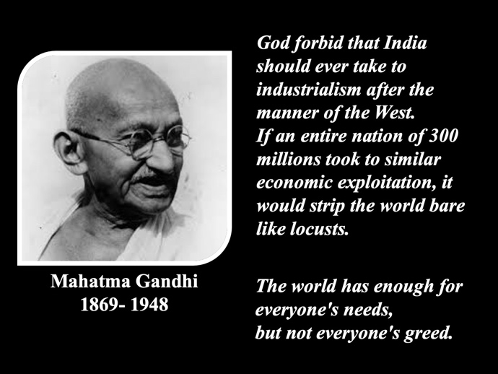 |  | 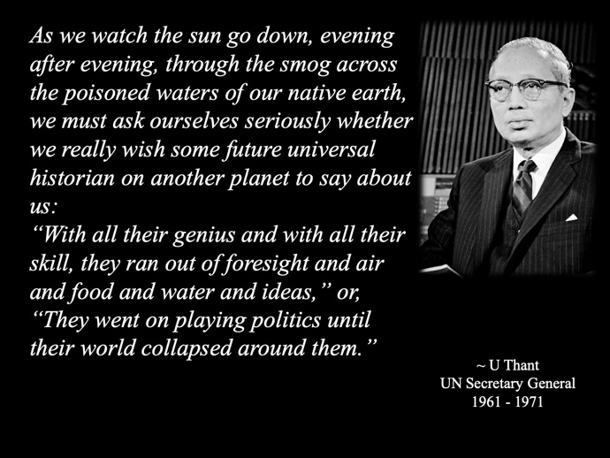
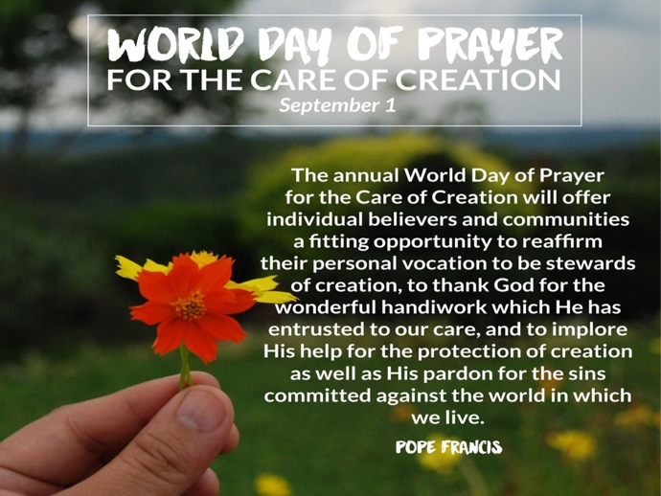 |  | 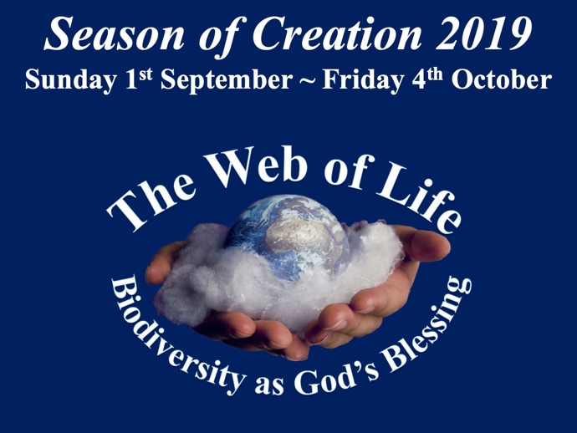
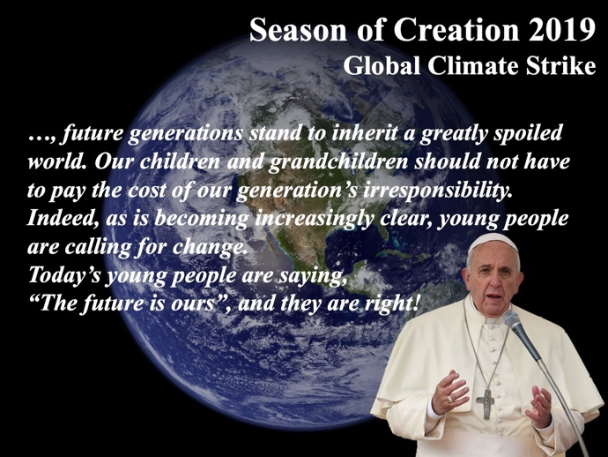 |  | 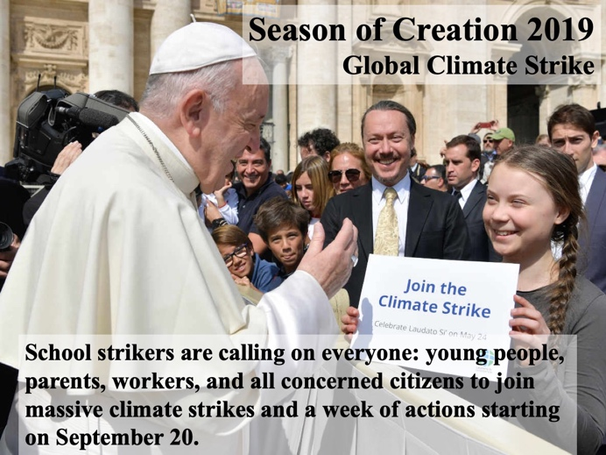
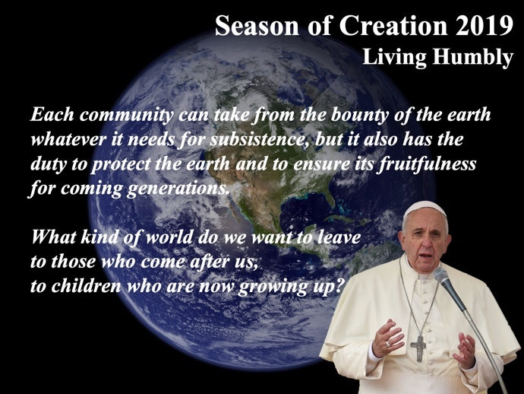 |  | 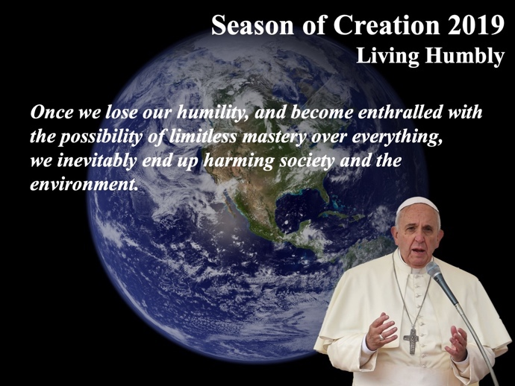
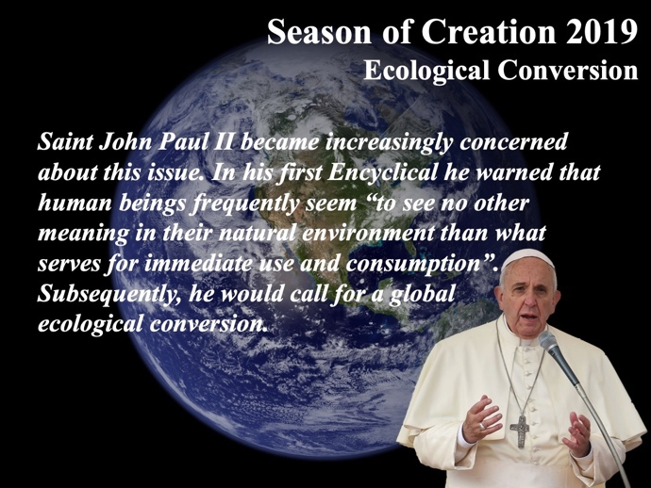 |  | 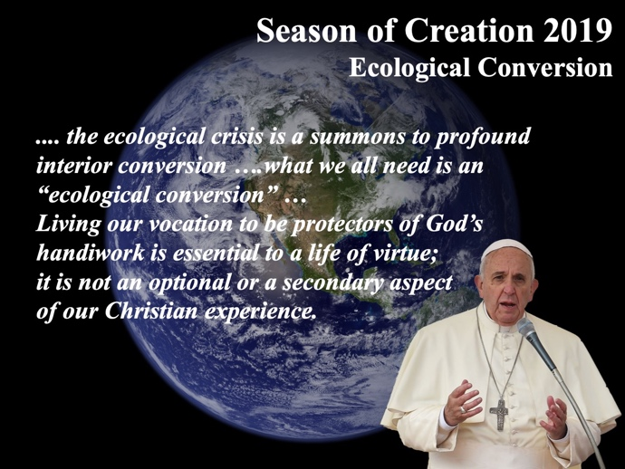
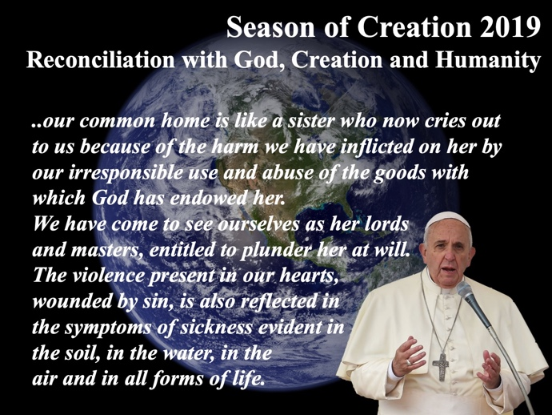 |  | 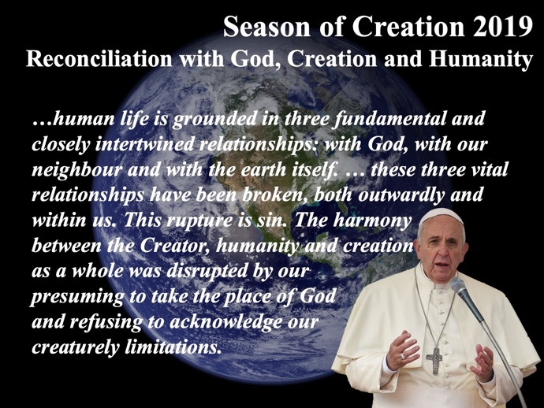
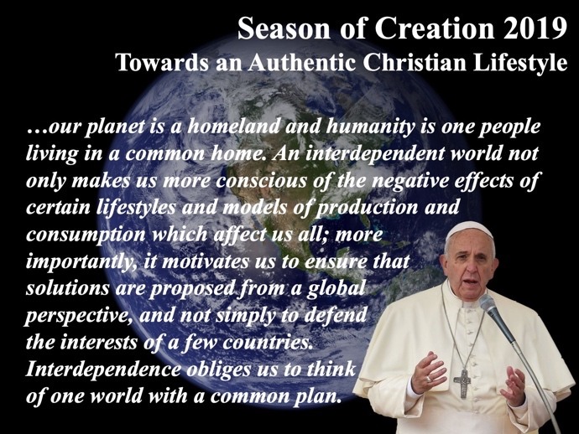 |  | 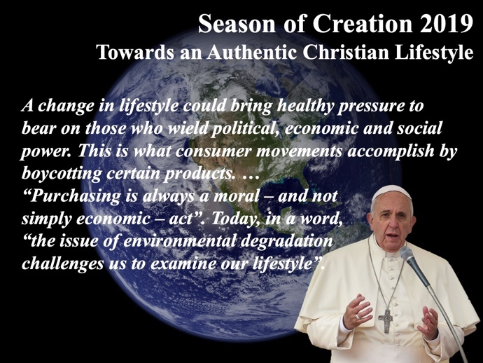
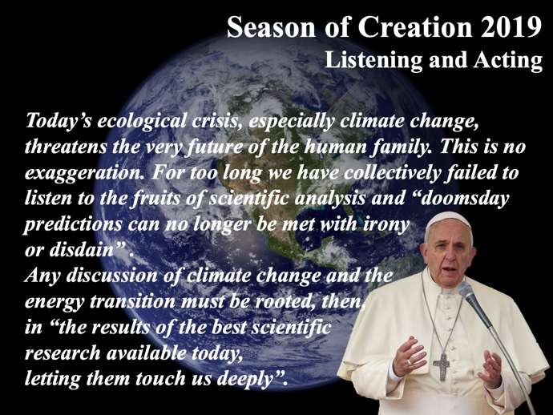 |  | 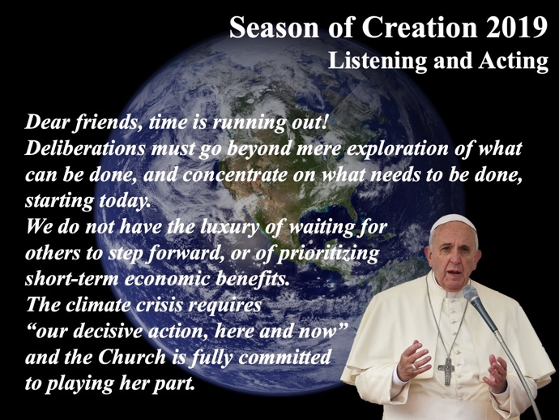

Top Ten Takeaways from Laudato Si’
In June 2015 Fr Jim Martin, in an article in America: The Jesuit Review, identified what he saw as the main messages or ‘takeaways’ of Laudato Si’.
They are:
- The spiritual perspective is now part of the discussion on the environment
- The poor are disproportionately affected by climate change
- Less is more
- Catholic social teaching now includes teaching on the environment
- Discussions about ecology can be grounded in the Bible and church tradition
- Everything is connected – including the economy
- Scientific research on the environment is to be praised and used
- Widespread indifference and selfishness worsen environmental problems
- Global dialogue and solidarity are needed
- A change of heart is required

The full article is available at: www.americamagazine.org/faith/2015/06/18/top-ten-takeaways-laudato-si

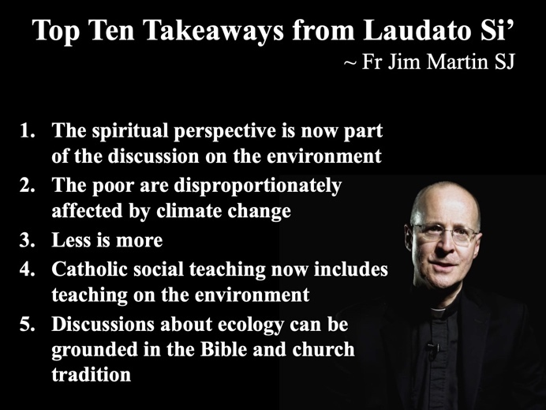 |  | 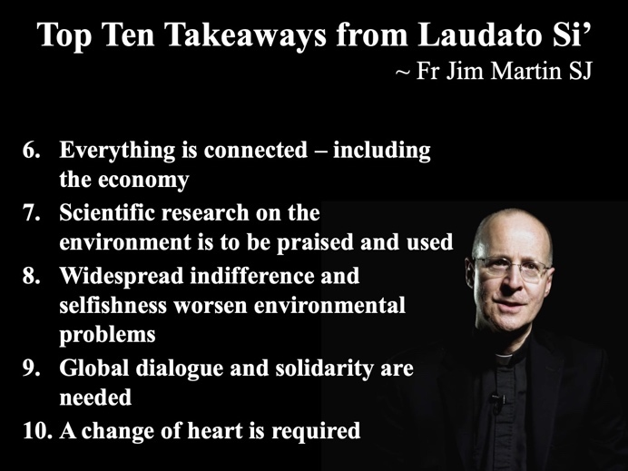

Additional Resources

CAFOD
The official aid agency for the Catholic Church in England and Wales.
Two dedicated areas relating to Climate Change:
- Climate located under its Campaign focus
- Laudato Si’ encyclical located under its Prayer focus
www.cafod.org.uk

Eco Congregation Scotland
Eco-Congregation Scotland is a movement of Scottish church congregations, of all denominations and none, committed to addressing environmental issues through their life and mission.
https://www.ecocongregationscotland.org/creation-time/

Global Catholic Climate Movement
The Global Catholic Climate Movement works within the Catholic Church to better care for our common home. Our founding document is Pope Francis’ encyclical on climate change and ecology, Laudato Si’.
The following are
The specific areas they have resources on:

Featured Campaign
- Climate Strike
Other Campaigns
- Divestment
- Season of Creation
- Amazon Synod
Live Laudato Si’
www.livelaudatosi.org
Laudato Si’ Pledge
- Pray for and with creation
- Live more simply

- Advocate to protect our common home
www.catholicclimatemovement.global

Justice and Peace Scotland
The National Commission for Justice and Peace advises the Scottish Bishops' Conference of the Catholic Church in matters relating to social justice, international peace and human rights, and promotes action in these areas.
With regard to Care for Creation the commission has resources for the following areas:

- Fashion
- Transport
- Carbon Offsetting
- Food
- Water
- Consumption – Reduce, Recycle, Reuse

www.justiceandpeacescotland.org.uk

SCIAF
SCIAF is the Scottish Catholic International Aid Fund, the official agency of the Catholic Church in Scotland.
It has the following dedicated resources on Climate change
- SCIAF Advocacy manual
A manual for global advocacy practitioners with advice on advocacy concepts and strategies.
- Agroecoglogical toolkit
Agroecological practices developed with partners across El Salvador and Nicaragua.
- Laudato Si’ study guide
Our Laudato Si' study guide includes passages from Pope Francis' encyclical, reflections, prayers and ideas for action.
- Caring for our common home
Tips and ideas to help you cut your carbon footprint and bring Laudato Si' to life in your parish.
- Powering our common home
We all need heat, electricity and fuel in our daily lives but often the types of energy we use cause harm to our planet and our fellow sisters and brothers. Our report sets out the path to a just energy system.
- Scotland’s new climate change bill
SCIAF’s paper setting out what we think must be included in Scotland’s new Climate Bill.
www.sciaf.org.uk

350
An international movement of ordinary people working to end the age of fossil fuels and build a world of community-led renewable energy for all.
www.350.org

‘Given in Rome at Saint Peter’s on 24 May, the Solemnity of Pentecost, in the year 2015, the third of my Pontificate.’ http://w2.vatican.va/content/francesco/en/encyclicals/documents/papa-francesco_20150524_enciclica-laudato-si.html
https://www.youtube.com/watch?v=t2XiT76tgCo
Pope Francis pointed to his head.
http://w2.vatican.va/content/francesco/en/letters/2015/documents/papa-francesco_20150806_lettera-giornata-cura-creato.html
http://w2.vatican.va/content/francesco/en/messages/pont-messages/2016/documents/papa-francesco_20160901_messaggio-giornata-cura-creato.html
http://w2.vatican.va/content/francesco/en/messages/pont-messages/2017/documents/papa-francesco_20170901_messaggio-giornata-cura-creato.html
http://w2.vatican.va/content/francesco/en/messages/pont-messages/2018/documents/papa-francesco_20180901_messaggio-giornata-cura-creato.html
Season of Creation, Celebration Guide, 2019 Theme: Web of Life (SoC-CG 2019) http://seasonofcreation.org/guide/
Pope Francis talking to journalists during a press conference on board a flight to Rome on September 11, 2017.
Soc-CG 2019.
Following in the Footsteps of Jesus: Meditations on the Gospels for Year C, José Antonio Pagola, Convivium Press © 2012. All rights reserved. Used with permission of The Crossroad Publishing Company, www.crossroadpublishing.com. – (Pagola)
Apostolic Exhortation Evangeli Gaudium – Chapter One, I http://w2.vatican.va/content/francesco/en/apost_exhortations/documents/papa-francesco_esortazione-ap_20131124_evangelii-gaudium.html
Laudato Si’ (LS) 236.
LS 238.
LS 246.
LS 2.
SoC-CG 2019
Pagola, Pages 128-129
LS 221.
LS 246.
Laudato Si’ (LS) 236.
LS 238.
LS 246.
LS 4.
SoC-CG 2019
Pagola, Page 130.
LS 221.
LS 246.
LS 236.
LS 238.
LS 246.
LS 20-22.
SoC-CG 2019
Pagola, Pages 132-133.
LS 221.
LS 246.
LS 236.
LS 238.
LS 246.
LS 25.
Pagola, Pages 135-136.
http://w2.vatican.va/content/francesco/en/speeches/2019/june/documents/papa-francesco_20190614_compagnie-petrolifere.html
LS 236.
LS 238.
LS 246.
Address of Pope Francis to participants at the meeting promoted by the Dicastery for Promoting Integral Human Development on the theme: The Energy Transition & Care of our Common Home. http://w2.vatican.va/content/francesco/en/speeches/2019/june/documents/papa-francesco_20190614_compagnie-petrolifere.html
Pagola, Page 137.
LS 221.
LS 246.
The Maasai Creed is a Profession of Faith composed in 1960 by the Maasai people of East Africa in collaboration with missionaries from the Congregation of the Holy Ghost. The creed attempts to express the essentials of the Christian faith within the Maasai culture. An early publication of the Maasai Creed appears in Fr. Vincent J. Donovan, “Christianity Rediscovered”, in which Donovan tells of his work among the Maasai through which they came to their own understandings of Christianity.
In February 1984, after four years of being closed due to bombing in 1980, the Christ the Saviour Church in the Zacamil district of San Salvador celebrated the 15th anniversary of the Christian base communities. The church was decorated with red flowers in commemoration of the 623 martyrs from the parish, the Eucharist was shared by a thousand people, and this prayer was offered by the gathered community.
Pagola, Page 79.
Diarmuid O’Murchu, http://www.diarmuid13.com/special-prayers

