Photographer: Mr/Mrs****
Phone Number:
Email:
Photography & Video Package
3 mounted 9 x 6" photos and the video costs £**
These consist of:
1 full length
1 mid shot
1 family shot
A full recording of the ceremony and the DVD will be personalised with a photograph of your child on the DVD disc and also on the case cover
If you would like to book a slot to have photographs taken at the altar before Mass then please contact the photographer directly. These are given out in 5 minute intervals starting approx 1 hour before Mass starts. This is on a first come first served basis. Those that book first will have a later time slot.
*Again all of this information is a suggestion and is to be edited appropriately*
St ?????? is a Parish of the Archdiocese of St Andrews and Edinburgh
a Charity registered in Scotland – number SC008540

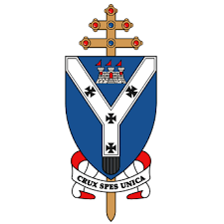
Parish Logo Here
Parish Name
Date
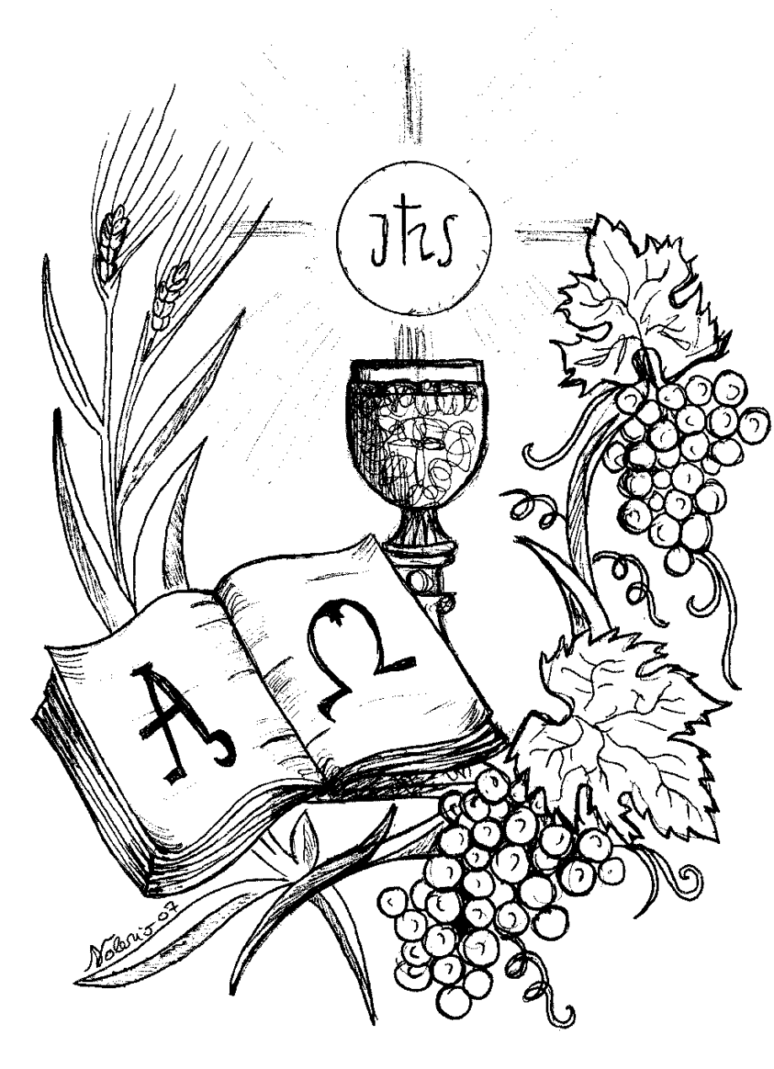
First Holy Communion

Guide for Parents

All information here is given as a suggestion which should be edited to suit your parish

Dress code – Girls should wear a simple white dress with a veil with no gloves, hats or bags.
Boys may wear school uniform, a kilt or white trousers and shirt.

Seating – All the children will sit together on the front pews on the left hand side, names plates will be in place on the day. Two representatives from each family will sit in the corresponding seat of their child on the opposite side. There will be no other seats reserved.

Photos - There will be a group photo taken before Mass begins on the altar by the parish photographer ONLY. This will be available to view on the parish website.
Individual and/or family photos is the responsibility of the families and on the back page of this flyer you will find details of prices and contact details of the photographer.
NO OTHER PHOTOS TO BE TAKEN DURING MASS.
But feel free to take photos after the Mass in the Chapel or after the reception in the Hall.
Holy Mass– A child(ren) will give the introduction before the start of Mass. The Reading & Psalm will be said by one of the Communicants parents, also Prayers of intercession. The Offertory will be carried by two teachers.

How to receive Holy Communion – Each child will come out at the same time as their two family members and receive together. The children will receive Holy Communion on the tongue, bless themselves and return to their places to say a prayer of thanksgiving. The remainder of the congregation will then process out to receive Holy Communion. The children should wait until they attend High School before receiving from the Chalice.

Reception – There will be a food provided for each child with tea, coffee & biscuits being served in the Hall and we would like to invite the Holy Communicant and four other members of the family to come along (party of 5 per family). We will have a large cake which will be cut once everyone is seated.

