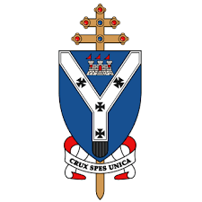

PARISH LOGO HERE

**Important Dates!**

**Stage II (2019-20) (P4)**

Here is a list of important dates for you and your child as they prepare to receive the Sacrament of Holy Communion:

|  |  |  |
| --- | --- | --- |
| **What** | **Where** | **When** |
| Parents’ Meeting | Chapel Hall (Example) | 07/10/19 |
| Priest & Parent Meetings | Fill in as appropriate | Fill in as appropriate |
| Enrolment Ceremony |  |  |
| Parents’ Meeting (Practical/Theoretical) |  |  |
| Presentation of the Our Father |  |  |
| **Sacrament of First Holy Communion** |  |  |
| Presentation of Certificates |  |  |

*St ??????is a Parish of the Archdiocese of St Andrews and Edinburgh*

*a Charity registered in Scotland – number SC008540*



PARISH LOGO HERE

**Important Dates!**

**Stage II (2019-20) (P4)**

Here is a list of important dates for you and your child as they prepare to receive the Sacrament of Holy Communion:

|  |  |  |
| --- | --- | --- |
| **What** | **Where** | **When** |
| Parents’ Meeting | Chapel Hall (Example) | 07/10/19 |
| Priest & Parent Meetings | Fill in as appropriate | Fill in as appropriate |
| Enrolment Ceremony |  |  |
| Parents’ Meeting (Practical/Theoretical) |  |  |
| Presentation of the Our Father |  |  |
| **Sacrament of First Holy Communion** |  |  |
| Presentation of Certificates |  |  |

*St ??????is a Parish of the Archdiocese of St Andrews and Edinburgh*

*a Charity registered in Scotland – number SC008540*

The Catholic Parish of

*Enter Parish Name/Town*



**Sacrament of Holy Communion**

PARISH LOGO HERE

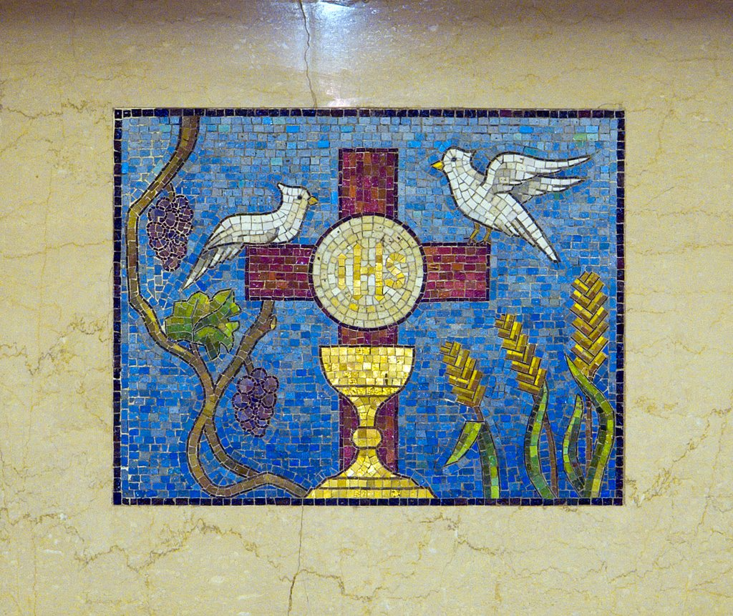

Prayer

###### Sacramental Programme 20**-20**

*St ??????is a Parish of the Archdiocese of St Andrews and Edinburgh*

*a Charity registered in Scotland – number SC008540*

The Catholic Parish of

*Enter Parish Name/Town*



PARISH LOGO HERE

**Sacrament of Holy Communion**

PARISH LOGO HERE





Prayer

###### Sacramental Programme 20**-20**

*St ??????is a Parish of the Archdiocese of St Andrews and Edinburgh*

*a Charity registered in Scotland – number SC008540*