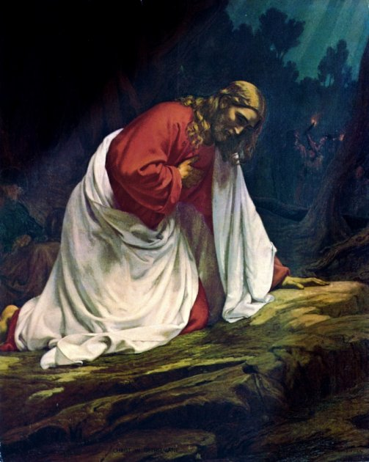

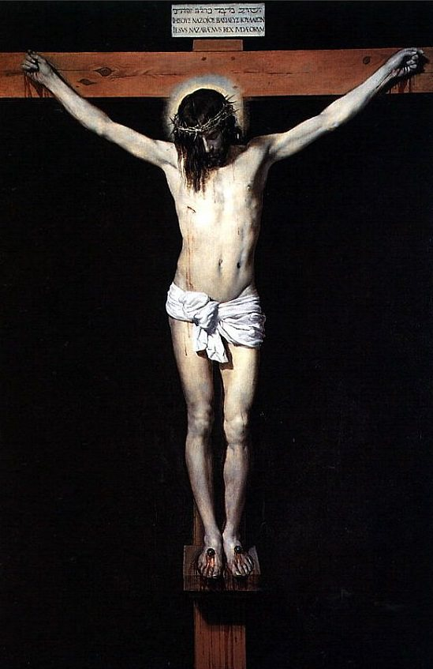

Holy Week Service
We watch with the Lord
in the Garden of Gethsemane

Hymn:

1

At the foot of the Cross
Beyond all my unworthiness,
You are the worthy One;

Beyond all my sin,
You are the sinless one;

Beyond all my selfishness,
You are the caring one;

Beyond all my weakness,
Your are the strong one;

Beyond all my limitations,
You are the infinite one;

Beyond all my lack of love,
You are the beloved one.

Beyond all my faults,
Beyond all my doubts,
Beyond all my failures,
You are to be praised and given glory, honour and blessing,
because by Your passion, death and resurrection
You redeem us into glory.

14
Hymn:

13
We watch and pray in the Garden
Priest
Present day Gethsemane is situated at, or near, the very place where Jesus went to pray. Gethsemane means, ‘olive press.’ It is situated to the east of Jerusalem, just above the Kidron Valley, at the foot of the Mount of Olives, this garden is today lovingly tended by Franciscans. Here, amid ancient olive trees and shrubs, we can picture the Lord in His agony as he offered Himself for our sakes.
Prayer to begin our watch
All
Lord, we seek to accompany You,
to watch and pray with You,
To share those agonising moments in the Garden
when You faced the hour of Your suffering
and willingly accepted Your death,
even death on a cross,
for the sake of us all.
Lord, by this vigil with You,
may we be strengthened in our trials
and remain faithful to You.

Amen.

2

Jesus goes to the Garden

Priest

After the Last Supper you all
leave the city and cross the Kedron Valley
to the foot of the Mount of Olives,
to a small estate called Gethsemane,
a place where You would often go.
You tell Your disciples that, this very night,
You will be betrayed, that they will all lose faith
and that Peter will have disowned You.
They all say they will never disown You.

All

Lord, like the disciples, I promise You so much
but in reality I am so weak, so frail of purpose,
so slow to do Your will.

Lord, be with me in time of temptation.
Help me to remain faithful to You,
for You were faithful to me, even unto death.
Amen.

3
Peter Denies Jesus Three Times

Priest

At a distance, Peter follows You to the courtyard of the house of Caiaphas. As he sits warming himself they ask him;
“Weren’t you with Jesus the Nazarene?”
Calling down curses on himself, he denies knowing You in front of them all.
At the third denial the cock crows, and You turn to look straight at Peter, and he remembers Your words.
He goes away and weeps bitterly.

All

Lord Your disciples and all of us too,
we have failed to watch with You,
we have lacked desire to pray with You,
we have betrayed You,
we have deserted You,
we have denied You,
we have left You all alone.

Yet You never stopped loving us,
never held back from offering Yourself.
You consecrated Yourself for our sakes,
and remained faithful to us through all Your trials.
For this we thank and praise You.
Amen.
12
Jesus is taken from the Garden
Priest
Lord, we watch with You and pray, lest we enter into temptation,
for the spirit is willing, but the flesh is weak.

Now You are alone without a friend,
surrounded by a large hostile crowd.
They seize You like a brigand to take You away from the Garden
to the house of Caiaphas, the High Priest,
where the Scribes and Elders await You.

Now the agony in the Garden is over!
Now You have entrusted Yourself to the Father’s will.
Now You have been handed over
for them to do with You as they wish.

All

Lord, as I think of You abandoned
to face Your suffering alone,
I thank You for accepting our weakness,
our hesitancy in following You.

Lord be with me in time of temptation.
Help me to remain faithful to You,
for You were faithful to me, even unto death.
Amen.

11
Jesus is overcome with fear and distress
Priest
Lord, we watch with You and pray, lest we enter into temptation,
for the spirit is willing, but the flesh is weak.

Taking Peter, James and John
You go further into the Garden.
Sudden fear comes over You and great distress.
Now is the time of agony, of darkness and gloom, (Zeph 1:14)

Your heart is stricken within You,
trembling and fear fall upon You,
horror overwhelms You (Ps 54)
You ask the three disciples to wait there and keep awake.

All

Lord, I am slow to learn from You,
to learn to love and not to fear You.
For You faced Your fear for my sake,
not to punish me, or to condemn me,
but to take my punishment on Yourself.

Lord be with me in time of temptation.
Help me to remain faithful to You,
for You were faithful to me, even unto death.
Amen.

4
Jesus prays the first time
Priest
Lord, we watch with You and pray, lest we enter into temptation,
for the spirit is willing, but the flesh is weak.

You withdraw, a stone’s throw away,
and fling Yourself to the ground,
You pray that, if possible this hour might pass You by.
“Abba”, You say, “Dear Father! Everything is possible for You!
Please take away this cup from Me,
but let it be as You, not I, would have it.”

All

Lord, I think of You praying alone,
and struggling to do not Your own will
but the will of the One who sent You.
How many times I put my own will first
and in my weakness fail to do Yours!

Lord be with me in time of temptation.
Help me to remain faithful to You,
for You were faithful to me, even unto death.
Amen.

5
The disciples desert Jesus and run away

Priest

Lord, we watch with You and pray, lest we enter into temptation,
for the spirit is willing, but the flesh is weak.

Even though You are abandoned by Your chosen disciples,
even though they all run away,
knowing it is ordained for You to suffer, You accept it all.

I shall strike the shepherd; the sheep will be scattered.
You are ready to drink the cup of the suffering one.

All

Lord, though we all desert You, all going our own way,
You never abandon us, You are faithful to the end.

Lord be with me in time of temptation.
Help me to remain faithful to You,
for You were faithful to me, even unto death.
Amen.

10
Jesus prays the second time

Priest

Lord, we watch with You and pray, lest we enter into temptation,
for the spirit is willing, but the flesh is weak.

You go away a second time, and You pray using the same words.
In Your anguish You pray even more earnestly.

You cry out in the early hours of darkness,
pour out Your heart before the Lord.
You offer up prayer and earnest entreaty
aloud and in silent tears
to the One who has power to save You.

All

Lord, I have pursued my own will,
my own paths and not Yours,
and yet I long to serve You with a willing heart.
Lord, Your will, not mine, be done!

Lord be with me in time of temptation.
Help me to remain faithful to You,
for You were faithful to me, even unto death.
Amen.

7
Jesus prays the third time

Priest

Lord, we watch with You and pray, lest we enter into temptation,
for the spirit is willing, but the flesh is weak.

You go away to pray the same way.
In the intensity of You agony
Your sweat falls to the ground
like great drops of blood.

Now My soul is so troubled! What shall I pray,
“Father, from this hour save Me?”
Yet it is for this reason that I come to this hour,
Father, glorify Your name!

All

You willingly accept death,
and resolutely set Your face like flint.
You are ready to do Your Father’s will.

Lord be with me in time of temptation.
Help me to remain faithful to You,
for You were faithful to me, even unto death.
Amen

8
Jesus is betrayed by Judas

Priest

Lord, we watch with You and pray, lest we enter into temptation,
for the spirit is willing, but the flesh is weak.

You come back at last to the disciples.
“Now it is all over. The hour has come.
Now the Son of Man is to be betrayed into the hands of sinners.”

As You are speaking, Judas arrives with men armed with swords
and clubs, sent by the Chief Priests, Scribes and Elders.
“The one I kiss”, he says, “He is the man.”
He comes straight to You.
“Rabbi”! he says, and kisses You.

All

As I see You betrayed by Your friend,
betrayed by a tender sign of affection,
Lord I am only too aware
of my own unworthiness before You,
my failure to live up to our friendship,
my spurning of Your trust.

Lord be with me in time of temptation.
Help me to remain faithful to You,
for You were faithful to me, even unto death.
Amen.
9

Jesus finds His disciples asleep

Priest

Lord, we watch with You and pray, lest we enter into temptation,
for the spirit is willing, but the flesh is weak.

You come back to the three disciples
and find them not watching but sleeping.
You say to Peter: “Simon, are you asleep?
Had you not the strength to stay awake with Me one hour?
You should be awake and praying not to be put to the test.
The spirit is willing, but the flesh is weak.”

All

Like the disciples, I too have failed to pray,
to accompany You for even one hour!
I have failed to share with You,
to keep You company, to share my life,
my thoughts, my time with You.
How many times have I been as if asleep?

Lord be with me in time of temptation.
Help me to remain faithful to You,
for You were faithful to me, even unto death.
Amen.

6

