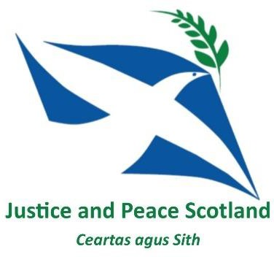
Dear Justice and Peace Supporter, Travels of a Social Justice Co-ordinator
It may be an odd thing to say, but the place I associate most with my job isn’t in Scotland. The port town of Calais more than anywhere else is what I think about, and indeed speak about in this job. Calais is a very small piece of a global picture of migration, and given all the current discourse (Pope Francis on one side, rising right-wing populists on the other) a very important one for us to engage with. I think it’s because the day I interviewed for this job was the same Monday that the demolition of the camp, known as ‘the jungle’ started. That morning I sat in the
NEWSLETTER
February 2019
hotel bar, watching the news waiting to go for my interview where, of all things, issues of social justice would be on the agenda! Less than a week later I was in Calais, with my old Home Office job to be part of the clearance of the camp, and accompanying a dozen young Afghan families and unaccompanied children to Toulon. I’ve been back since, most recently leading our Encounter: Calais project (see below). This opportunity to take volunteers to witness first hand the hostile environment those in Calais are subjected to also reminded me how ‘under the radar’ the situation is. Volunteering with Care 4 Calais (one of the organisations working on the ground) both groups travelled to Brussels. This is a regular trip, made each Thursday with emergency aid (it was blankets the first week due to the snows) and also
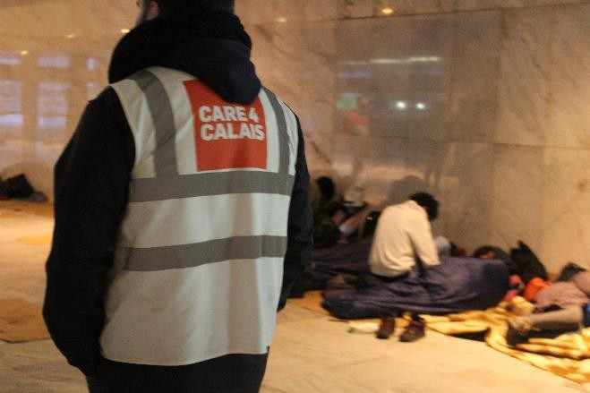‘services’; generators to charge phones, wifi, a pop-up barber shop, games, and hot drinks. While I seem to have normalised the situation in and around Calais; fences, barbed wire, camps in areas of wasteland (not to say that this is normal or acceptable) seeing groups of people ignored and abandoned in the heart of a European capital still had the capacity to shock me. I walked through Gare de Bruxelles-Nord train station, 5 minutes from the park where we were working. Hundreds of young refugees, men and women were sitting in a concourse forgotten and ignored by the
Danny walking through a Brussels train station as part of our Encounter : Calais project.
commuters passing through. I learnt that the authorities’ tolerance of those in the station was only due to the cold weather outside, and they would have to leave at 2am when the station closed. The second week I went with others deliberately to let those who were there know that this week we had a medical charity with us. Had we attempted to distribute aid in the station we would have been stopped. While the politics of all this are complex, as a nation I have to believe we are better than this, and perhaps putting UK taxes into facilities and safe, legal routes would be a more Christian use of that money than on barbed wire, security cameras and deterrence.
Danny (Co-ordinator)

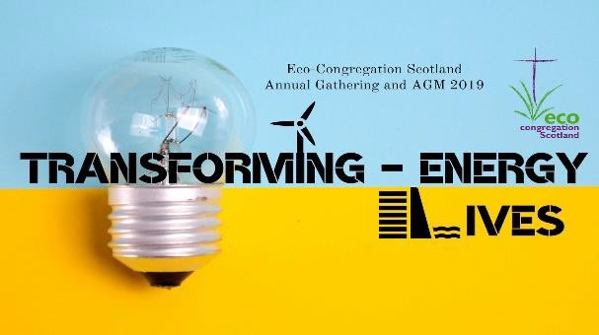
Glasgow: UN Anti-Racism Day Demonstration Saturday 16th March 2019 @ 11am starting at George Square in Glasgow city centre, marching route around the city centre and then back to George Square. Look out for the J&P banner and join us to unite against racism and fascism.

Eco Congregations - Annual gathering and AGM Saturday 30th March 10am – 4pm Gate Church International 158 Perth Road Dundee DD1 4JS - A day of talks and workshops on transforming energy and transforming lives.

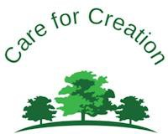
To celebrate our 40th anniversary, we invite you to join us at Carfin Grotto on Monday 1st April at 1:00 pm
Bishop Nolan will celebrate Mass followed by a tree planting ceremony. Four Juniper trees and four Scots Pine trees will symbolise each of the eight Scottish dioceses.
Refreshments will be available after the ceremony. All welcome!
Glasgow Catholic Worker - Wednesday 6th March – Ash Wednesday Witness at Faslane South Gate 2:45pm Join us for our annual Ash Wednesday Service of repentance and resistance at the home of the UK's weapons of mass destruction.

We start at the car park next to the South Gate where we will mark each other with ashes and then process with the cross to the South Gate accompanied by readings, prayers and hymns. All are welcome. Transport is available email glw@catholicworker.org.uk.
Time to book your place at Pax Christi Scotland's next event. March 9th, registration and coffee at 10am for a day-long programme of reflection. Contact Anna at anna@confortiinstitute.org. The cost for the day is £12 (£5 for students & low waged) including lunch & teas/coffees. If you're coming from a distance you can book B&B at Conforti overnight Friday/Saturday for £35. Hope to see you there.

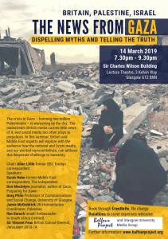
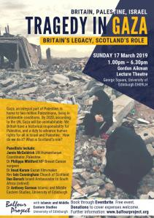
Glasgow – The News from Gaza :
Dispelling Myths and Telling the Truth, 14th March, 7:30pm – 9:30pm.
Edinburgh – Tragedy in Gaza : Britain’s Legacy, Scotland’s Role, 17th March, 1pm – 6:30pm.
The Balfour Project is holding two major events, concentrating on Britain’s role in, and historical responsibility for, the current state of affairs in Palestine and Israel and particularly Gaza. Exploring history, particularly Britain’s historical responsibility in Mandate Palestine and the critical state of health, welfare and sheer survival of the largely refugee
population, and for Britain—and Scotland in particular—to search for our part in the way ahead. See the website for how to book. http://www.balfourproject.org/

SCIAF’s Family Fun Run on Saturday 4th May 2019 at Strathclyde Country Park, Motherwell – starts 10am

Whether you’re old or young, running or walking, with family, friends or going
solo, SCIAF’s WEE BOX 6K Family Fun Run can help raise money so the poorest can survive and thrive. Sign up here! https://www.sciaf.org.uk/get-involved/events/281-wee-box-6k- family-fun-run

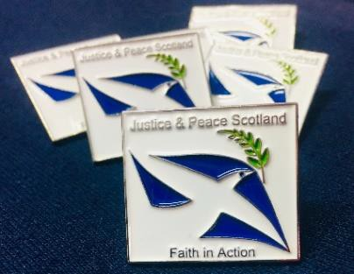
Justice and Peace Scotland badges are now available for all members / supporters in parishes, schools, anywhere and everywhere. Please contact the office if you would like to order some. There is no charge, but any donations to help us cover the costs of postage will be most gratefully received. Diocesan Justice and Peace Commissioners also have them available locally.

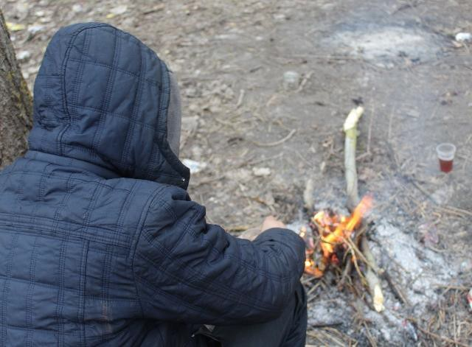
Two groups of volunteers from Scotland participated in our first Encounter: Calais programme. Working as volunteers on the frontline of the UK’s border with those abandoned by the authorities, and ignored by the press, with the chance to meet refugees, faith leaders and volunteers, and reflecting on Christ’s command to ‘welcome the stranger’. If your school, parish, community group, or workplace would be interested in hearing more about the situation in Calais and other areas and the experience of the participants please get in touch.

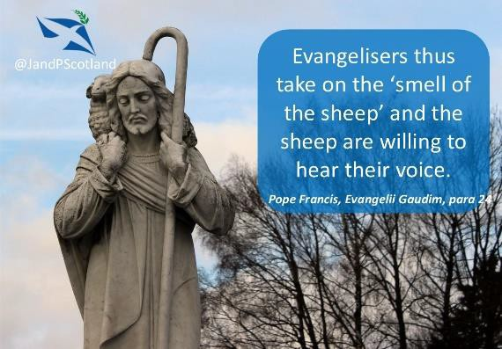
#WeeklyCST for 2019
Followers on Facebook, Twitter and Instagram will know that every Sunday we release #weeklyCST – a weekly quote from Catholic Social Teaching, themed to match either the Mass scripture, or a significant social justice event in the coming week. These are intended for use in parish newsletters / bulletins, and are also great for schools (thought for the day), prayer/ study groups, or for private reflection and prayer. For the CST quotes for 2019 please click here, alternatively contact the office, or keep an eye on our social media.

Music for Worship
A selection of music for praise, thanksgiving, and comfort inspired by faith.

WYD 2019 Panama – Here I am, the Servant of the Lord
https://www.youtube.com/watch?v=EXM_M4fEmak
The English language translation of ‘Hágase en mi Según tu Palabra’ the official anthem
of World Youth Day 2019, celebrated by Pope Francis in Panama last month.

Matt Maher – Rise up https://www.youtube.com/watch?v=hfa3GZOEb38

Matt Maher is a Canadian, Catholic, worship leader and composer. He has performed for both Pope Benedict XVI (USA visit 2008), and Pope Francis (WYD Rio 2013).

Food for thought
Each edition we will try to bring something thought provoking, and perhaps challenging for you to reflect on. This edition we have three selections. First the Huffington Post; Calais ‘Life after
the Jungle’.
https://www.youtube.com/watch?v=IzFi0SP8tdo
Over 2 years since the demolition of the ‘Jungle’ camp in Calais there are still over 3000 refugees dispersed and living around Northern France and Belgium. Deteriorating conditions have lead refugees to try increasingly risky methods of reaching the UK.
Our second piece is ‘Dream’ from the Wildlife Conservation Film Festival.
http://www.wcff.org/dream/

In the heartbreakingly powerful 2016 animation “Dream”, created for the Wildlife
Conservation Film Festival by Zombie Studio, four very different, critically endangered
animals sing “I Dreamed a Dream” from the Les Misérables soundtrack. With the lyrics of the particular song, each animal – a blue whale, a brown pelican, a baby harp seal and a rhinoceros – tell of their own fate by human hands.

The third video comes from BBC3 looking at the issues around knife crime.
https://www.bbc.co.uk/iplayer/episode/p04xwqh7/teenage-knife-wars

Documentary in which former England footballer Jermaine Jenas returns to his home city of Nottingham to investigate the spike in knife crime that is devastating young lives and families. He meets with young men and gang members to find out why they carry knives and what is driving the brutal stabbings across the city.

Don’t hesitate to be in touch with the Justice and Peace National office on 0141 333 0238 and please consider printing out a copy of our newsletter and leaving it at the back of your church, or sharing it with a friend in print, or by email.

www.justiceandpeacescotland.org.uk

Twitter : @JandPScotland
Facebook & Youtube: Justice and Peace Scotland Instagram : justiceandpeacescotland

If you have any upcoming events, interesting articles, music selections you think would be good to share with the Justice and Peace network in Scotland please get in touch!

