The Parish of ????
Your

Parish

Logo
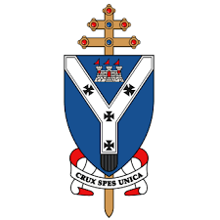

Parish Priest
Email:
Telephone:

September 2020

Dear Parent/Carer,

PREPARATION FOR THE SACRAMENT OF FIRST HOLY COMMUNION 2021

At this time of the year, I like to contact parents/carers of children who are in Primary 4 or above, who will celebrate their First Holy Communion in May 2021.

The Parish and School invest immense time and human resources in our Sacramental Programme, as we understand it is very important in preparing our children for this Sacrament.

There will be a meeting in the Chapel Hall on…………………………………………

At this meeting, we will discuss the following: dates and rites of passage for the children; a deeper understanding of the Sacrament of Holy Communion and some of the practical details.

Please ensure that at least one, preferably both parents, or carer is free to attend.

If you need further details please do not hesitate to contact me.

Yours sincerely,

Rev.
Parish Priest

