PRAYER TO THE HOLY SPIRIT

Come Holy Spirit fill the hearts of your faithful and kindle in them the fire of your love. Send forth
Your Spirit and they shall be created and You shall
renew the face of the earth.

O God, who has taught the hearts of the faithful by the light of your Holy Spirit, grant that, by the gift of the same Spirit, we may be always truly wise and ever rejoice in His
consolation. Through the same Christ our Lord. Amen

Prayer of Commitment

God our Father,

When we presented our children for the Sacrament of
Baptism, this marked the beginning of their Faith Journey.
We made a commitment to travel with them on this Journey.
As they now prepare to take the next significant steps on their Journey of Faith, through the reception of the Sacraments of Reconciliation, Confirmation and Holy Communion, may we be given the grace and blessings to support our children, encourage children and lead them by our example, so that they may experience the fullness of God's love for them, in our homes, in our Parish and in our School.

We ask this through Christ our Lord.
Amen
4
St ??????is a Parish of the Archdiocese of St Andrews and Edinburgh,
Charity registered in Scotland

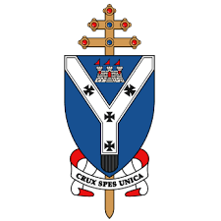
Parish Logo
The Parish of
????????????????????????

The Sacrament of Confirmation

Notes for parents and godparents

At Baptism you presented your child to be baptised showing that you wanted to share your faith. You assumed the responsibility to give them a Christian upbringing. During the ceremony of Baptism you made the promises, and made the commitment for your child.
At Confirmation your child will make his/her own commitment. He/she will be asked to confirm his/her own Christian identity
This is my Belief
This is my Church
This is who I am

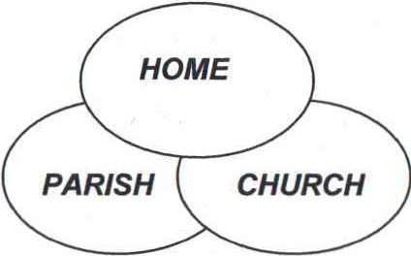
All three must combine to offer them

HELP
SUPPORT
PRAYER

In our schools and in our parishes we follow, This is our Faith programme, and also additional resources. If the children are to confirm their beliefs, they must be presented with a programme which enables them to:
Know God the Father and relate to Him as a child

- Know Jesus, understand His teaching, and desire to follow Him
- Know the Holy Spirit and be aware of His presence in Jesus and have a greater sense of belonging to the parish family
- Be aware of the Church's missionary activities and have a desire to be outreaching to others.
2
CONFIRMATION NOTES for PARENTS

What is Confirmation? It is a sacrament which deepens the grace of baptism so that we are better able to share the life of Jesus with others. As the disciples gathered in the upper room at Pentecost, they were given strength to tell others about Jesus and to be "up-front" about being Christians, so the grace of Confirmation helps people live as part of God's Church and gives them the courage to be visible as Christians.
What is a sponsor? A sponsor provides support to the person being confirmed - this is the support of someone who already is an active, committed, practising Catholic. If you don't know someone suitable, i.e. someone, who attends Mass each Sunday and normally receives Holy Communion, then speak to the Parish Priest. When the child is being confirmed, the sponsor puts his/her right hand on the right shoulder.
Why does one receive a new name? This is a sign of entering a new state and is also another sign of support, in this case from a member of the Church in heaven. Every child should spend time reading about saints and choosing a suitable saint who appeals to them - on whom they can model their life on and ask their help and intercession throughout their lives.
The Prayer of Confirmation
All-powerful God, Father of our Lord Jesus Christ, by water and the Holy Spirit you freed your sons and daughters from sin and gave them new life. Send Your Holy Spirit upon them to be their helper and guide. Give them the spirit of wisdom and understanding, the spirit of right judgment and courage, the spirit of knowledge and reverence. Fill them with the spirit of wonder and awe in your presence. We ask this through Christ our Lord. AMEN.

3

