Concluding Prayer
Lord God,
Creator and ruler of Your kingdom of light,
in Your great love for this world
You gave up Your only Son
for our salvation.
His cross has redeemed us,
His death has given us life,
His resurrection has raised us to glory.
Through Him we ask You
to be always present among Your family.
Teach us to be reverent in the presence of Your glory;
fill our hearts with faith,
our days with good works,
our lives with Your love;
A Lenten Service
on the Seven Last Words of Christ from the Cross
We watch with the Lord
in the Garden of Gethsemane
may Your truth be on our lips
and Your wisdom in all our actions,
that we may receive the reward of everlasting life.
We ask this through Christ our Lord.
Amen.
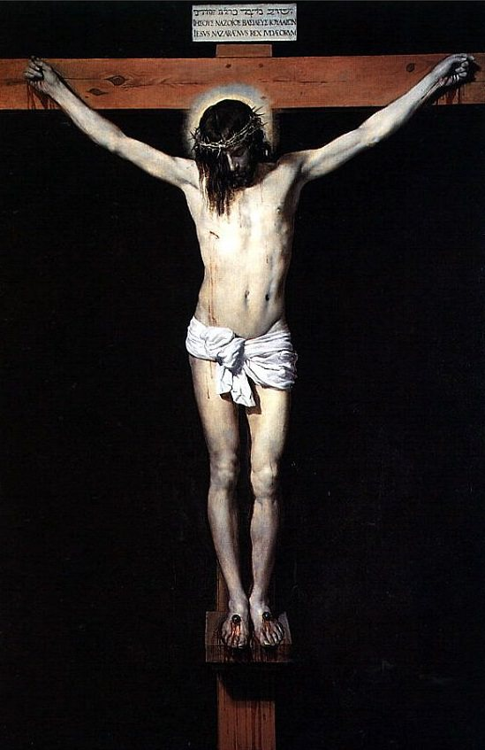

Opening Prayer
Priest: The passion, death and resurrection of Our Lord Jesus Christ is at the centre, not only of Lent, but of the whole Christian life. In baptism, we freely choose to go through the suffering and death of Jesus, in the hope of rising with Him to a new life. This is the Paschal Mystery, a mystery that takes flesh in the sufferings and deaths of every Christian.
(pause)
Merciful Father, You so loved the world that You gave Your only Son, that we might have life to the full. We gather today to ask You once again to make us aware of our sinfulness and to fill us with repentance, that we might live more truly as disciples.
We ask this through our Lord Jesus Christ.

All: Amen

We are going to pray the Seven Last Words of Christ in a slow and meditative way; they are like an examination of conscience, a good and holy way to begin the most powerful and devout week.
We also have only one candle lit - Easter/Paschal Candle. This one is lit for the final time and a new one will be blessed on Holy Saturday night.
It symbolises Christ the Light of the world.
Please feel free to join in at the appropriate places.

Have I avoided giving encouragement to those in sorrow or depression?
Do I pray for the needs of the Church, especially leaders?
Pause for reflection

Priest: Together we pray.
All: In the greatness of Thy compassion wipe out my offences.
I love Thee Jesus my love above all things; I repent with my whole
heart for having offended Thee. Never permit me to separate myself from Thee again. Grant that I may love Thee always and then do with me what Thou wilt.
SEVENTH WORD: “FATHER INTO THY HANDS I COMMEND MY SPIRIT.”
Luke 23:46
Reader 1: Faithful to the Father to the last, Jesus gave up His spirit in confidence.
Do I believe God will care for me, no matter what?
Reader 2: Do I pray regularly for what I need?
Have I prayed for the needs of others?
Pause for reflection

Priest: Together we pray.
All: In the greatness of Thy compassion wipe out my offences.
I love Thee Jesus my love above all things; I repent with my whole
heart for having offended Thee. Never permit me to separate myself from Thee again. Grant that I may love Thee always and then do with me what Thou wilt.
FIFTH WORD: “I THIRST”
John 19:28
Reader 1: The violence that was being done to His Body led Jesus to cry out for something to drink. His physical needs remained with Him until the moment of His death.
Do I care for the need of my own body?
Reader 2: Do I cherish the gift of my sexuality and take care to maintain my physical health?
Do I always appreciate the wonderful resources of the earth God provides for us, so that we are never thirsty or hungry?
Pause for reflection

Priest: Together we pray.
All: In the greatness of Thy compassion wipe out my offences.
I love Thee Jesus my love above all things; I repent with my whole
heart for having offended Thee. Never permit me to separate myself from Thee again. Grant that I may love Thee always and then do with me what Thou wilt.
SIXTH WORD: “IT IS FINISHED”
John 19:30
Reader 1: Jesus embraced all the limitations of human life - including death - He chose to become one of us.
Do I accept death, caring for the dying and preparing myself for my own death?
Reader 2: Am I able to follow Christ with charity and hope, or have I lost the zeal as the journey stretches on?
FIRST WORD: “FATHER, FORGIVE THEM, THEY KNOW NOT WHAT THEY DO.”
Luke 23:34
Reader 1: Though we find it hard to forgive minor insults and slights, Jesus asked forgiveness for those who tortured Him.
Reader 2: Do I hold grudges, talk behind people’s back, or do I pray for those who injure me?
All: Do I misuse the name of Jesus?
Do I ‘know what I am doing’ when I take the Lord’s name in vain?

Pause for reflection

Priest: Together we pray.
All: In the greatness of Thy compassion wipe out my offences.
I love Thee Jesus my love above all things; I repent with my whole heart for having offended Thee. Never permit me to separate myself from Thee again. Grant that I may love Thee always and then do with me what Thou wilt.

SECOND WORD: “AMEN, I SAY TO YOU, TODAY YOU WILL BE WITH ME IN PARADISE.” Luke 23:43
Reader 1: Jesus promised salvation to a common thief, to the one who had faith in Him.
Do I believe that faith in Jesus will bring me eternal life?
Reader 2: Have I consoled those who mourn, offering them the encouragement of my faith?
Do I pray for the dead and ask God’s pardon for sinners?

All: Have I rejoiced in the conversion of sinners, or do I hold people’s past against them?
Do I look down on those who have served time in jail?

Pause for reflection
Priest: Together we pray.
All: In the greatness of Thy compassion wipe out my offences.
I love Thee Jesus my love above all things; I repent with my whole
heart for having offended Thee. Never permit me to separate myself from Thee again. Grant that I may love Thee always and then do with me what Thou wilt.

THIRD WORD: “WHEN JESUS SAW HIS MOTHER AND THE DISCIPLE WHOM HE LOVED, HE SAID TO HIS MOTHER - WOMAN, BEHOLD THY SON - THEN HE SAID TO THE DISCIPLE, - BEHOLD THY MOTHER.”
John 19:26
Reader 1: In caring for His Mother, Jesus gave a gift and a responsibility to His disciple, John.
Have I cared for family members, regarding them as a precious gift from God?
Reader 2: Have I faithfully supported the work of the Church?
Do I share my time, talent and treasure with those in need?
Pause for reflection

Priest: Together we pray.
All: In the greatness of Thy compassion wipe out my offences.
I love Thee Jesus my love above all things; I repent with my whole
heart for having offended Thee. Never permit me to separate myself from Thee again. Grant that I may love Thee always and then do with me what Thou wilt.

FOURTH WORD: “MY GOD, MY GOD, WHY HAVE THOU FORSAKEN ME?”
MATTHEW 27:46
Reader 1: Fully united with the Father, Jesus cried out in prayer during His darkest moment.
Have I prayed for God’s help with my most pressing problems?
Reader 2: Have I faithfully worshipped with the Church and received the sacraments with sincerity?
Pause for reflection

Priest: Together we pray.
All: In the greatness of Thy compassion wipe out my offences.
I love thee Jesus my love above all things; I repent with my whole
heart for having offended thee. Never permit me to separate myself from thee again. Grant that I may love thee always and then do with me what thou wilt.

